**raiche joins pink sweat$ for the pink beginnings tour**

**tour begins 5/22 in vancouver, bc**

**download/stream her debut ep *drive* now:** [**https://raiche.lnk.to/Drive**](https://raiche.lnk.to/Drive)

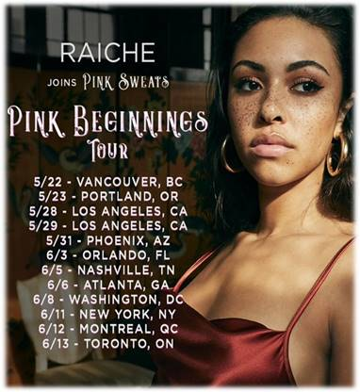

After releasing her debut EP earlier this spring, Raiche returns to announce that she’ll be joining Pink Sweat$ for “The Pink Beginnings Tour” which is kicking off on May 22nd in Vancouver, BC with already three sold out dates. The tour is set to visit Los Angeles, Nashville, TN and Atlanta, GA before coming to an end in Toronto, ON. For ticket purchase and more information please visit: <http://www.mynameisraiche.com/>

**THE PINK BEGINNINGS TOUR**

May 22  - Vancouver, BC - Fortune Sound Club

May 23 - Portland, OR - Holocene

May 28 - Hollywood, CA - Fonda Theater

May 29 - Hollywood, CA - Fonda Theater

May 31 - Phoenix, AZ - The Crescent Ballroom

June 03 - Orlando, FL - The Social

June 05 - Nashville, TN - The Basement East

June 06 - Atlanta, GA - Terminal West

June 08  - Washington, DC - 9:30 Club

June 11 - New York, NY - Webster Hall

June 12 - Montreal, QC  - L’Astral

June 13 - Toronto, ON - Danforth Music Hall

Raiche also recently unveiled her newest video “Drive” available for watching/sharing now: <https://Raiche.lnk.to/DriveVideo>. “Cheers to “Drive!” It’s one of my favorite songs on my EP....it's for the ones who have been told no. It’s for the ones who never give up. It’s for the ones who choose love over hate even when the world is against them.  I want everyone to cruise to “Drive” and allow all the cares of the world to slip away....just DRIVE,” Raiche exclaims. Get a behind the scenes look at the making of the video [here](https://drive.google.com/file/d/1Jlqdpo8yLWZyahIDGjcH6u1IaWVG0n6F/view?usp=drivesdk).

This visual also arrives after her latest videos “Complicated” which drew inspiration from the 1927 classic  “I Miss You” by Harold Melvin and the Blue Notes and “Money Pies” which was greeted by immediate praise with [Essence](https://www.essence.com/entertainment/raiche-money-pies-video/) writing, “If you’re looking for a new bop, add Raiche’s ‘Money Pies’ to your rotation.”

**CONNECT WITH RAICHE**

[MYNAMEISRAICHE.COM](http://www.mynameisraiche.com/)

[FACEBOOK](http://www.facebook.com/mynameisraiche/)

[TWITTER](http://twitter.com/mynameisraiche?lang=en)

[YOUTUBE](http://www.youtube.com/channel/UCPvxMHz48A5qFB68Cp42uqw)

[INSTAGRAM](http://www.instagram.com/mynameisraiche/?hl=en)

[SPOTIFY](http://open.spotify.com/artist/4yaRDENYr8yAAlEUf23DRI?si=-svImg0oQ-OgNEWSo6X5bg)

[SOUNDCLOUD](http://soundcloud.com/mynameisraiche)

**PRESS CONTACT**

SYDNEY MARGETSON / [SYDNEY.MARGETSON@ATLANTICRECORDS.COM](mailto:SYDNEY.MARGETSON@ATLANTICRECORDS.COM)