FOR IMMEDIATE RELEASE
SEPTEMBER 3RD, 2020

RAICHE RELEASES OFFICIAL MUSIC VIDEO FOR “PICK A SIDE” FROM FORTHCOMING DEBUT ALBUM

WATCH NOW HERE

LISTEN TO “PICK A SIDE”

STREAM DEBUT EP DRIVE NOW HERE
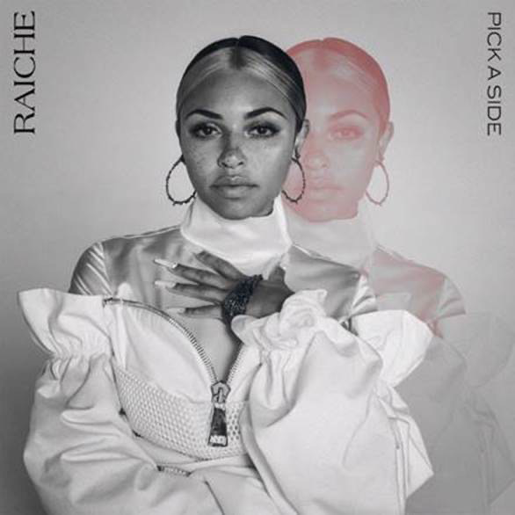

GDE/Island Prolific/Atlantic’s R&B/soulpop songstress has announced the official music video for “Pick A Side,” shortly after the song’s release last week. Watch the creative new visual HERE. “Pick A Side” is available via all digital retailers and streaming platforms HERE.

In her latest release, Raiche sends a message to those who are just all talk. The song, produced by the well-known Menardini “Bridgetown” Timothee (Mary J Blige, Beyonce, Trey Songz) and coproduced by araabMUZIK & Audio Anthem, is the first of soon to be released singles. Her upcoming album can best be described as her “Coming of Age” project and is an exploration of self-discovery, self-love and self-acceptance.

This female forward single follows her earlier release this year “Complicated.” Watch the in-studio visual now HERE. The release of “Complicated’ arrived shortly after her vlog-style, quarantine-edition music video to revamp her 2019 record, “Drive”; watch HERE. In addition, “Drive” was recently featured in the acclaimed series Self Made: Inspired by the Life of Madam C.J. Walker on Netflix. Get a behind the scenes look at the making of the video here. “Complicated,” which draws inspiration from the 1972 classic “I Miss You” by Harold Melvin and the Blue Notes, arrived shortly after her 2018 “Money Pies,” which was greeted by immediate praise with Essence writing, “If you’re looking for a new bop, add Raiche’s ‘Money Pies’ to your rotation.” Raiche first broke out into the music scene in 2018, with a viral cover of “Chasing Pirates” and becoming an overnight sensation. Signed to GDE/Island Prolific/Atlantic Records, the artist has had a number of accomplishments in her career, from touring with Pink Sweat$ on the Pink Beginnings Tour, to opening for Jacquees, to her aforementioned feature in Netflix’s Self Made: Inspired by the Life of Madam C.J. Walker.

About Raiche:
With her breezy vocals and refreshingly unique singing style, Raiche has proven herself to be a breath of fresh air. The young artist fuses soulful roots with modern pop to concoct a genuinely distinctive new sound all her own, lit up with confidence, consistency and positivity. Born and raised in Pittsfield, MA, just two hours outside of Boston, Raiche devoted her energies towards music from an early age, uploading cover videos to YouTube that almost immediately earned her online applause. Her musical dreams almost came to a halt following high school graduation but some encouraging words from her beloved Nana eventually led her to Boston, where she met and began being mentored by DJ Knock Out. The local legend soon introduced Raiche to her GDE production team as well as to award-winning songwriter and producer Prince Charlez (Rihanna, Beyoncé, Usher), who promptly signed the gifted young vocalist to his recently launched Island Prolific imprint at Atlantic Records.

“My mission is to work hard and keep going, no matter what,” Raiche says. “And to make music that reflects solid, positive energy along the way.”

# # #

CONNECT WITH RAICHE
MYNAMEISRAICHE.COM
FACEBOOK
TWITTER
YOUTUBE
INSTAGRAM
SPOTIFY
SOUNDCLOUD

PRESS CONTACT
SYDNEY MARGETSON / SYDNEY.MARGETSON@ATLANTICRECORDS.COM

