RAICHE TEAMS UP WITH TY DOLLA $IGN TO DELIVER A SENSUAL NEW REMIX TO "PICK A SIDE"

LISTEN NOW HERE

ARTIST RECENTLY NAMED YOUTUBE’S ARTIST ON THE RISE TRENDING
FOR HER “PICK A SIDE” IN-STUDIO VISUAL

WATCH THE OFFICIAL “PICK A SIDE” VIDEO

RAICHE'S DEBUT ALBUM COMING SOON
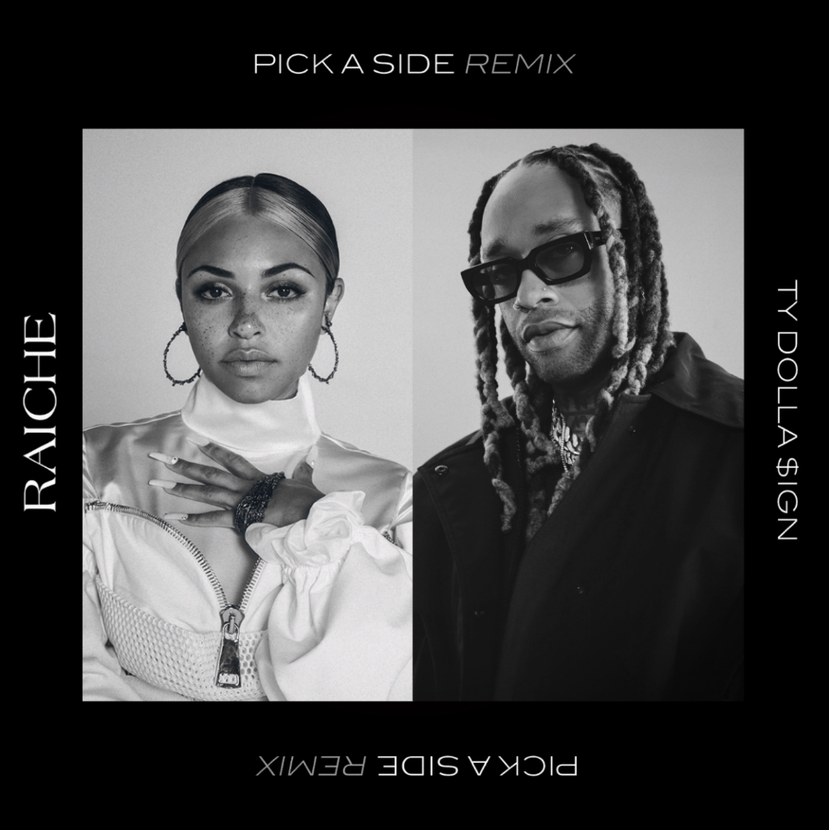

Raiche has arrived with her latest release, pairing up with R&B singer/songwriter Ty Dolla $ign to drop a melodic new remix to last year's "Pick A Side." Ty Dolla $ign's appearance on the new remix is refreshing, bringing his signature sound to complement Raiche's soothing vocals. Check out "Pick A Side (Remix)" now available via all digital retailers and streaming platforms HERE.

Raiche's latest collaboration with Ty Dolla $ign is her first release since "Funeral," which came after the original "Pick A Side" record, which has Raiche currently featured as YouTube's Artist On The Rise Trending with an exclusive in-studio visual; watch HERE. As if that weren't enough, the record has peaked #2 at radio along with Raiche having been iHeart's On The Verge artist. "Pick A Side" boasts an official companion visual, watch it HERE. “Pick A Side” was produced by the well-known Menardini “Bridgetown” Timothee (Mary J Blige, Beyonce, Trey Songz) and coproduced by araabMUZIK & Audio Anthem.

Most recently, Raiche was named an Artist To Watch by both ESSENCE and Billboard.

About Raiche:
With her breezy vocals and refreshingly unique singing style, Raiche has proven herself to be a breath of fresh air. The young artist fuses soulful roots with modern pop to concoct a genuinely distinctive new sound all her own, lit up with confidence, consistency and positivity. Born and raised in Pittsfield, MA, just two hours outside of Boston, Raiche devoted her energies towards music from an early age, uploading cover videos to YouTube that almost immediately earned her online applause. Her musical dreams almost came to a halt following high school graduation but some encouraging words from her beloved Nana eventually led her to Boston, where she met and began being mentored by DJ Knock Out. The local legend soon introduced Raiche to her GDE production team as well as to award-winning songwriter and producer Prince Charlez (Rihanna, Beyoncé, Usher), who promptly signed the gifted young vocalist to his recently launched Island Prolific imprint at Atlantic Records.

“My mission is to work hard and keep going, no matter what,” Raiche says. “And to make music that reflects solid, positive energy along the way.”

# # #

CONNECT WITH RAICHE
MYNAMEISRAICHE.COM
FACEBOOK
TWITTER
YOUTUBE
INSTAGRAM
SPOTIFY
SOUNDCLOUD

PRESS CONTACT
SYDNEY MARGETSON / SYDNEY.MARGETSON@ATLANTICRECORDS.COM

