FOR IMMEDIATE RELEASE

FEBRUARY 9, 2018

RAVYN LENAE RETURNS WITH “CRUSH” EP

CHICAGO-BASED POP SENSATION FINALLY UNVEILS NEW EP

FIVE-TRACK COLLECTION EXECUTIVE PRODUCED BY STEVE LACY

“CRUSH” AVAILABLE TODAY AT ALL DSPS AND STREAMING SERVICES

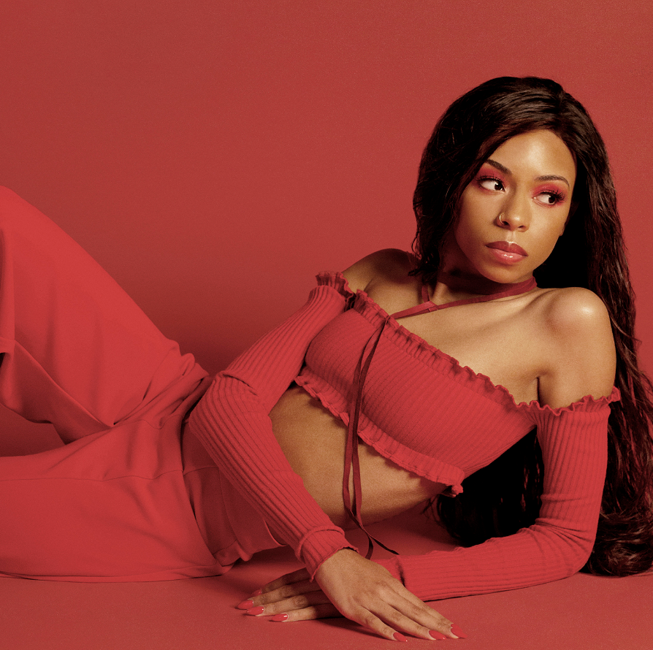

Acclaimed modern pop sensation Ravyn Lenae is back with her much-anticipated new EP. “CRUSH” is available today at all digital music retailers and streaming services via 323 Music Group/ Atlantic Records https://atlantic.lnk.to/CRUSH.

“CRUSH” is Executive Produced by Steve Lacy (The Internet, Kendrick Lamar), who also joins Lenae on two of its five tracks including the vocal call-and-response, “4 Leaf Clover” (track listing attached). The EP is highlighted by the sultry new single, “Sticky,” available now at all DSPs and streaming services.

“Sticky” is drawing wide-ranging critical acclamation, with Pitchfork declaring it “Best New Track” while raving, “’Sticky’ is a steamy affair with a slinky R&B beat, but Lenae sounds like a playfully annoyed lover, glued into a relationship that‘s falling apart. She uses Lacy’s wide-open production – electric organ and psychedelic guitar strums – to experiment with her vocals...The pacing mirrors all the frantic ups and downs of a teetering relationship, with Lenae storming around Lacy’s instrumental, changing her tone and her mind over and over again. Even through all this relationship drama, Lenae makes falling out sound very fun.” The FADER named “Sticky” one of its “11 Songs You Need In Your Life This Week,” writing, “is an incredibly apt title for this Ravyn Lenae song, which Steve Lacy provided the beats for. Those organ sounds and Lenae's wild high notes really sound like a gooey sweet treat.”

One of Billboard’s “2018's R&B Class: Three Artists Poised For Breakout Success In 2018,” Lenae celebrated the arrival of “CRUSH” with a spectacular performance of “Sticky” on yesterday’s episode of MTV’s TRL, streaming now at https://www.youtube.com/watch?v=QxCiarAeVHg. In addition, the Chicago-based artist is among the faces featured in Nike’s new The Force Is Female campaign.

Acclaimed by Rolling Stone in its “10 New Artists You Need to Know: March 2017” for her “thoughtful and highly lyrical electronic soul,” Lenae made her label debut earlier this year with “MIDNIGHT MOONLIGHT.” The EP – which has now amassing 16.5 million on-demand US streams, according to Nielsen Music – Includes the single, “Unknown,” joined by a companion visual directed by Weird Life Films (Joey Purp, Chance the Rapper) and streaming now at the official Rayvn Lenae YouTube channel.

“MIDNIGHT MOONLIGHT” instantly received a range of critical applause, with Pitchfork raving, “Chicago R&B singer Ravyn Lenae’s impressive new EP brims with quiet intensity, as her subtle falsetto glides over a blend of modern bounce, dream pop, and electro-soul…the vocalist captures a robust spectrum of black art while establishing her own aesthetic. Lenae doesn’t sing, per se; instead, her blend of atmospheric hums speaks directly to you, even as (producer Monte) Booker’s swirling beats threaten to take most of the attention. There’s a strong nostalgia to Lenae’s music that borrows from her late ’90s and early ’00s influences, but she doesn’t simply mimic them. Lenae’s art feels current.”

Named by NYLON as one of “21 Cool Artists 21 And Under,” Lenae recently wrapped “The CTRL Tour” alongside fellow R&B sensation SZA; new live dates of her very own will be announced soon. Please see www.ravynlenae.com for updates and more.

For more information, please visit www.ravynlenae.com, twitter.com/ravynlenae, www.instagram.com/ravynlenae, facebook.com/ravynlenae, youtube.com/ravynlenae, and www.atlanticrecords.com.

RAYVN LENAE
“CRUSH” EP
(323 Music Group/Atlantic Records)

Track Listing

- Sticky
- Closer (ODE 2 U)
- Computer Luv feat. Steve Lacy
- The Night Song
- 4 Leaf Clover feat. Steve Lacy

* * * * *

For press inquiries, please contact:
Ariana White // 212.707.2236 // Ariana.White@atlanticrecords.com

