FOR IMMEDIATE RELEASE
NOVEMBER 18, 2021

RICO NASTY AND FLO MILLI JOIN FORCES FOR THE END OF YEAR BANGER “MONEY”

SURPRISE-PACKED OFFICIAL MUSIC VIDEO PREMIERES TODAY

NORTH AMERICAN ARENA TOUR ALONGSIDE PLAYBOI CARTI
CONTINUES THROUGH DECEMBER

“MONEY (FEAT. FLO MILLI)” DROPS TODAY AT ALL DSPS AND STREAMING SERVICES

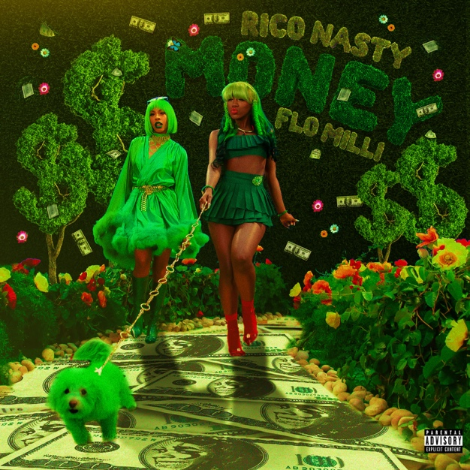

LISTEN TO “MONEY (FEAT. FLO MILLI)” | WATCH OFFICIAL MUSIC VIDEO

One thing the Queen of Punk Rap doesn’t play about is her fans and when they ask, they shall receive – so here we are today. Rico Nasty is back with a fierce burst of girl power energy on her eagerly awaited new single. “Money (Feat. Flo Milli)” is available now at all DSPs and streaming services; an official music video – directed by in-demand filmmaker Roxana Baldovin, who also brought the hit collaboration, “Tia Tamera” to life. The video features an assortment of surprises, including the launch of Rico’s own Community fan number (+1 -202-519-1840) – Check it out HERE.

Produced by legendary German electronic dance music DJ/producer Boys Noize (Frank Ocean, Skrillex, Snoop Dogg), “Money” sees Rico joining forces with feisty Mobile, AL-based rapper Flo Milli for what proves a bawdy, unadulterated banger unlike any other. The track – which interpolates classic samples from 2 Live Crew’s “We Want Some Pussy” and Tone Loc’s timeless “Wild Thing” – has already proven a viral favorite fueled in part by Rico teasing the track during fiery sets on the “King Vamp Tour” and performances at such festivals as Rolling Loud NYC and Outside Lands. Indeed, fans around the world have been eagerly expecting the arrival of “Money,” inspiring the recent #FloNasty hashtag blazing across social media platforms everywhere. Rico further ignited excitement by officially announcing “Money” earlier this week with an exclusive video announcement on Twitter, declaring “I wanna see some cash, I wanna see some ass, I wanna see some motherfucking bad bitches making dances!”

“Money” comes days after the release of Rico Nasty’s ToyQube Collectable figurine. The collaboration with acclaimed illustrative designer/animator Rhymezlikedimez, is available exclusively via mobile-first video shopping platform NTWRK. The track is supported by an exclusive “Money” merch drop and Rico’s national takeover/premiere with Sirius/Hip Hop Nation which will be spinning the record through the weekend in celebration of the epic collaboration.

An incredible live performer known for her non-stop onstage action, Rico is currently traveling North America as special guest on Playboi Carti’s epic “King Vamp Tour,” with arena dates scheduled through late December. For complete details and ticket availability, please see www.riconastymusic.com.

RICO NASTY
NORTH AMERICAN TOUR 2021

NOVEMBER
18 - Salt Lake City, UT - The Great Saltair
19 - Morrison, CO - Red Rocks Amphitheater (AEG)
23 - Minneapolis, MN - The Armory
24 - Chicago, IL - Credit Union 1 Arena
26 - Milwaukee, WI - Eagles Ballroom
27 - St. Charles, MO - The Family Arena
28 - Independence, MO - Cable Dahmer Arena
30 - Indianapolis, IN - Indiana Farmers Coliseum

DECEMBER
1 - Cincinnati, OH - BB&T Arena
2 - Canton, OH - Canton Civic Center
4 - Detroit, MI - Masonic Temple
5 - Pittsburgh, PA - UPMC Event Center
7 - Lowell, MA - Tsongas Center
8 - Rochester, NY - Main Street Armory
9 - Toronto, ON - Coca-Cola Coliseum
10 - Columbus, OH - Nationwide Arena
14 - Hartford, CT - XL Center
16 - Kingston, RI - Ryan Center
17 - Brooklyn, NY - Barclays Center
18 - Washington, D.C. - DC Armory
19 - Philadelphia, PA - Liacouras Center
21 - Norfolk, VA - Chartway Arena
22 - Greensboro, NC - Special Events Center
23 - Atlanta, GA - State Farm Arena

ALL DATES W/PLAYBOI CARTI “KING VAMP TOUR”

# # #

ABOUT FLO MILLI:
Known for her bubbly delivery and aggressive bars, 21-year old, Alabama-born rapper Flo Milli has taken the internet by storm in her short accent. Releasing tracks and visuals throughout 2019, she followed up with “In The Party” which has been streamed and viewed nearly 200M times worldwide. 2020 saw the release of her debut mixtape, Ho, why is you here?, earning rave reviews from the likes of New York, Pitchfork, Rolling Stone, Complex, The FADER, and NYLON, to name but a few.

2021 is proving to be another incredible year for Flo Milli, including a BET Awards “Best New Artist” nomination and MTV Video Music Award nomination for “Best Breakthrough Song,” honoring her feature on Yung Baby Tate’s “I Am (Ft. Flo Milli).” Along with Rico Nasty, Flo Milli has recently collaborated with some of today’s most buzzed-about artists, including GoldLink, Destiny Rogers, and TOBi. Indeed, Flo’s verses on tracks like “I Am” and YungManny’s “Clap For Em (Feat. Flo Milli & Sada Baby)” have had massive moments on TikTok, with both sounds inspiring the cumulative creation of over 4M videos. Flo – who has graced major festival stages including Lollapalooza, Rolling Loud Miami, Firefly, Music Festival and more – recently unveiled a long awaited new single, “Roaring 20s,” released to coincide with Spotify’s RADAR campaign highlighting emerging artists on the rise. For more, please visit www.flomilli.com.

# # #

CONNECT WITH RICO NASTY:
WEBSITE | INSTAGRAM | TWITTER | FACEBOOK | YOUTUBE

