**SHORELINE MAFIA’S ROB VICIOUS AND MASTER KATO TO KICK OFF *MAFIA TWINS* TOUR IN NOVEMBER**

**MASTER KATO UNVEILS DEBUT SOLO TRACK “RIDE AROUND”**

**ROB VICIOUS TO DROP VISUALS FOR “LA FLOCKERS” ON WORLDSTAR AT 3PM EST**

**LISTEN TO “RIDE AROUND”** [**HERE**](https://shoreline.lnk.to/RideAround)

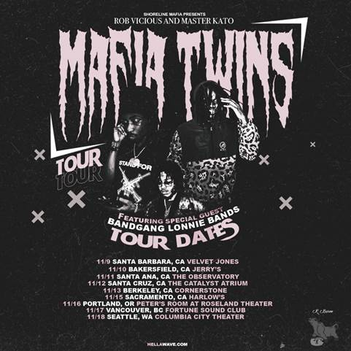

**SHORELINE MAFIA** officially announced the **MAFIA TWINS TOUR** featuring group members **ROB VICIOUS** and **MASTER KATO** kicking off November 9th in Santa Barbara, CA. The tour follows Kato’s solo debut with the release of [**“RIDE AROUND.”**](https://soundcloud.com/shorelinemafia/master-kato-shoreline-mafia-ride-around)  “‘Ride Around’ is a showcase for the gravel-voice rapper as he jumps on a breezy beat from prolific West Coast producer Ron-Ron,” says Pitchfork.

This announcement also comes on the heels of Rob Vicious gearing up to drop visuals for **“LA FLOCKER”** on Worldstar today at 3pm EST as a follow up to the release of the ‘Traplantic’ stand out track, [**“BANDS.”**](https://www.youtube.com/watch?v=l41LN8QJVzo&feature=youtu.be)

Coming off of a successful third headlining tour, **SHORELINE MAFIA**, the most played artist on Spotify in California, is gearing up to hit the stage for their last performance of the year at **Rolling Loud** in Los Angeles in December. As fans get ready for the **Mafia Twins Tour** and the **Rolling Loud** performance, they can check out the **BROOKLYN PROJECTS** collab capsule sold [**HERE**](https://brooklynprojects.com/collections/collaborations) and at select Zumiez locations.

**MAFIA TWINS TOUR DATES**

*For updates and ticket availability, please see* [***hellawave.com/tour***](https://hellawave.com/tour)

**11.9 Santa Barbara, CA** – Velvet Jones

**11.10 Bakersfield, CA** – Jerry’s

**11.11 Santa Ana, CA** – The Observatory

**11.12 Santa Cruz, CA** – The Catalyst Atrium

**11.13 Berkeley, CA** – Cornerstone

**11.15 Sacramento, CA** – Harlow’s

**11.16 Portland, OR** – Peter’s Room At Roseland Theater

**11.17 Vancouver, BC** – Fortune Sound Club

**11.18 Seattle, WA** – Columbia City Theater

**CONNECT WITH SHORELINE MAFIA:**

[**HELLAWAVE.COM**](http://hellawave.com/)

[**TWITTER**](https://twitter.com/shorelinemafia)

[**FACEBOOK**](https://www.facebook.com/ShorelineMafia/)

[**SOUNDCLOUD**](https://soundcloud.com/shorelinemafia)

[**YOUTUBE**](https://www.youtube.com/shorelinemafia)