FOR IMMEDIATE RELEASE
OCTOBER 13, 2021

RUDIE EDWARDS

‘ALL OR NOTHING’

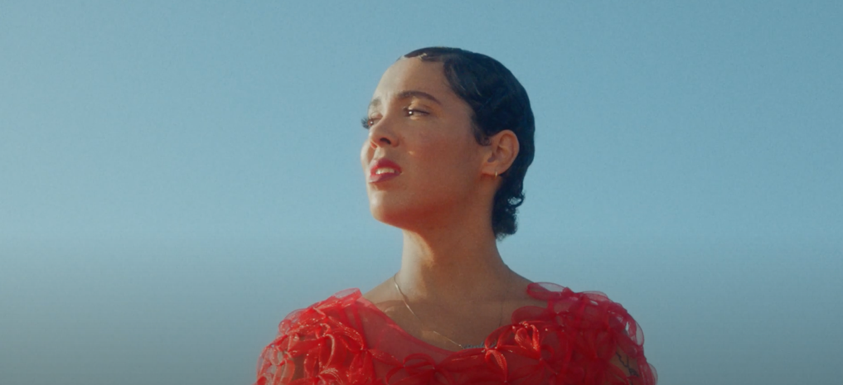

WATCH ‘ALL OR NOTHING’ HERE

Spellbinding UK talent Rudie Edwards releases artful video for ‘All Or Nothing’, plucked from her recent heartfelt EP ‘Worst Ways’.

Blending organic instrumentation with euphoric pop sonics, ‘All Or Nothing’ accelerates into climactic oblivion as Rudie showcases her signature blood-rushing vocal capabilities. Accompanied by its intoxicating visual, exuding tasteful amounts of warmth and nostalgia, the Dover hailed singer-songwriter continues to embody all the qualities of a future-classic artist.

Earlier this month the ‘Worst Ways’ EP emerged a stunningly potent and compelling body of work - and looks set to continue the attention forming around Rudie as a significant new name in the UK landscape. Consolidating the sense of an artist, writer and producer (Rudie co-writes and co-produces everything she creates), tracks ‘All or Nothing’, ‘The Saddest Song’ and ‘Jumperman’ showcase a rare ability to blend pop hooks and meaningful lyricism with a real persona. Rudie’s effortless command of her vocal talent acting as the bridge across the different moods, never waning in its appeal and ability to keep the listener on tenterhooks.

Rudie’s emergence this year has already seen critical support across both sides of the Atlantic - with CLASH, NYLON, AV CLUB and MIXTAPE MADNESS amongst others all proclaiming a compelling new voice.

Originally from Dover on the south coast of England, it was Edwards’ own musical ambition which eventually drove her out into the wider world, to arts school in London and eventually to the US - writing for the likes of CeeLo Green - before coming home and finding her own sound. With the kind of talent plainly on show with this, her first body of work – makes for a very exciting trajectory for the homegrown star.

For more information, contact: Ariana.white@atlanticrecords.com
INSTAGRAM
TWITTER
YOUTUBE

