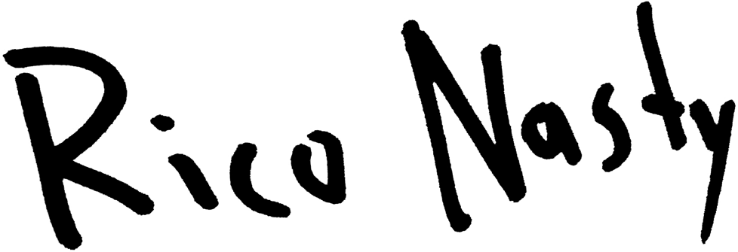

Rico Nasty is the queen of punk rap.

After years of inciting mosh pits internationally, the 23-year-old has successfully created her own lane as an artist. But although she’s spent time cultivating her sound, Rico has remained malleable—evolving from the pop-tinged Sugar Trap era to the more raucous, hard-hitting energy of her recently released debut album, Nightmare Vacation. When speaking on the album, she says that oftentimes, people expect her new bodies of work to sound like her older material. Nightmare Vacation, however, is Rico’s unfiltered, punk self, having self-described her recent debut as “authentically Rico.”

Even with the shifts, dedicated fans won't have a difficult time tracing how Rico arrived at her fully-formed, innovative approach to her new material, but they’ll certainly be impressed by her growth. For Nightmare Vacation, Rico took cues from fellow disrupters, such as Missy Elliott and Busta Rhymes, leaning more into the magic of music videos to add another facet to her creativity. “iPhone” and “Own It,” boasting over 3.2 million views on YouTube combined, are testaments of her prowess as a visionary. She is one of the rare artists equipped to consistently satiate both supporters and industry giants, making her one of the breakout artists of this generation.

Since her formal debut in 2016, Rico has become a favorite in the press, covering a number of magazines in her signature style, including The Fader, NME, Acclaim, and XXL as a 2020 Freshman. Her work has received certification from the Recording Industry Association of America (RIAA) as well, with 2018’s “Smack A Bitch” going gold. The rapper has also built a serious presence in the fashion/beauty realm and in 2019, was named a brand ambassador for Rihanna’s Savage X Fenty. In October 2020, she was granted the opportunity to walk in the brand’s second annual fashion show, which was streamed globally via Amazon Prime for the first time. In addition, she was selected to model for the brand and amplify their statement pieces that same month. In the past, Rico has discussed how warmly the fashion industry embraced her early on and how she made it a point to use the exposure to her benefit as an artist.

In addition, Rico Nasty has been coming into her own as an entrepreneur. Last September, she released her first makeup line in collaboration with Il Makiage, which quickly sold out. With palette names like “Bitchcraft” and “Rave Kween,” the collection worked in tandem with her rocker style and unapologetic attitude.

As a dedicated mother and a performer, Rico says that things are truly a balancing act, but she remains true to herself through it all. She sums up her purpose by saying, “Yes, I am going as hard as all of these dudes are. Yes, I am loud. If you’re female, get some confidence from what I’m doing. I’m the representation of a lot of girls who don’t get love.” That same representation is embodied on her debut album, Nightmare Vacation, unveiled in December of 2020 and heralded as her most raw body of work to date.

