MAHALIA AND AJ TRACEY JOIN FORCES ON NEW SINGLE ‘ROADSIDE’
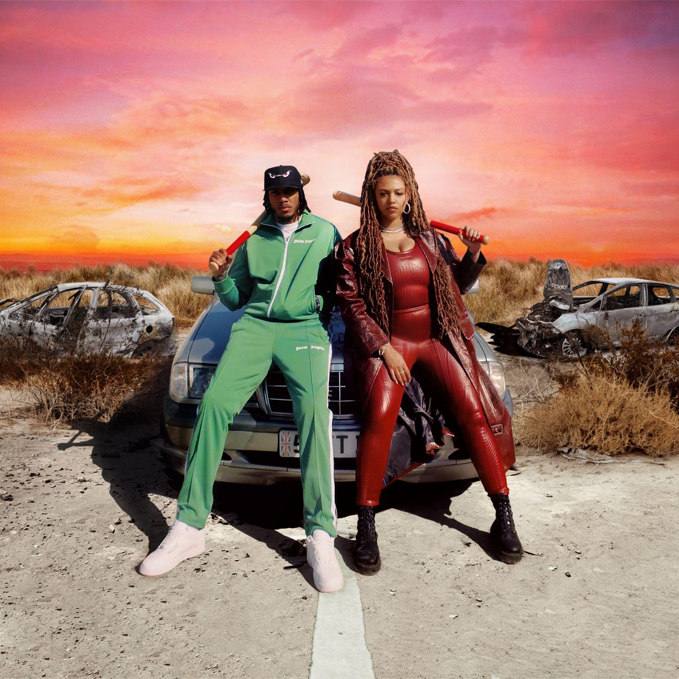

LISTEN HERE
WATCH VIDEO HERE

SOLD-OUT O2 BRIXTON ACADEMY HEADLINE SHOW - 19TH NOVEMBER 2021

September 30th 2021 —Today, GRAMMY-nominated R&B star Mahalia has returned with her brand-new single, ‘Roadside’ featuring one of Britain’s biggest rappers, AJ Tracey.

Following on from ‘Whenever You’re Ready’, Mahalia’s sizzling release earlier this year, ‘Roadside’ is another head-bop-inducing track produced by British duo The Elements. Premiered by The FADER, the luminous accompanying video sees Mahalia and AJ Tracey running a burger van, teaching the heartbreakers a lesson, and leaving them on the ‘roadside'.

“I’ve kinda been excited about releasing this one since I started writing it. Fresh out of a breakup, I made this one with The Elements and two of my favorite girls and songwriters Abby (Absolutely) and Kamille. We had so much fun writing and making this together. Getting AJ on it was the cherry on top for me. I’ve wanted to work with him forever and I was so happy that it could be on this tune. I hope you love it!” – Mahalia says of the track.

In addition to new music, last month Mahalia was nominated for her first ever Ivor Novello award for her 2020 collaboration with UK lyricist Pa Salieu for his single ‘Energy’ and subsequently will conclude the year with her rescheduled headline show at London’s prestigious venue, O2 Brixton academy - detailed dates listed below.

2020 marked a year of achievement for the Leicester-born star. Starting the year with her second BRIT nomination, Mahalia featured on up-and-coming fellow Midlands rapper Pa Salieu’s debut mixtape, ‘Send Them To Coventry’, whilst also gracing the track list of Headie One’s #1 album ‘Edna’. Subsequently, Mahalia also received a GRAMMY nomination for ‘All I Need’ - Jacob Collier’s single of which she features alongside US rapper, Ty Dolla $ign. Shortly after, Mahalia concluded the year with three MOBO nominations for ‘Best Female Act’, ‘Best R&B/Soul Act’ and ‘Album Of The Year’ for her debut album, ‘Love and Compromise’, winning in the first two categories.

Besides the awards and nominations, it’s also been 18 months of deep personal growth, one that Mahalia describes as a real rollercoaster in her personal and professional life. Reflection has been the thread running through Mahalia’s writing and while the current global situation offers little more than uncertainty, the singer hopes that her music will encourage her listeners to carve out time to also look back and re-evaluate: “We’re all fixated on how we can make ourselves better during and after this period of time but I want people to also reminisce on lovely or painful situations they’ve lived through and how they’ve helped shape the people they are now.”

Listen/watch ‘Roadside’’ here

# # #

2021 Live Dates
November 19th O2 Brixton Academy - Headline show

CONNECT WITH MAHALIA
OFFICIAL WEBSITE | TWITTER | FACEBOOK | INSTAGRAM

CONTACT:
ARIANA.WHITE@ATLANTICRECORDS.COM

