FOR IMMEDIATE RELEASE
APRIL 12, 2019

ROB THOMAS PREMIERES “TIMELESS”

NEW ALBUM CHIP TOOTH SMILE ARRIVING APRIL 26TH,
FEATURING NEW SINGLE “ONE LESS DAY (DYING YOUNG)”

MULTI GRAMMY®-WINNING SUPERSTAR TO CELEBRATE
ALBUM RELEASE ON GOOD MORNING AMERICA

NORTH AMERICAN CHIP TOOTH TOUR KICKS OFF MAY 28TH

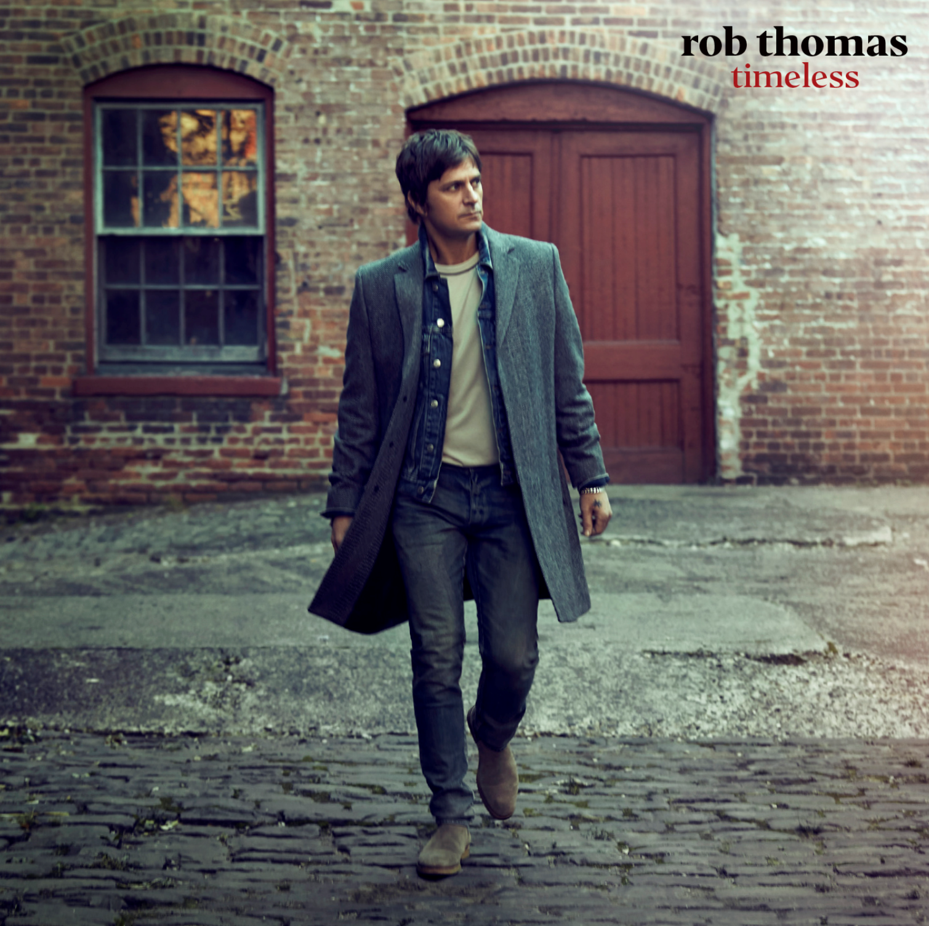

stream “Timeless”: LINK
Pre-order Chip Tooth Smile: link

Emblem/Atlantic recording artist and multiple-GRAMMY® Award-winning singer/songwriter Rob Thomas has released “Timeless,” the third instant-grat track from his highly anticipated fourth solo album Chip Tooth Smile – arriving everywhere April 26th (pre-order available now). The Butch Walker-produced song lives up to its title, calling out the classics and namechecking everything from “Nothing Compares 2 U” to “Girls Just Wanna Have Fun.”

The album’s lead single “One Less Day (Dying Young)” is continuing to see success at Hot AC radio, charting in the Top 15 this week and climbing. Last week saw the TV debut performance of the single on The Ellen DeGeneres Show (WATCH), in addition to the release of anthemic album track “I Love It” (STREAM). Thomas is set to celebrate the release of Chip Tooth Smile with a performance of “One Less Day (Dying Young)” on ABC’s Good Morning America – airing April 26th (check local listings).

This summer will see Thomas hitting the road for his extensive North American Chip Tooth Tour with special guest Abby Anderson. The outing kicks off May 28th in Red Bank, NJ at the Count Basie Center for the Arts and will continue through early August (tickets available now). Each ticket purchased online for the North American tour comes with a digital download of the new album. For further details and ticket information, please visit http://www.robthomasmusic.com.

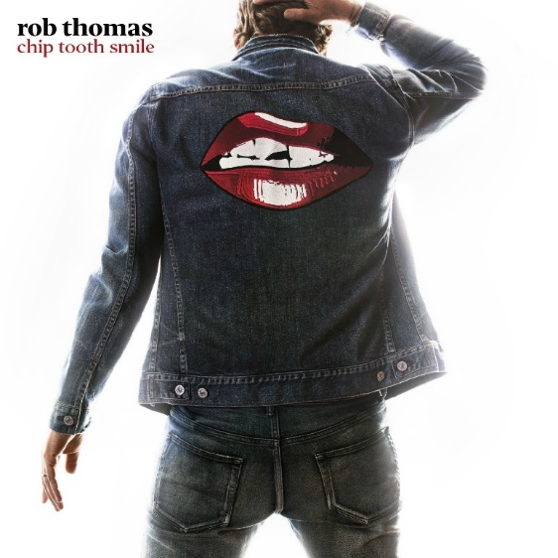

ROB THOMAS
2019 NORTH AMERICAN ‘CHIP TOOTH TOUR’
WITH SPECIAL GUEST ABBY ANDERSON

Tues May 28 | Red Bank, NJ | Count Basie Center for the Arts
Thurs May 30 | Battle Creek, MI | Firekeeper’s Casino
Fri May 31 | Northfield, OH | Hard Rock Rocksino Northfield Park
Sat Jun 01 | Rochester Hills, MI | Meadow Brook Amphitheatre
Mon Jun 03 | Cincinnati, OH | PNC Pavilion at Riverbend Music Center
Tue Jun 04 | Indianapolis, IN | Farm Bureau Insurance Lawn at White River State Park
Fri Jun 07 | Madison, WI | Breese Stevens Field
Sat Jun 08 | Prior Lake, MN | Mystic Lake
Mon Jun 10 | Denver, CO | Levitt Pavilion Denver
Tue Jun 11 | Salt Lake City, UT | The Depot
Thu Jun 13 | Seattle, WA | Chateau Ste. Michelle Winery
Fri Jun 14 | Portland, OR | Theater of the Clouds
Sun Jun 16 | Saratoga, CA | Mountain Winery
Tue Jun 18 | Los Angeles, CA | Greek Theatre
Thu Jun 20 | San Diego, CA | Humphreys Concerts By the Bay
Fri Jun 21 | Las Vegas, NV | Zappos Theater at Planet Hollywood
Sun Jun 23 | Phoenix, AZ | Comerica Theatre
Tue Jun 25 | Austin, TX | ACL Live at The Moody Theater
Wed Jun 26 | Irving, TX | The Pavilion at Toyota Music Factory
Fri Jun 28 | Sugar Land, TX | Smart Financial Centre at Sugar Land
Sat Jun 29 | New Orleans, LA | Saenger Theater
Sun Jun 30 | Tuscaloosa, AL | Tuscaloosa Amphitheater
Tue Jul 02 | Boca Raton, FL | Mizner Park Amphitheater
Wed Jul 03 | Orlando, FL | Hard Rock Live Orlando
Fri Jul 05 | St Petersburg, FL | The Mahaffey Theater
Sat Jul 06 | Jacksonville, FL | Daily’s Place
Mon Jul 08 | Atlanta, GA | State Bank Amphitheatre at Chastain Park
Tue Jul 09 | Nashville, TN | Schermerhorn Symphony Center
Thu Jul 11 | Raleigh, NC | Red Hat Amphitheater
Fri Jul 12 | Washington, DC | The Anthem
Sat Jul 13 | Philadelphia, PA | The Met Philadelphia
Mon Jul 15 | Bethlehem, PA | The Sands Event Center
Wed Jul 17 | Englewood, NJ | Bergen Performing Arts Center
Thu Jul 18 | Boston, MA | Rockland Trust Bank Pavilion
Sat Jul 20 | Orillia, ON | Casino Rama Resort
Sun Jul 21 | Canandaigua, NY | CMAC Performing Arts Center
Tue Jul 23 | Syracuse, NY | Lakeview Amphitheatre
Wed Jul 24 | Saratoga Springs, NY | Saratoga Performing Arts Center
Thu Jul 25 | Gilford, NH | Bank of New Hampshire Pavilion
Sat Jul 27 | Atlantic City, NJ | Borgata
Mon Jul 29 | New York, NY | Beacon Theatre
Tue Jul 30 | New York, NY | Beacon Theatre
Fri Aug 02 | Port Chester, NY | The Capitol Theatre
Sat Aug 03 | Morristown, NJ | Mayo Performing Arts Center
Sun Aug 04 | Uncasville, CT | Mohegan Sun Arena

***

Rob Thomas is one of the most distinctive artists of this or any other era – a gifted vocalist, spellbinding performer, and acclaimed songwriter known worldwide as lead singer and primary composer with Matchbox Twenty as well as for his multi-platinum certified solo work and chart-topping collaborations with other artists. Among his countless hits are solo classics like “Lonely No More,” “This Is How A Heart Breaks,” and “Streetcorner Symphony,” Matchbox Twenty favorites including “Push,” “3AM,” “If You’re Gone,” and “Bent,” and of course “Smooth,” his 3x RIAA platinum certified worldwide hit collaboration with Santana which celebrates it’s 20th anniversary this year. Thomas earned three GRAMMY® Awards for his role as co-writer and vocalist on “Smooth,” which topped Billboard’s “Hot 100” for an astounding 12 consecutive weeks and spent 58 total weeks on the chart, the #1 song in Billboard’s “Top Hot 100 Rock Songs” chart history and #2 “Hot 100” song of all time. As if that weren’t enough, “Smooth” was declared the all-time #1 song on Billboard’s “Adult Pop Songs” radio airplay chart, the #1 song of the rock era based on chart performance on Billboard's Hot 100, and recently declared to still hold the spot as the second most successful song of all time by Billboard.

In 2004, Thomas was the first artist to be honored with the Songwriters Hall of Fame’s prestigious “Hal David Starlight Award,” created to recognize a composer in the early years of his or her career that has already made a lasting impact. He has won numerous BMI and ASCAP Awards, and twice earned the “Songwriter of the Year” crown from both Billboard and BMI. Overall, Thomas has contributed to sales of more than 80 million records.

Thomas made his solo debut with 2005’s platinum certified …Something To Be and immediately made history as the first album by a male artist from a rock or pop group to ever debut at # 1 on the Billboard 200. Thomas’ sophomore solo album, 2009’s Cradlesong, marked still another milestone, generating two #1 singles in “Her Diamonds” and “Someday.” Billboard chart history was made once again, with Thomas tying P!nk for the most #1 Adult Top 40 hits by a solo artist as well becoming the first male solo artist to score multiple chart-toppers at the format.

In 2012, Matchbox Twenty returned with their first all-new album in a decade, North. Fueled by the hit singles, “She’s So Mean,” “Overjoyed,” and “Our Song,” North proved a landmark for the band, their first ever #1 debut and Billboard 200 chart-topper. Thomas’ third solo album, 2015’s internationally acclaimed The Great Unknown, had a top 10 debut on the SoundScan/Billboard 200 upon its release and featured hit singles “Hold On Forever” and “Pieces.”

A charismatic, engaging, and indefatigable live performer, Thomas has spent much of the past two decades on the road, fronting massive world treks with Matchbox Twenty and on his own as well as a series of intimate acoustic tours. Thomas is also a dedicated philanthropist, establishing Sidewalk Angels Foundation with his wife Marisol Thomas in 2003. The organization is dedicated to providing critically needed funds and support to over 20 no-kill animal shelters and animal rescues, across the country, that help to fight for the rights and fair treatment of those with no voice. For additional information on Sidewalk Angels Foundation, please visit www.sidewalkangelsfoundation.org.

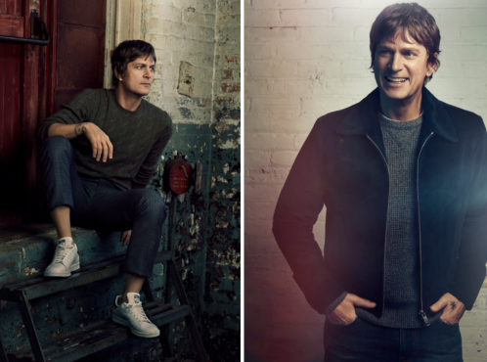
DOWNLOAD HIGH-RES PRESS IMAGES (CREDIT: RANDALL SLAVIN)

CONNECT:
RobThomasMusic.com | Twitter | Facebook | YouTube | Instagram | Press Assets
CONTACT:
Sheila Richman | sheila.richman@atlanticrecords.com
Ted Sullivan | ted.sullivan@atlanticrecords.com

