FOR IMMEDIATE RELEASE
JULY 31, 2019

SABRINA CLAUDIO UNVEILS BOLD NEW SINGLE “HOLDING THE GUN”

ACCLAIMED SINGER-SONGWRITER DELIVERS FIRST OFFICIAL RELEASE
FROM FORTHCOMING BODY OF WORK – LISTEN HERE

WATCH THE CINEMATIC AND STRIKING VIDEO HERE

“TRUTH IS TOUR” OPENS WITH SOLD-OUT LA SHOW AT THE WILTERN ON SEPT. 21ST;
SECOND LA SHOW ADDED ON SEPT. 22ND DUE TO HIGH DEMAND

LARGEST HEADLINE TOUR INCLUDES A NIGHT AT
HAMMERSTEIN BALLROOM IN NYC ON OCT. 18TH

SABRINA INSTANTLY SELLS OUT LONDON SHOW AT BRIXTON ELECTRIC ON NOV. 19TH
WITH SECOND NIGHT ADDED ON NOV. 18th
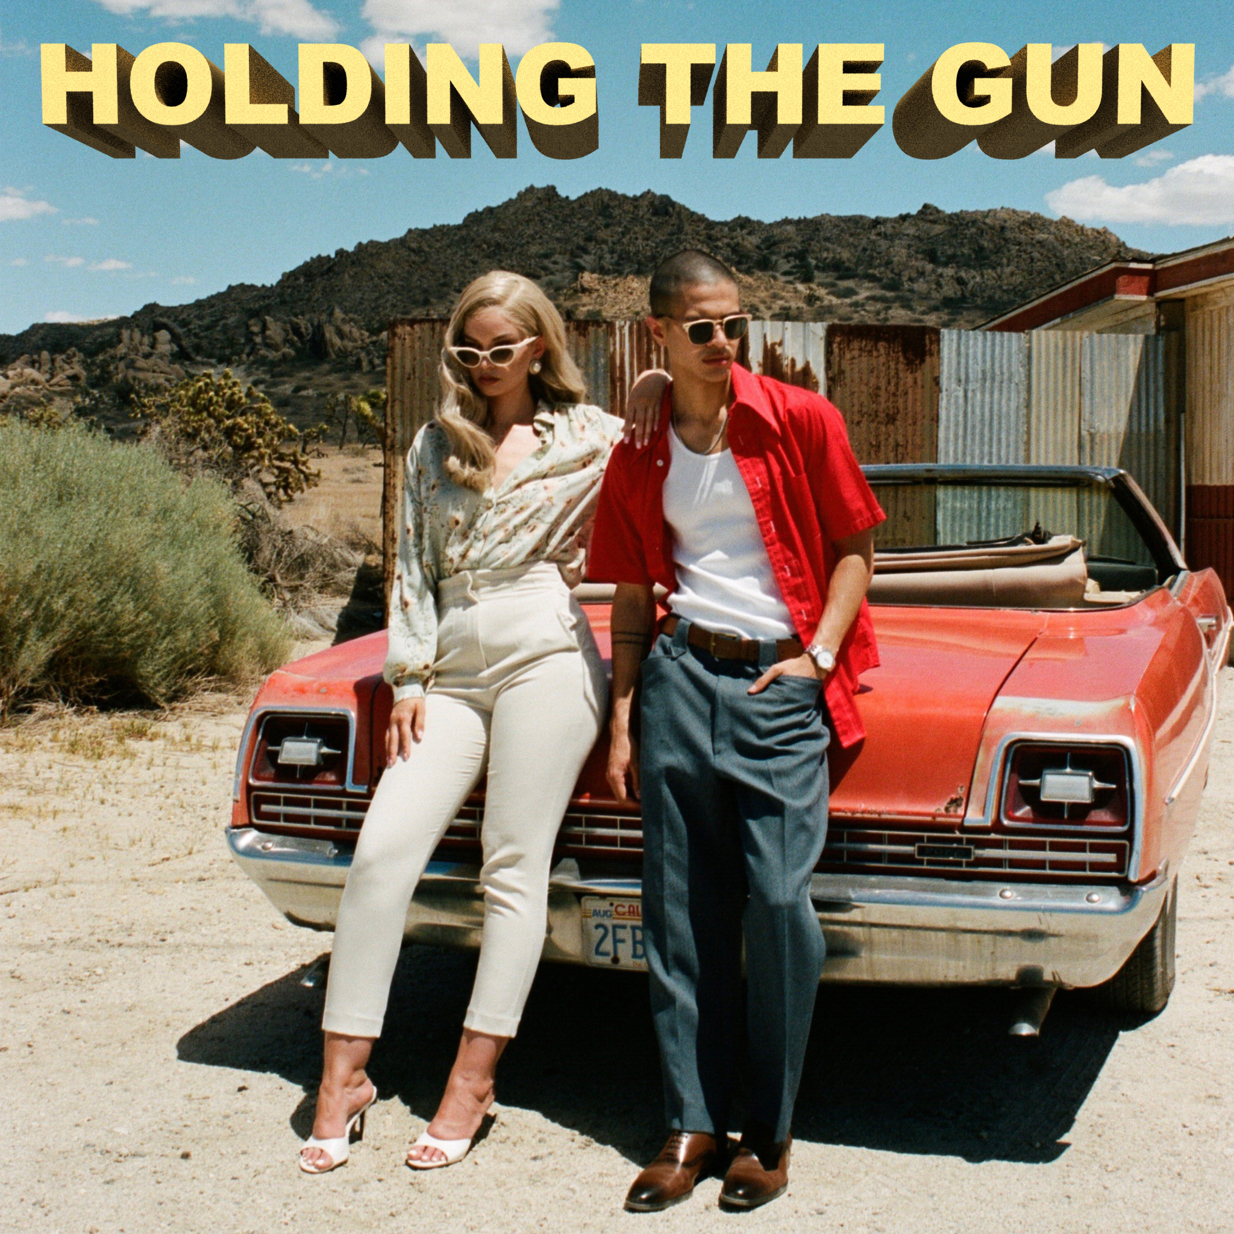
Download high res artwork + additional press photos HERE

The critically acclaimed Puerto Rican/Cuban songstress Sabrina Claudio has delivered her entrancing new single “Holding The Gun” alongside a striking and cinematic companion visual. “Holding The Gun” is available now at all DSPs and streaming services HERE. Watch the Bonnie & Clyde inspired journey into madness and obsession on Sabrina’s official YouTube channel HERE.

“Holding The Gun symbolizes loyalty and an everlasting type of love,” says Sabrina. “I wanted to make sure that showing violence was not a factor within the visual as violence, conceptually, isn’t what the song is about. The blood & insinuation of crime represents the lengths one would go when so deeply in love.”
According to PAPER, who premiered the video earlier today, “it's pure, delicious cinema.” “Adding to her catalogue of stormy, sultry neo-R&B that frequently gets her listed alongside folks like SZA, Jorja Smith, Daniel Caesar and H.E.R…the song, as always, hinges on her angelic, liquid velvet voice, which stretches out over atmospheric strings, and a syrupy pulsating beat.”

“Holding The Gun” marks the first official single from Sabrina’s confident, collaborative and empowered new body of work due to arrive later this year. The track follows the seductive “As Long As You’re Asleep” as well as recent collaborations with Wale on “All My Love” and BURNS and A$AP Rocky on “Energy.” In April, Sabrina made her captivating debut Coachella performance impressively commanding attention from the festival’s main stage, garnering love from PAPER, Entertainment Weekly, Billboard, New York Mag and more.

This fall, Sabrina will embark on her biggest North American headline run to date. The “Truth Is Tour” – featuring backing from her live band – kicks off September 21st at The Wiltern in Los Angeles, CA and travels the U.S. and Canada through early November. Sabrina instantly sold out her London show at Brixton Electric on November 19th and high demand also led to the announcement of a second LA show at The Wiltern on September 22nd. See full itinerary below – for complete details and ticket information visit sabrinaclaudio.com/tour.

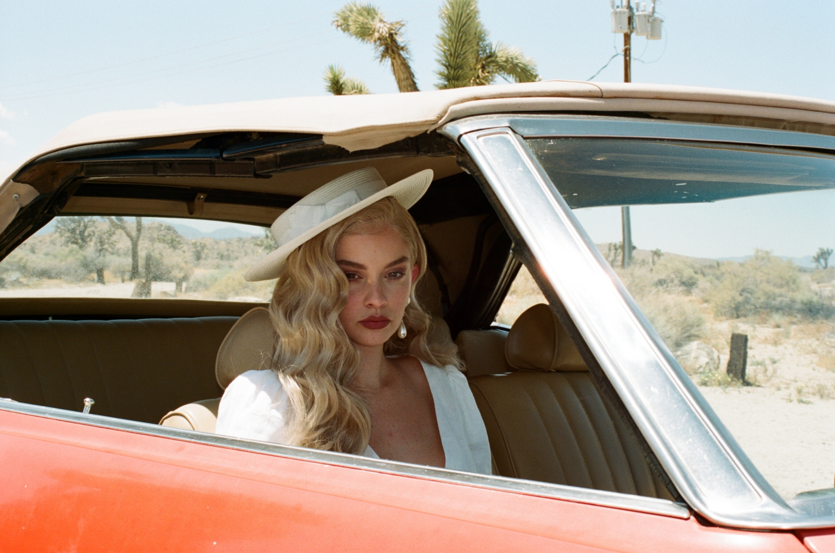
(Credit: Cassandra Borges)

ABOUT SABRINA CLAUDIO:
Sabrina Claudio has been garnering much attention from fans and critics alike since she independently unveiled her debut EP Confidently Lost in 2016 on Soundcloud. In under six months, she quietly amassed over 3 million cumulative plays. The EP was eventually released commercially and shot to No. 3 on the iTunes R&B chart sitting only behind Khalid and The Weeknd. This was only the beginning for the Puerto Rican/Cuban singer-songwriter whose breathy vocals immediately hypnotize and captivate. Sabrina would follow with a 12-song collection About Time that shot to the top of R & B charts and continued to cement Claudio as one to watch. On the heels of the new music, Sabrina was announced as Apple’s “Up Next” Artist and made her national TV debut with an alluring performance on The Late Late Show with James Corden. Audiences were treated to seeing Claudio’s sultry, beautiful live performances on her first ever-national tour as main support for 6LACK. Sabrina was featured on the Fifty Shades Freed Original Motion Picture Soundtrack, with an original song called “Cross Your Mind.” Most recently, Claudio released the titillating new song “All To You.” MTV said the song is “so good that you might want to cancel your plans and go straight home, because it will leave you all hot and bothered.”

SABRINA CLAUDIO
ON TOUR FALL 2019

SEPTEMBER
21 - Los Angeles, CA - The Wiltern
22 – Los Angeles, CA – The Wiltern
25 - Anaheim, CA - House of Blues
26 - San Francisco, CA - The Masonic
28 - Sacramento, CA - Ace of Spades
30 - Portland, OR - Crystal Ballroom

OCTOBER
1 - Vancouver, BC - Vogue Theater
3 - Seattle, WA - Showbox at the Market
5 - Salt Lake City, UT - The Depot
6 - Denver, CO - Summit Music Hall
8 - Minneapolis, MN - The Varsity Theater
9 - Milwaukee, WI - The Rave
11 - Chicago, IL - Riviera Theater
12 - Detroit, MI - St. Andrews Hall
14 - Boston, MA - House of Blues
16 - Toronto, ON - Rebel Complex
17 - Montreal, QC - Corona Theatre
18 - New York, NY - Hammerstein Ballroom
19 - Philadelphia, PA - The Fillmore
21 - Silver Spring, MD - The Fillmore
22 - Charlotte, NC - The Fillmore
23 - Atlanta, GA - The Buckhead Theatre
25 - Fort Lauderdale, FL - Revolution
26 - Orlando, FL - The Becham Theatre
27 - Tampa, FL - The Ritz Theatre
29 - New Orleans, LA - House of Blues
30 - Austin, TX - Emo’s
31 - Dallas, TX - House of Blues

NOVEMBER
1 - Houston, TX - House of Blues
2 - San Antonio, TX - House of Blues
5 - Tucson, AZ - Rialto Theatre
6 - Phoenix, AZ - The Van Buren
7 - Las Vegas, NV - House of Blues
8 - San Diego, CA - Soma
17 - Manchester, UK - Academy 2
19 - London, UK - Brixton Electric
22 - Berlin, DE - Kesselhaus
24 - Paris, FR - Alhambra
25 - Amsterdam, ML - Melkweg (The Max)
26 - Antwerp, BE - Trix

CONNECT:
youtube.com/user/sabrinaclaudiomusic
instagram.com/sabrina_claudio
soundcloud.com/sabrina-claudio
twitter.com/sabrina_claudio
facebook.com/SabrinaClaudioMusic

CONTACT:
Chelsey Northern // Chelsey.Northern@atlanticrecords.com
Andrew George // Andrew.George@atlanticrecords.com

