SAM BRUNO UNLEASHES “HELLO HATER” REMIX BY WRLD
AVAILABLE NOW VIA ALL DSPS

THE SINGER/SONGWRITER/ENGINEER/PRODUCER’S
DEBUT EP “I AM SAM PT. 1” IS OUT NOW

“HELLO HATER” (WRLD REMIX)
Stream/Download: https://Atlantic.lnk.to/HHWRLDPR
Listen/Share: https://atlanti.cr/ythhwrld

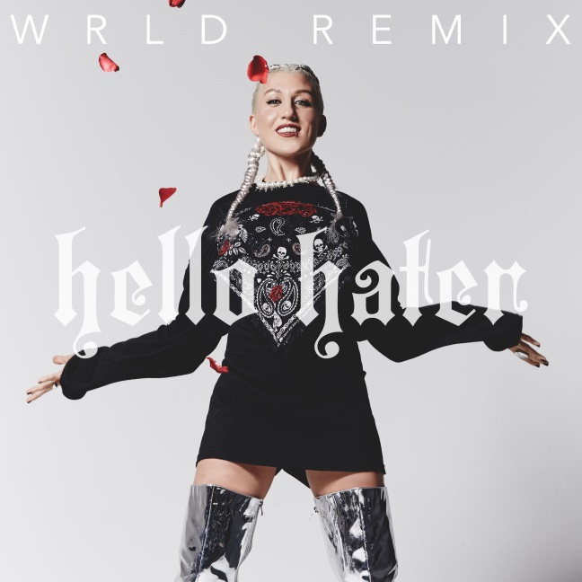
*DOWNLOAD HI-RES ART HERE*

Atlantic Records singer, songwriter, producer, and engineer Sam Bruno has released an official remix for her EP’s empowering lead single, “Hello Hater” – available today via all DSPs. The “Hello Hater” (WRLD Remix) premiered exclusively yesterday via BlackBook and can be downloaded and streamed HERE.

The recording artist’s debut EP “I AM SAM PT. 1,” released earlier this year, is available now at all DSPs and streaming services HERE. Watch the official video for “Hello Hater” which premiered via Galore up on Sam’s YouTube channel HERE.

Sam Bruno first came onto the scene with her electro-pop anthem, “Search Party”, which served as the lead track and official song of the Paper Towns soundtrack. Check out the official video for “Search Party” HERE. Since, she went on to release the sultry “Tip of My Tongue,” also featured on the EP, and unleashed a 90’s inspired visual for the track which premiered via PopCrush and can be viewed HERE. Bruno also lent her vocal talents to the GTA track, “Red Lips” for which the official video has now surpassed over 8 million views. Watch HERE. “Red Lips” continued to make waves with the official visual for its Skrillex remix which premiered exclusively with Apple Music and has garnered nearly 29 million views on YouTube to date. Check out the sci-fi themed video treatment for the remix HERE. Having worked alongside superstar artists including Kanye West, Lady Gaga, and Britney Spears, Bruno is excited to properly introduce listeners to her own sound with her debut EP.

ABOUT WRLD
Also known as David Lawson, WRLD is a young artist that produces with the musical versatility of a seasoned veteran, merging electronic with dance and pop. WRLD first stepped into the scene with Vancouver based label Monstercat and a feature on their “Frontier’ compilation. This fruitful relationship secured several releases with Monstercat over the years, ranging in sound from future bass to drum and bass records. His versatility and talent would eventually lead him to work with Moving Castle & Nest HQ/OWSLA. In 2017, WRLD has evolved immensely, dabbling more in the indie dance realm with tracks released off Heroic including “Hideaway”, which landed David his first Hype Machine #1 in the process, while achieving over 2 million Spotify streams. Additionally, WRLD’s release “Stranded” with SMLE, marked the beginning their joint Stranded Tour, in which they embarked a 12 date live tour across North America. “Stranded” released on Heroic, had achieved over 1 million streams on SoundCloud and Spotify, while once again showing WRLD’s seamless ability to transition genres release after release with ease.

CONNECT WITH SAM BRUNO:
WEBSITE |FACEBOOK | TWITTER | INSTAGRAM | YOUTUBE

CONNECT WITH WRLD:
WEBSITE |FACEBOOK | TWITTER | INSTAGRAM | YOUTUBE

