FOR IMMEDIATE RELEASE:

MULTI-GRAMMY NOMINATED R&B CROONER TANK IS SET TO DROP NEW ALBUM “SAVAGE” SEPTEMBER 29; AVAILABLE FOR PRE-ORDER TODAY!

“THE SAVAGE TOUR” KICKS OFF SEPTEMBER 5

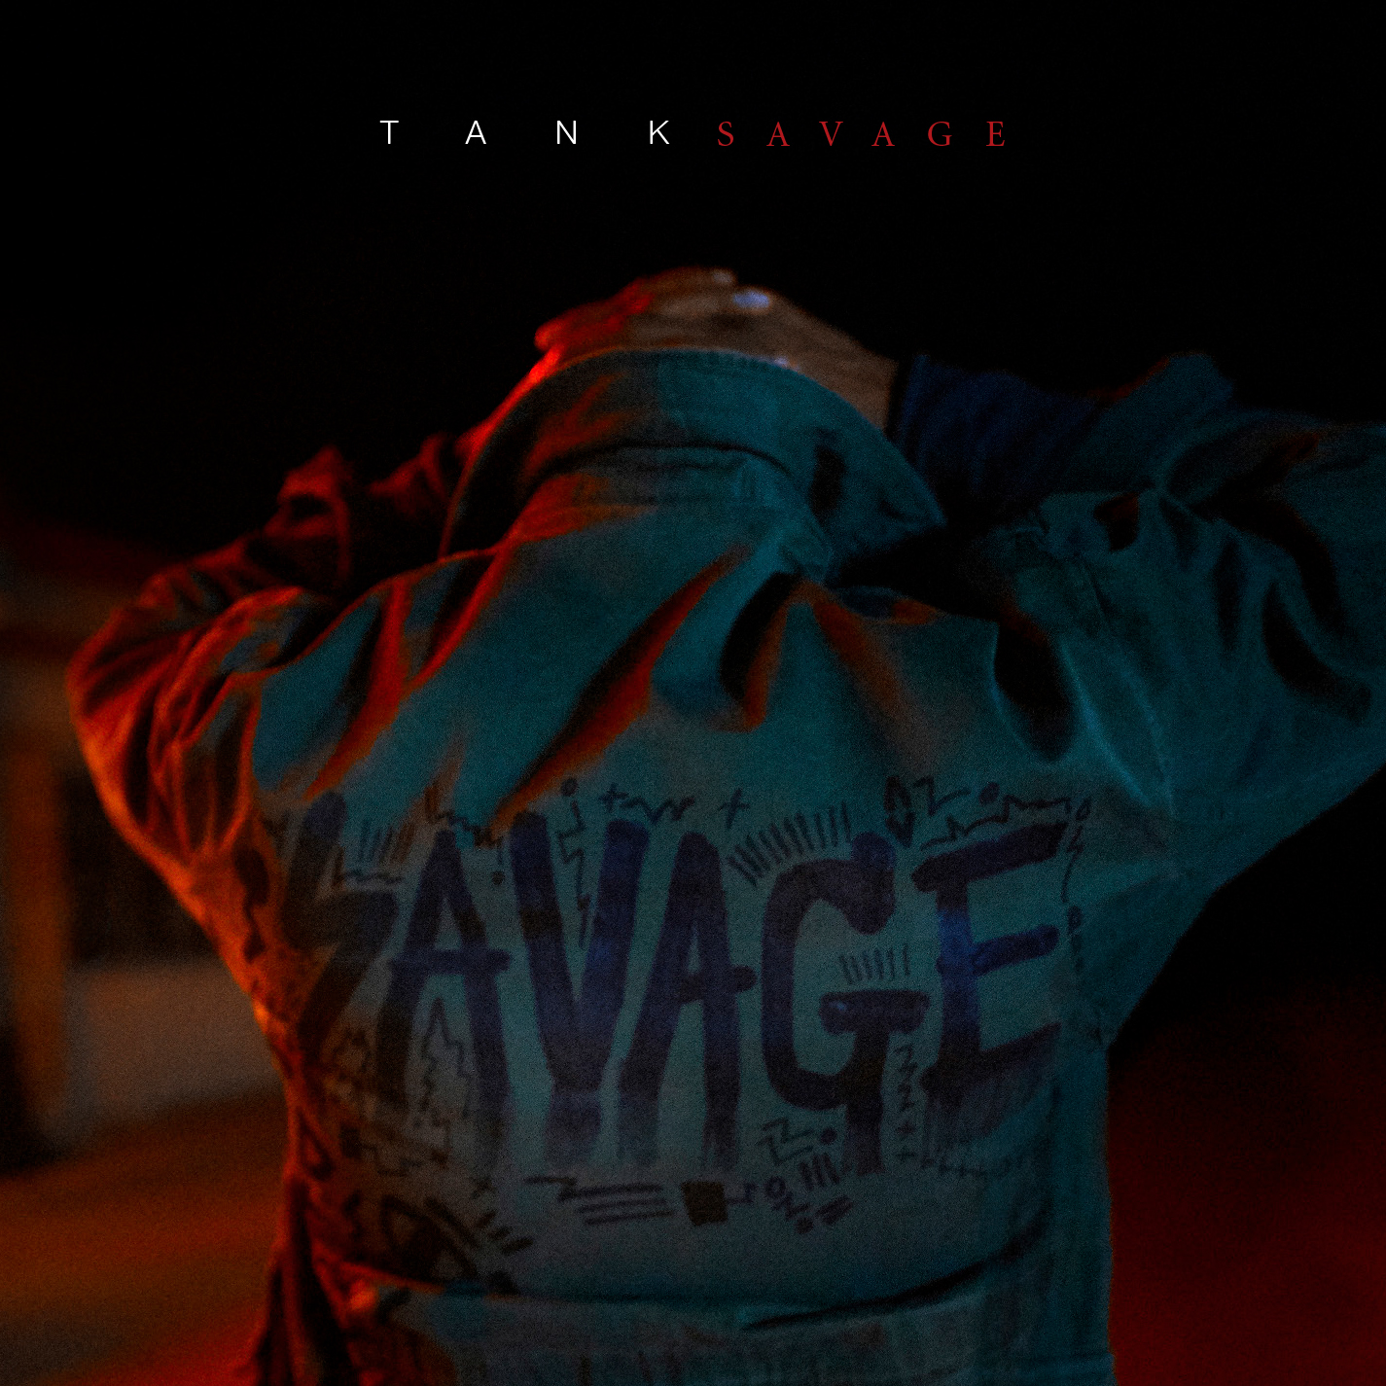

(New York, NY- August 25) R&B Money/Atlantic Records recording artist and multi-Grammy nominated R&B star Tank is excited to announce that his new album SAVAGE is set to be released on September 29. The 11-track LP features appearances by Candice Boyd, J. Valentine, Ludacris, and labelmate Trey Songz as well as production from Da Internz, Harmony Samuels, and Cardiak. Currently available for pre-order starting today (Click Here), SAVAGE will feature lead single “When We,” which has garnered airplay on stations around the country with the accompanying video premiered via Vibe.com (Click Here). In addition, Tank has also released the title track “Savage” for fans to enjoy (Click Here).

Tank will also be embarking on a 15 city “SAVAGE Tour,” in support of the new album. The tour kicks off on September 5 at the City Winery in Nashville and culminating on September 27 in Pittsburgh at the Rex Theater. The tour will be stopping in New York, Boston, Little Rock, Memphis among others, where he will perform fan favorites like "Please Don't Go," "I Can't Make You Love Me," "You Don't Know," and "Maybe I Deserve" as well as new songs off the album. Tickets for the tour can be purchased via Tank’s website (Click Here).

TANK TOUR DATES
Date City Venue
9/1/17 Miramar, FL* Miramar Regional Park – Support for Maze
9/2/17 Tampa, FL* USF – SUN DOME – Support for Maze
9/3/17 Atlanta, GA* Wolf Creek Amphitheater – Support for Anthony
Hamilton
9/5/17 Nashville, TN City Winery
9/6/17 Raleigh, NC Lincoln Theatre
9/8/17 Washington, DC The Howard Theatre
9/9/17 New York, NY BB Kings
9/10/17 Boston, MA House of Blues
9/12/17 Buffalo, NY Waiting Room
9/13/17 Cleveland, OH House of Blues
9/17/17 Mobile, AL Soul Kitchen
9/19/17 Augusta, GA Sky City
9/21/17 Birmingham, AL Work Play
9/22/17 Jackson, MS The Hideaway
9/23/17 Little Rock, AR Metroplex
9/24/17 Memphis, TN New Daisy Theatre
9/26/17 Cincinnati, OH Bogart's
9/27/17 Pittsburgh, PA Rex Theater

Follow Tank:
Website: www.therealtank.com
Instagram: @therealtank
Facebook: therealtank
Twitter: @therealtank

###

Press Contact:
Tasha Stoute/Decota Letman
Strong Arm Media
tasha@strongarmmedia.com / decota@strongarmmedia.com

Ashley Kalmanowitz
Atlantic Records
ashley.kalmanowitz@atlanticrecords.com

