FOR IMMEDIATE RELEASE

DECEMBER 7, 2018

**SHORELINE MAFIA UNWRAP *OTXMAS***

**LOS ANGELES RAP FAMILY CELEBRATE THE SEASON WITH NEW MIXTAPE**

**“OFF THE X” TOUR BEGINS JANUARY 19TH IN NEW ORLEANS**

**ROLLING LOUD LOS ANGELES PERFORMANCE SET FOR DECEMBER 14TH**

**HOLIDAY-THEMED MERCH BUNDLE ON SALE NOW**

***SHORELINE MAFIA PRESENTS OTXMAS* AVAILABLE TODAY**

**AT ALL DSPS AND STREAMING SERVICES**

**LISTEN/STREAM OTXMAS** [**HERE**](https://shoreline.lnk.to/OTXmas)

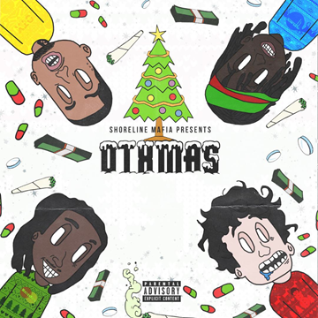

**DOWLOAD ARTWORK** [**HERE**](https://warnermusicgroup.box.com/s/h9dap7o7x77shkgje1uu752fo2goxzx2)

Atlantic recording group Shoreline Mafia has announced today’s arrival of a brand new mixtape. *Shoreline Mafia Present OTXmas* is available now for streaming and download [HERE.](https://shoreline.lnk.to/OTXmas)

Produced by RonRon, AceTheFace, Slade The Monster & Bruce24K, *Shoreline Mafia Present OTXmas* includes “Homicide,” featuring Detroit’s BandGang Lonnie Bands and available at all DSPs and streaming services [HERE](https://shoreline.lnk.to/Homicide). The track is joined by a new companion video, directed, shot, and edited by Laced Visuals and streaming now via the official Shoreline Mafia YouTube channel [HERE](https://www.youtube.com/watch?v=u_uDgWpYqcU).

Shoreline Mafia will further mark *OTXMas* with a new holiday-themed merch bundle featuring exclusive Shoreline Mafia gift wrapping paper and a custom Shoreline Mafia crew neck. In addition, the group will be hosting a special listening party and pop-up merchandise giveaway at The Hyve in Los Angeles on December 28th. For details, please see [www.hellawave.com](http://www.hellawave.com/).

Shoreline Mafia – a.k.a. OhGeesy  (real name: Alejandro Coranza), Rob Vicious (Robert Maggee), Fenix Flexin (Fenix Rypinski), and Master Kato (Malik Carson) – will kick off 2019 with their “Off The X Tour” after hopping off their last tour, selling out their European dates. It begins January 19th at New Orleans’ LA Republic and then travels the U.S. through early February (see attached itinerary). For updates and ticket availability, please see [hellawave.com/tour](https://hellawave.com/tour).

What’s more, Shoreline Mafia will be on the mainstage and among the stars rocking Rolling Loud Los Angeles, set for December 14th at Los Angeles, CA’ Banc of California Stadium Grounds & Exposition Park – limited tickets remain available [HERE](https://rollingloudla.frontgatetickets.com/). They will be the last new Los Angeles group to perform on night one. Shoreline Mafia and management R Baron will also partner with Rolling Loud founders Matt Zingler and Tariq Cherif for a special Holiday Toy Drive. Presented in conjunction with urban radio station Power 106 FM and Paradigm Talent Agency, the toy drive will benefit East L.A. Rising, a local non-profit organization that empower underprivileged children with food, supplies, and educational opportunities, and Schools On Wheels, which provides tutoring and education to children without a permanent home. Fans may bring unwrapped toys to the festival – Rolling Loud will operate a toy donation tent near the festival entrance. Complete details will be announced soon; Shoreline Mafia asks fans to spread the word using the hashtag #ShorelineRLToyDrive.

Hailed as an electrifying live act, Shoreline Mafia spent much of 2018 traveling on *three* sold out headline tours: “Off The Xtras,” “Still OTX,” and “Only The Xclusives.” In addition, the Los Angeles-based rap family has unleashed show-stopping performances at festivals like Rolling Loud, Made In America, and the Billboard Hot 100 Music Festival.

Now boasting over 1.3 million monthly listeners via Spotify alone, Shoreline Mafia leapt to the forefront of contemporary hip-hop last year with their first full-length mixtape, *ShorelineDoThatShit*, highlighted by such viral favorites as tracks like “Nun Major,” “Spaceship,” “Serve A Boat,” and “Whuss The Deal.” High profile media attention followed, including [Noisey Beats 1](https://noisey.vice.com/en_us/article/d3wpnm/noisey-beats-1-shoreline-mafia-and-ron-ron-the-producer), [XXL](http://www.xxlmag.com/news/2018/01/shoreline-mafia-interview-the-break/), and [LyricalLemonade](http://lyricallemonade.com/ll-presents-the-shoreline-mafia-qa/), which noted, “OhGeesy, Fenix, Rob Vicious, and Master Kato…naturally blend their different sounds together perfectly and are quickly proving to be a huge force in the next wave of rap music.” [PassionWeiss.com](https://www.passionweiss.com/2018/02/22/shoreline-mafia/) declared the quartet “Los Angeles’ fastest rising rap group” while praising *ShorelineDoThatShit* as “one of the strongest releases in recent memory, full of songs that are destined to remain in rotation for the foreseeable future.”

Recent releases include the hit single, “Bands,” originally found on Shoreline Mafia member Rob Vicious’ major label debut mixtape, [*Traplantic*](https://shoreline.lnk.to/TraplanticID), available at all digital music retailers and streaming services [HERE](https://shoreline.lnk.to/TraplanticID). The track’s companion video, recently included in *The New York Times* list of “Top 65 Songs of 2018” by Jon Caramanica, has earned over 12 million views at the official Shoreline Mafia YouTube channel [HERE](https://www.youtube.com/watch?v=l41LN8QJVzo). [*Traplantic*](https://shoreline.lnk.to/TraplanticID) also includes “LA Flocker,” joined by a new video streaming exclusively via WorldstarHipHop [HERE](https://www.youtube.com/watch?v=lCqJ4EchNuQ).

As if that weren’t enough, Shoreline Mafia member Master Kato recently unleashed his own solo debut mixtape, [*Ride Around*](https://shoreline.lnk.to/RideAround), streaming [HERE](https://shoreline.lnk.to/RideAround).

CONNECT WITH SHORELINE MAFIA:

[HELLAWAVE.COM](http://hellawave.com/)

[TWITTER](https://twitter.com/shorelinemafia)

[FACEBOOK](https://www.facebook.com/ShorelineMafia/)

[SOUNDCLOUD](https://soundcloud.com/shorelinemafia)

[YOUTUBE](https://www.youtube.com/shorelinemafia)

# # #

**SHORELINE MAFIA**

***SHORELINE MAFIA PRESENTS OTXMAS***

(ATLANTIC RECORDS)

Release Date: December 7th

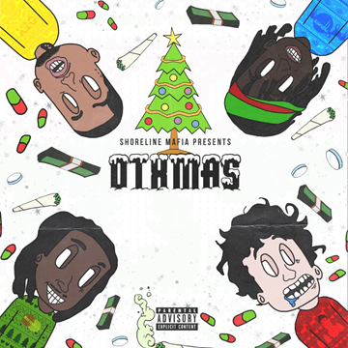

TRACKLISTING

1. Bathing Ape (OhGeesy, Fenix Flexin)
2. Occupied (Rob Vicious, Fenix Flexin)
3. Moving Work (Fenix Flexin, Rob Vicious, OhGeesy)
4. Pressure (OhGeesy, Fenix Flexin)
5. Ride Around (Master Kato)
6. Homicide (OhGeesy Ft. BandGang Lonnie Bands)
7. Pistol Love (Rob Vicious)
8. Molly Water (Fenix Flexin, OhGeesy)

# # #**SHORELINE MAFIA**

**OFF THE X TOUR 2019**

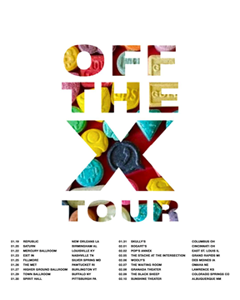

**JANUARY**

19           New Orleans, LA               Republic

20           Birmingham, AL                Saturn

22           Louisville, KY                      Mercury Ballroom

23           Nashville, TN                     Exit In

25           Silver Spring, MD              Fillmore

26           Pawtucket, RI                    The Met

27           Burlington, VT                   Higher Ground Ballroom

29           Buffalo, NY                        Town Ballroom

30           Pittsburgh, PA                    Spirit Hall

31           Columbus, OH                   Skully’s

**FEBRUARY**

1             Cincinnati, OH                   Bogart’s

2             East St. Louis, IL                Pop’s Annex

5             Grand Rapids, MI              The Stache at the Intersection

6             Des Moines, IA                  Wooly’s

7             Omaha, NE                        The Waiting Room

8             Lawrence, KS                     Granada Theater

9             Colorado Springs, CO      The Black Sheep

10           Albuquerque, NM             Sunshine Theater

[hellawave.com/tour](https://hellawave.com/tour)

# # #