FOR IMMEDIATE RELEASE
OCTOBER 5, 2021

YOUNGBOY NEVER BROKE AGAIN MAKES HISTORY WITH SINCERELY, KENTRELL

ACCLAIMED NEW ALBUM ROCKETS TO #1 ON SOUNDSCAN/BILLBOARD 200
WITH SUPERSTAR RAPPER’S BIGGEST SALES WEEK TO DATE

CHART-TOPPING SUCCESS MARKS FOURTH #1 PROJECT IN LESS THAN TWO YEARS

HIGHLIGHTS INCLUDE SUCH MULTI-MILLION STREAMING HITS AS
“LIFE SUPPORT,” “ON MY SIDE,” “NEVADA,” “TOXIC PUNK,”
“WHITE TEETH,” AND “BREAK OR MAKE ME”

FAN DEMAND FORCES ADDITION OF TWO EXCLUSIVE BONUS TRACKS
IN DAYS FOLLOWING RELEASE

SINCERELY, KENTRELL AVAILABLE EVERYWHERE NOW

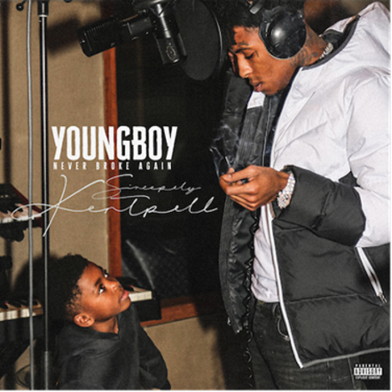

Chart-topping, multi-platinum rap superstar YoungBoy Never Broke Again has made history with his acclaimed new album. SINCERELY, KENTRELL makes its triumphant chart debut this week at #1 on the overall SoundScan/Billboard 200, narrowly defeating Drake’s CERTIFIED LOVER BOY with cumulative sales exceeding 137K – YoungBoy’s biggest sales week to date and fourth #1 project in less than two years. Furthermore, the album instantly debuted at #1 on both Apple Music’s “Top Albums” and iTunes’ “US Albums” charts while also being added to more than 55 top playlists across all major streaming platforms. SINCERELY, KENTRELL is available everywhere now via Never Broke Again, LLC/Atlantic Records HERE.

Last week’s arrival of SINCERELY, KENTRELL was celebrated with the premiere of the official music video for the album’s latest single, “Break Or Make Me,” now boasting over 5.2M views via YouTube after earning more than 1.2M views in the first 24 hours following its premiere. In addition, Amazon Music heralded SINCERELY, KENTRELL by hosting an exclusive listening party via Twitch, drawing more than 280K views and highlighted by a visit from YoungBoy’s longtime studio collaborator, recording engineer Jason “Cheese” Goldberg.

Incredible fan demand from around the world then prompted the addition of two major bonus tracks, and an official video for the track “Kickstand” mere days after the album’s initial release. Recorded over the jail phone at St. Martin Parish Jail in St. Martinville, LA where YoungBoy remains incarcerated with no bond, “Still Waiting” was previewed by the rapper’s sister via her Instagram page last month and instantly went viral. SINCERELY, KENTRELL further adds “Footstep,” a track eagerly expected by YoungBoy’s devoted following but were surprised not to find it upon the original release.

YoungBoy has also kicked off an official SINCERELY, KENTRELL freestyle competition by unveiling a round of exclusive album instrumentals via YouTube HERE. Fans are invited to submit their own freestyle videos, with the Grand Prize Winner receiving a once-in-a-lifetime recording session with Jason “Cheese” Goldberg.

Along with its explosive popular success, SINCERELY, KENTRELL has been met with early critical acclaim:

“Full of conviction and bruised passion… the songs here sound like exuberant confessionals… If these are the proverbial scars YoungBoy Never Broke Again ’s chosen to reveal to us, they’re from battles, thankfully, he’s already won.”
– ROLLING STONE

“Raw and intimate…a startling glimpse of a larger-than-life figure whose tragic shadow extends over everything he touches.”
– PITCHFORK

“A certified masterpiece…YoungBoy offers a glimpse into his daily struggles that offer a perspective many don’t understand nor see.”
– LYRICAL LEMONADE

SINCERELY, KENTRELL serves as a testament to YoungBoy’s remarkable talent and versatility, showcasing the Baton Rouge, LA-native’s true heart and soul over 21 featureless tracks. The album sees YoungBoy joined in the studio by a number of longtime collaborators and rising new producers, including Dubba-AA, Mike Laury, TnTXD & Dmac, Smashdavid (Big Sean, Chris Brown, Khalid, Bad Bunny), MikeWillMadeIt (Kendrick Lamar, Rae Sremmurd, Eminem, Beyonce), and TayTayMadeIt (Roddy Ricch, Swae Lee, Jack Harlow).

SINCERELY, KENTRELL – which follows six consecutive top 10 releases for YoungBoy, with three of the past five (2019’s AI YOUNGBOY 2 and 2020’s 38 BABY 2 and TOP) all debuting at #1 on the overall SoundScan/Billboard 200 – includes such recently released singles as “On My Side,” “Life Support,” “Nevada,” “Toxic Punk,” and “White Teeth,” all of which have already earned more than 197M cumulative streams in the US alone.

YoungBoy has further made history as just the third-ever rapper to release a Billboard #1 album from behind bars, following Tupac Shakur and Lil Wayne. The chart-topping success of SINCERELY, KENTRELL affirms the iconic star’s deeply personal relationship with a devoted audience who recently united to create an official Change.org petition asking President Joe Biden to grant his much-deserved release, now with over 75K signatures and counting.

From 10/11 - 10/17 YoungBoy hopes to lend a helping hand to his home of Louisiana as it rebuilds after the devastation of Hurricane Ida. Through the Pull Up Neighbor, Sincerely Kentrell Hurricane Ida Support drive, the Young team will work to distribute essentials such as water, dry foods, clothes and more to those who need it most. To volunteer, send an email to joinus@pullupneighbor.org

# # #

FOR MORE INFORMATION, PLEASE VISIT:
INSTAGRAM | TWITTER | FACEBOOK

FOR ALL PRESS INQUIRIES, PLEASE CONTACT:
ARIANA.WHITE@ATLANTICRECORDS.COM

