YOUNGBOY NEVER BROKE AGAIN RELEASES OFFICIAL MUSIC VIDEO FOR ALBUM TRACK “KICKSTAND”
FAN FAVORITE BONUS TRACKS “FOOTSTEP” AND “STILL WAITING” STREAMING NOW

SINCERELY, KENTRELL AVAILABLE EVERYWHERE NOW

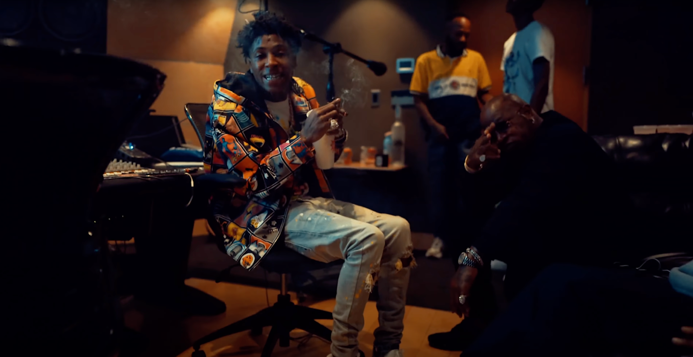

Just days after the release of his acclaimed new album, SINCERELY, KENTRELL, chart-topping, multi-platinum rap superstar YoungBoy Never Broke Again is back with even more fire. In celebration of the album which instantly debuted at #1 on both Apple Music’s “Top Albums” and iTunes’ “US Albums” charts; YoungBoy is releasing the bonus tracks “Footstep” and “Still Waiting”, as well as an official video for the standout album track “Kickstand” that features a cameo from hip hop legend Birdman and is available to watch now via YouTube HERE. SINCERELY, KENTRELL is available everywhere now via Never Broke Again, LLC/Atlantic Records HERE.

A snippet of “Still Waiting” was previewed by YoungBoy’s sister, via her Instagram page, last month. The leaked snippet was recorded over the phone at St. Martin Parish Jail, and instantly went viral when it was made public.

Fans of the rap star will be delighted to know that “Footstep” is the final bonus track on the album. Fans have campaigned for its release since it was leaked early this year and were disheartened when it did not appear on the final track list. But the track is now available to stream HERE.

2021 has seen YoungBoy making history with his wildly popular YouTube channel reaching more than 8.5B individual views – surpassing the total population of Planet Earth by almost 1B. The new year kicked off with “Nevada,” which fast proved a fan favorite as well as a TikTok sensation featured in thousands of user-created videos. “Toxic Punk” followed, earning immediate critical praise from the likes of Billboard, which raved, “The Baton Rouge MC contemplates drugs' toxic effects on his life over a guitar-driven trap melody.” “YoungBoy Never Broke Again continues to display why he's one of hip-hop's most versatile artists with the release of his new song ‘Toxic Punk,’” declared Yahoo!, “The Baton Rouge native creates a melody that feels inspired by pop-rock hits. Skillfully riding the DJ Trebble, Dmac, and TnTXD-produced instrumental, he uses his time to touch on the dark themes that permeate his music.”

“White Teeth” dropped in the spring, joined by an official music video which earned close to 1M views within its first 12 hours online and currently boasts close to 21.5M individual views via his massively popular YouTube channel HERE. Like its predecessor, the track was met by praise from such high profile media outlets as Revolt, which hailed the track as, “a TayTayMadeIt-produced effort that keeps with the rags-to-riches subject matter that (YoungBoy’s) become popular for.”

“Life Support” hit earlier this month joined by an official video which instantly ascended to the #2 spot on YouTube’s “Trending” chart and has now received more than 8.5M views HERE. “The lyrics of ‘Life Support’ weave a tale of survival,” enthused Complex, “with YoungBoy crooning through heavy topics like taking his grandmother to chemo, discussing how his pain keeps him going, and how he feels like he’s living on life support; one move away from getting the chord pulled.”

“On My Side” was released last week and currently sits at #4 on YouTube’s “Trending” chart. The track was teased via Instagram in February and since its release last Friday it has amassed over 3.5M YouTube as well as critical praise from XXL, Complex, Revolt and more.

With 76 total RIAA certifications and over 72.5M certified units under his belt thus far, YoungBoy Never Broke Again is without question among the landmark hip-hop artists of this or any era. 2020 and 2021 have both seen him become America’s #1 most video on demand streamed artist of any genre. His second studio Album, TOP, is officially platinum certified after an explosive debut at #1 on the SoundScan/Billboard 200 upon its September 2020 release. YoungBoy was also last year’s #3 most audio on demand streamed artist industrywide and is currently #5 for 2021 thus far. Currently incarcerated with no bond at St. Martin Parish Jail in St. Martinville, LA, YoungBoy marked today’s release of SINCERELY, KENTRELL with a handwritten letter to his fans around the world. Indeed, the iconic star has fostered an intimate and personal relationship with his devoted audience, many of whom recently united to create an official Change.org petition asking President Joe Biden to grant his much-deserved release.

# # #

FOR MORE INFORMATION, PLEASE VISIT:
INSTAGRAM | TWITTER | FACEBOOK

FOR ALL PRESS INQUIRIES, PLEASE CONTACT:
ARIANA.WHITE@ATLANTICRECORDS.COM

