SK8 TAPS TYLA YAWEH FOR “FAMOUS”

ROCK-INFUSED NEW SINGLE FROM TAYLOR GANG SINGER’S FORTHCOMING
PROJECT ARRIVES ALONGSIDE NEW DANIEL KELLY-DIRECTED VISUAL

WATCH “FAMOUS (FEAT. TYLA YAWEH)” HERE
[Directed By: Daniel Kelly]

New York, NY – March 12, 2021 – Emerging Taylor Gang singer, SK8, is starting a new era with his latest single, “Famous,” featuring rising rapper Tyla Yaweh. Arriving today alongside a Daniel Kelly-directed visual, “Famous” is the inaugural single for SK8’s new era of music in which his evolved sound combines his signature hip-hop influence with nostalgic punk/rock instrumentation.

“Releasing “Famous’ is such a big moment for me because I wanted to hone in on a sound that felt both current and nostalgic, while also making music that felt true to me. I think this song represents the overall essence of what’s on the way with my upcoming project and I’m excited to give fans a taste of the new music that my team and I have been grinding on in the studio for so long. Tyla and I have worked so hard on our craft, and we’re getting to the point in our careers where people treat us differently because of our fame, which was the inspiration behind ‘Famous.’”
-SK8

LISTEN TO “FAMOUS (FEAT. TYLA YAWEH) HERE
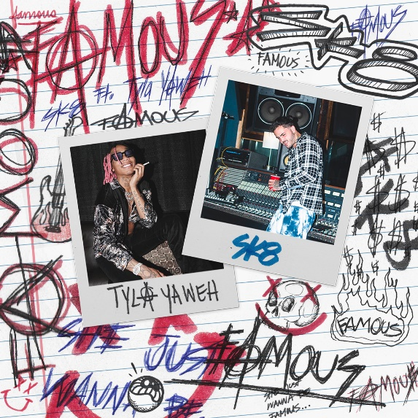
DOWNLOAD ARTWORK HERE

***

ABOUT SK8:
At 15, you could find SK8 in his room writing lyrics, and by his sophomore year, you could find him handing out CDs in high school. The 23-year-old moved to Los Angeles from Omaha, Nebraska and linked with the venerable Taylor Gang, first breaking into the mainstream with his gold-certified single, “Like That,” with Jack & Jack and opening for revered rap icons like Lil Wayne, 2 Chainz and Rae Sremmurd. SK8 began building a dedicated fanbase of dreamers who related to his message of seizing every moment long before his eventual move to LA. Shortly after founding his own imprint, Alignment, and formally signing a joint venture with Atlantic Records via James McMillan’s ART@WAR, SK8 released his major label debut EP, sk8sounds, which was buttressed by the standout singles “Omme (Feat. Wiz Khalifa),” “XXX” and “Mood (Feat. YK Osiris).” Over a year later, SK8 has turned a new page in his career with his first single of 2021, “Famous (Feat. Tyla Yaweh),” and its associated forthcoming project which finds the rising singer seamlessly blending punk/rock instrumentation with his hip-hop origins, the latest but not last development in SK8’s rapidly evolving artistry.
PRESS PHOTOS:
[Credit: Michael Stryder]
DOWNLOAD PRESS PHOTOS HERE
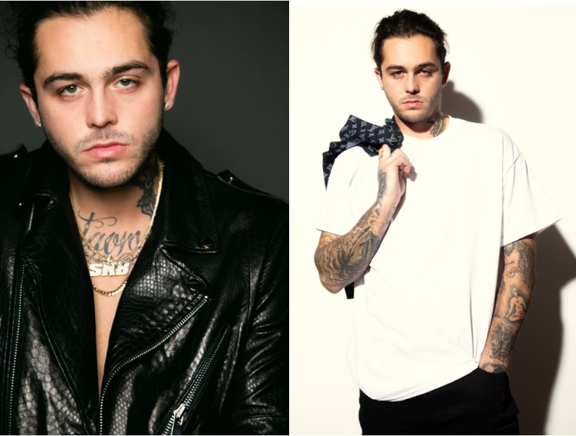

CONNECT:
Instagram | Twitter | Facebook | YouTube | Press Site

FOR PRESS INQUIRIES:
Brian Sommer | Brian.Sommer@Atlanticrecords.com
Jason Davis | Jason.Davis@Atlanticrecords.com

# # #

