**SK8 DEBUTS MESMERIZING NEW MUSIC VIDEO FOR “OBVIOUS”**

[**WATCH “OBVIOUS” HERE**](https://sk8.lnk.to/obviousvideo)

*[Directed by Rock Davis]*



**+ WATCH SK8 THROW THE ULTIMATE BACKYARD PARTY IN HIS “HOW IT BE” VISUAL**

[**WATCH “HOW IT BE” HERE**](https://youtu.be/6Id6uTyd6SI)

*[Directed by Rock Davis]*

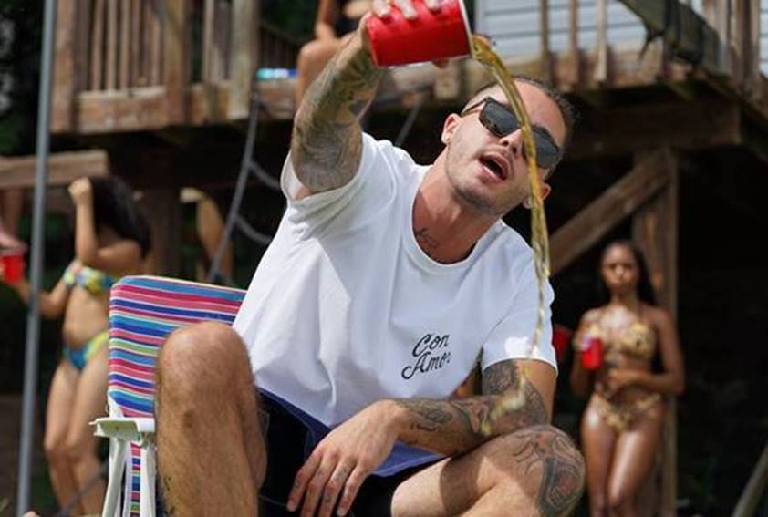

***ABOUT SK8:***

Known for merging hypnotic rap and otherworldly R&B crooning over smoked-out landscapes, SK8 has spent countless hours perfecting his craft. Originally an aspiring pro basketball player, SK8’s trajectory changed after attending Wiz Khalifa’s *Waken Baken* tour in 2011. Shortly thereafter, the Omaha, Nebraska native was inspired to pursue music and went on to release several independent mixtapes and teamed up with fellow hometown sensation Jack & Jack for the gold-certified single “Like That.” After amassing millions of streams on his independent catalog, opening for artists including Lil Wayne, 2 Chainz and Rae Sremmurd, and embarking on his headlining *Skaterade* Tour, SK8 locked down management with Taylor Gang Management, cofounded his own imprint, *Alignment* with entertainment executive James McMillan, and signed to Atlantic Records via McMillan’s *ART@WAR* joint venture. In 2019, SK8 dropped his major label debut single, [“Private Party (feat. 24hrs),”](https://nam04.safelinks.protection.outlook.com/?url=https%3A%2F%2Fwww.youtube.com%2Fwatch%3Fv%3DKgjV_41Br4o&data=02%7C01%7CBrian.Sommer%40atlanticrecords.com%7Ccf759ac0e95948c9cda708d85b2488e0%7C8367939002ec4ba1ad3d69da3fdd637e%7C0%7C0%7C637359559752102502&sdata=itqHo0%2BrEZ4UCMZp9vBfWBleZ%2F4unIurTLDmxn9TPSU%3D&reserved=0) and subsequently released his *sk8sounds EP* in 2020 bolstered by companion visuals for the standout tracks [“Mood (Feat. YK Osiris),”](https://nam04.safelinks.protection.outlook.com/?url=https%3A%2F%2Fwww.youtube.com%2Fwatch%3Fv%3Dzr5oThzy7wg%26feature%3Dyoutu.be%26src%3DLinkfire%26lId%3D9337340c-a915-46da-9a37-c99c230e1088%26cId%3Dd3d58fd7-4c47-11e6-9fd0-066c3e7a8751&data=02%7C01%7CBrian.Sommer%40atlanticrecords.com%7Ccf759ac0e95948c9cda708d85b2488e0%7C8367939002ec4ba1ad3d69da3fdd637e%7C0%7C0%7C637359559752112496&sdata=869XcX8CQ8QZOmWf%2FjyjX28uOPXIbDJtfBpdyBQM3Ao%3D&reserved=0) [“Omme (Feat. Wiz Khalifa),”](https://nam04.safelinks.protection.outlook.com/?url=https%3A%2F%2Fwww.youtube.com%2Fwatch%3Fv%3Dpy6p9uk7VjU&data=02%7C01%7CBrian.Sommer%40atlanticrecords.com%7Ccf759ac0e95948c9cda708d85b2488e0%7C8367939002ec4ba1ad3d69da3fdd637e%7C0%7C0%7C637359559752112496&sdata=WhqDe6LaiFjOZvrr7eek6Vevaq6oLcHY5%2B3FdzMaStQ%3D&reserved=0) [“XXX”](https://nam04.safelinks.protection.outlook.com/?url=https%3A%2F%2Fwww.youtube.com%2Fwatch%3Fv%3DQupCe8YZ7_8&data=02%7C01%7CBrian.Sommer%40atlanticrecords.com%7Ccf759ac0e95948c9cda708d85b2488e0%7C8367939002ec4ba1ad3d69da3fdd637e%7C0%7C0%7C637359559752122492&sdata=m9kLdNoYloYFpFJrU2rM38o9GWJMCXH2PQl6327zTwA%3D&reserved=0) and [“Take Me There.”](https://nam04.safelinks.protection.outlook.com/?url=https%3A%2F%2Fwww.youtube.com%2Fwatch%3Fv%3DHVrYG28Yjgk&data=02%7C01%7CBrian.Sommer%40atlanticrecords.com%7Ccf759ac0e95948c9cda708d85b2488e0%7C8367939002ec4ba1ad3d69da3fdd637e%7C0%7C0%7C637359559752122492&sdata=o1N02T5uSXcenAsnU0SDSS3PyYGOi0V%2Bvn0GACqVE1I%3D&reserved=0)

**PRESS PHOTOS:**

*[Credit: Daniel Kelly]*



[DOWNLOAD PRESS PHOTOS HERE](https://nam04.safelinks.protection.outlook.com/?url=http%3A%2F%2Fpress.atlanticrecords.com%2Fsk8%2F&data=02%7C01%7CBrian.Sommer%40atlanticrecords.com%7Ccf759ac0e95948c9cda708d85b2488e0%7C8367939002ec4ba1ad3d69da3fdd637e%7C0%7C0%7C637359559752102502&sdata=JLnfunwhnDA10SsgwFiUjuNNCJE4V3Eb11FvVZ0DAGQ%3D&reserved=0)

**CONNECT:**

[Instagram](https://nam04.safelinks.protection.outlook.com/?url=https%3A%2F%2Fwww.instagram.com%2Fskatemaloley%2F%3Fhl%3Den&data=02%7C01%7CBrian.Sommer%40atlanticrecords.com%7Ccf759ac0e95948c9cda708d85b2488e0%7C8367939002ec4ba1ad3d69da3fdd637e%7C0%7C0%7C637359559752132485&sdata=b1ahj8PNC%2Fk4etbVtlnT1B2cCcRQpvjiFNcRoLshYzU%3D&reserved=0) | [Twitter](https://nam04.safelinks.protection.outlook.com/?url=https%3A%2F%2Ftwitter.com%2Fskatemaloley%3Flang%3Den&data=02%7C01%7CBrian.Sommer%40atlanticrecords.com%7Ccf759ac0e95948c9cda708d85b2488e0%7C8367939002ec4ba1ad3d69da3fdd637e%7C0%7C0%7C637359559752132485&sdata=up%2F%2FIJcspgIu1S1NPzC0I6wBwcZhNo5fiDr0IOFE%2FtQ%3D&reserved=0) | [Facebook](https://nam04.safelinks.protection.outlook.com/?url=https%3A%2F%2Fwww.facebook.com%2FSK8%2F&data=02%7C01%7CBrian.Sommer%40atlanticrecords.com%7Ccf759ac0e95948c9cda708d85b2488e0%7C8367939002ec4ba1ad3d69da3fdd637e%7C0%7C0%7C637359559752142489&sdata=MQ%2FQk9XJs4LazXEGYE4u6voAjMtjBgJAhCvlzLSsmIU%3D&reserved=0) | [YouTube](https://nam04.safelinks.protection.outlook.com/?url=https%3A%2F%2Fwww.youtube.com%2Fchannel%2FUCaj_A_xOWgxwEkgsbe961og&data=02%7C01%7CBrian.Sommer%40atlanticrecords.com%7Ccf759ac0e95948c9cda708d85b2488e0%7C8367939002ec4ba1ad3d69da3fdd637e%7C0%7C0%7C637359559752142489&sdata=AQcqshLDbiRph9Z%2F3gt%2FZI3NRZmB1ZJr5D1P0CdxxO8%3D&reserved=0) | [Press Site](https://nam04.safelinks.protection.outlook.com/?url=http%3A%2F%2Fpress.atlanticrecords.com%2Fsk8%2F&data=02%7C01%7CBrian.Sommer%40atlanticrecords.com%7Ccf759ac0e95948c9cda708d85b2488e0%7C8367939002ec4ba1ad3d69da3fdd637e%7C0%7C0%7C637359559752152475&sdata=bGQ9QoRJhd2yvqSS%2FagEW3KofD6C1%2F9xr0mJ4KlvsVo%3D&reserved=0)

**FOR PRESS INQUIRIES:**

Brian Sommer | [Brian.Sommer@Atlanticrecords.com](mailto:Brian.Sommer@Atlanticrecords.com)

Jason Davis | [Jason.Davis@Atlanticrecords.com](mailto:Jason.Davis@Atlanticrecords.com)

# # #