FOR IMMEDIATE RELEASE
MAY 4, 2018
STRAIGHT NO CHASER ANNOUNCE THE “ONE SHOT TOUR”
“ONE SHOT TOUR” MARKS THE 10TH ANNIVERSARY OF STRAIGHT NO CHASER’S
DEBUT ALBUM “HOLIDAY SPIRITS” & SIGNING WITH ATLANTIC RECORDS

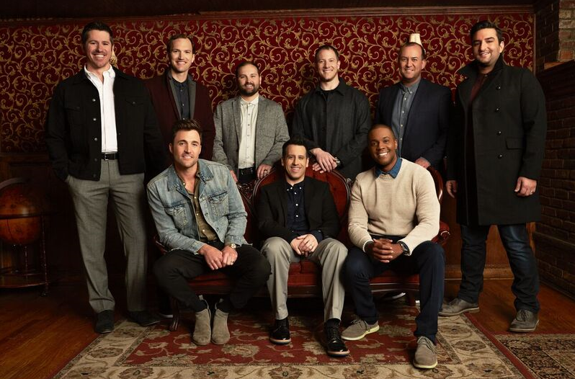
Atlantic Records recording group Straight No Chaser has announced early details of their upcoming “One Shot Tour” with dates in the US and Europe. The European leg kicks off on September 12th at the House of Culture in Helsinki, Finland with dates through the month wrapping on September 25th at Vicar Street in Dublin, Ireland. The North American leg of the “One Shot Tour” will begin on October 26th at the Mystic Lake Showroom in Prior Lake, MN and continues through the holiday season, wrapping up on December 31st at McCaw Hall in Seattle, WA. See all dates below.
The upcoming tour coincides with the 10th Anniversary of Straight No Chaser signing with Atlantic Records and the release of their RIAA gold certified debut album, “HOLIDAY SPIRITS” after a video of the group performing “12 Days of Christmas” went viral on YouTube and became the most viewed video of 2007. Upon the release of “HOLIDAY SPIRITS” in 2008, The New York Times predicted” this may be the year’s most unlikely major label story.” Now, ten years later with six full length albums and four EPs under their belt, the group will hit the road to celebrate and invite fans to join them on the “One Shot Tour.”
Pre-sale tickets will be available to members of Straight No Chaser’s official fan club beginning Tuesday, May 8th; all remaining tickets will go on sale to the general public on Friday, May 11th. For complete ticket information and other news, please see www.sncmusic.com/tour.
Additionally, Straight No Chaser is currently working on new music, with more details to come over the next few months. In the meantime, the world famous a cappella group will hit the road this summer to bring “An Evening with Straight No Chaser” to select cities with dates throughout July. The summer run follows the group’s recently wrapped “The Speakeasy Tour” in support of last summer’s “Six Pack: Volume 3” EP that saw Straight No Chaser crack open a number of contemporary pop hits and rock classics, highlighted by “Sweet Dreams/HandClap” – their one-of-a-kind mash-up of Eurythmics’ “Sweet Dreams (Are Made Of This)” and Fitz and the Tantrums’ “HandClap” – as well their show-stopping “Beyoncé Medley.”
STRAIGHT NO CHASER 2018 TOUR DATES
* Denotes “An Evening With Straight No Chaser” Dates
+ Denotes “One Shot Tour” Dates
JULY
8 | Costa Mesa, CA | Pacific Amphitheatre *
10 | San Diego, CA | Humphrey’s Concerts by the Bay *
11 | Paso Robles, CA | Vina Robles Amphitheatre *
12 | Napa, CA | Uptown Theatre *
13 | Saratoga, CA | Mountain Winery *
14 | Jacksonville, OR | Britt Pavilion *
17 | Vienna, VA | Wolf Trap *
18 | Portsmouth, NH | Music Hall *
19 | Reading, PA | Santander Performing Arts Center *
20 | Chautauqua, NY | Chautauqua Institution Amphitheater *
21 | Cohasset, MA | South Shore Music Circus *
22 | Hyannis, MA | Cape Cod Melody Tent *
23 | Ocean City, NJ | Ocean City Music Pier (2 Shows) *
24 | Selbyville, DE | The Freeman Stage at Bayside *
SEPTEMBER
12 | Helsinki, Finland | House of Culture +
14 | Arendal, Norway | Arendal Kulturhus +
15 | Drammen, Norway | Drammens Teater +
17 | Stockholm, Sweden | Nalen +
18 | Skive, Denmark | Skive Teater +
20 | Paris, France | Le Trianon +
21 | Brussels, Belgium | La Madeleine +
22 | Utrecht, Holland | TivoliVredenburg +
23 | London, UK | O2 Shepherd’s Bush Empire +
24 | Liverpool, UK | Epstein Theatre +
25 | Dublin, Ireland | Vicar Street +
OCTOBER
26 | Prior Lake, MN | Mystic Lake Showroom +
27 | Davenport, IA | Adler Theatre +
28 | Springfield, IL | Sangamon Auditorium +
29 | Appleton, WI | Fox Cities Performing Arts Center +
30 | Cedar Rapids, IA | Paramount Theatre +
NOVEMBER
1 | Billings, MT | Alberta Bair Theater +
2 | Denver, CO | Paramount Theatre +
3 | Albuquerque, NM | Kiva Auditorium +
4 | Greeley, CO | Union Colony Civic Center +
7 | Salina, KS | Stiefel Theatre for the Performing Arts +
8 | Oklahoma City, OK | Rose State College Hudiburg Chevrolet Center +
9 | Midland, TX | Wagner Noel PAC +
10 | Houston, TX | Cullen Performance Hall +
11 | Dallas, TX | McFarlin Auditorium +
13 | Des Moines, IA | Des Moines Civic Center+
14 | Rockford, IL | Coronado Theatre +
15 | Lexington, KY | Lexington Opera House +
16 | Birmingham, AL | Alabama Theatre +
17 | Lakeland, FL | Youkey Theatre +
18 | Jacksonville, FL | Florida Theatre +
23 | Atlanta, GA | Fox Theatre +
24 | Charlotte, NC | Ovens Auditorium +
25 | Baltimore, MD | Modell Performing Arts Center at The Lyric +
27 | Columbus, OH | Palace Theatre +
28 | South Bend, IN | Morris Performing Arts Center +
29 | Fort Wayne, IN | Embassy Theatre +
30 | Midland, MI | Midland Center for the Arts +
DECEMBER
1 | Milwaukee, WI | Riverside Theater +
2 | Dayton, OH | Mead Theatre at Schuster Center +
4 | Grand Rapids, MI | DeVos Performance Hall +
5 | Pittsburgh, PA | Benedum Center +
6 | Pittsburgh, PA | Benedum Center +
7 | Uncasville, CT | Mohegan Sun Arena +
9 | Hershey, PA | Hershey Theatre (2 Shows) +
13 | Bloomington, IN | IU Auditorium +
14 | Evansville, IN | Old National Events Plaza +
15 | Chicago, IL | Civic Opera House (2 Shows) +
16 | Cleveland, OH | KeyBank State Theatre (2 Shows) +
18 | St. Louis, MO | The Fabulous Fox Theatre +
19 | Detroit, MI | Fox Theatre +
20 | Cincinnati, OH | Taft Theater +
21 | Indianapolis, IN | Murat Theatre at Old National Center +
22 | Indianapolis, IN | Murat Theatre at Old National Center (2 Shows) +
23 | Indianapolis, IN | Murat Theatre at Old National Center (2 Shows) +
27 | Mesa, AZ | Mesa Arts Center +
28 | Los Angeles, CA | Dolby Theatre +
30 | Portland, OR | Keller Auditorium +
31 | Seattle, WA | McCaw Hall +

CONNECT WITH STRAIGHT NO CHASER
OFFICIAL – FACEBOOK – TWITTER – YOUTUBE - PRESS
CONTACT:
Amy Laudicano | amy.laudicano@atlanticrecords.com

