STRAIGHT NO CHASER TAKES ON BRUNO MARS’ “THAT’S WHAT I LIKE” IN NEW VIDEO
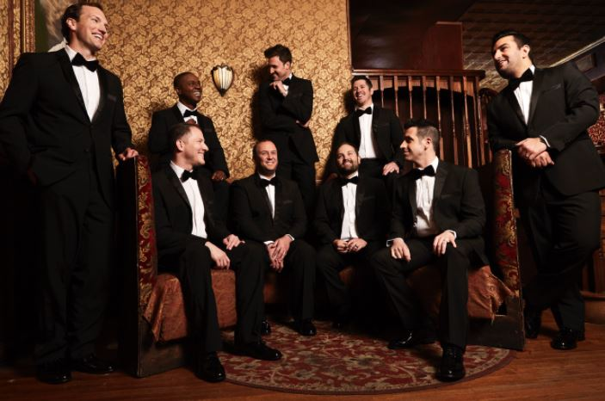
WATCH/POST: https://www.youtube.com/watch?v=MbCgvqI8_oI
PRE-ORDER EP / STREAM: https://atlantic.lnk.to/SixPackVol3PR

June 21, 2017 -- A cappella group Straight No Chaser has released a “cheeky new video” (according to Billboard) for their take on Bruno Mars’ “That’s What I Like,” which will appear on their upcoming EP, “Six Pack: Volume 3,” out July 21.
“SIX PACK: VOLUME 3” sees the world famous a cappella group cracking open a number of contemporary pop hits and classics, highlighted by “Sweet Dreams/HandClap” – their one-of-a-kind mash-up of Eurythmics’ “Sweet Dreams (Are Made Of This)” and Fitz and the Tantrums’ “HandClap” – as well their show-stopping “Beyoncé Medley.”
On July 13th, Straight No Chaser will kick off a summer co-headline tour with Scott Bradlee’s Postmodern Jukebox in in Chicago, IL, wrapping up at Denver, CO’s Red Rocks Amphitheatre on October 4.
Following that run, Straight No Chaser will kick off their fall headline tour, The Speakeasy Tour, on October 28 in Providence, RI, which will conclude on January 2, 2018 in Honolulu, HI.
See full itinerary below.
STRAIGHT NO CHASER
U.S. TOUR 2017-2018

* DOUBLE FEATURE WITH POSTMODERN JUKEBOX
† THE SPEAKEASY TOUR
JULY
13 Chicago, IL Huntington Bank Pavilion at Northerly Island *
14 Toledo, OH Toledo Zoo Amphitheatre *
15 Rochester Hills, MI Meadow Brook Amphitheatre *
16 Cleveland, OH Jacobs Pavilion at Nautica *
17 Interlochen, MI Kresge Auditorium
19 Saratoga Springs, NY Saratoga Performing Arts Center (SPAC) *
21 Holmdel, NJ PNC Bank Arts Center *
22 Boston, MA Blue Hills Bank Pavilion *
23 Wallingford, CT Toyota Oakdale Theatre *
25 Philadelphia, PA BB&T Pavilion *
27 Baltimore, MD Pier Six Pavilion *
28 Raleigh, NC Red Hat Amphitheater *
29 Greensboro, NC White Oak Amphitheatre *
30 Charlotte, NC Charlotte Metro Credit Union Amphitheatre *

AUGUST
1 Boca Raton, FL Mizner Park Amphitheatre *
2 Jacksonville, FL Daily's Place *
4 Atlanta, GA Chastain Park Amphitheatre *
5 Nashville, TN Ascend Amphitheatre *
6 Rogers, AR Walmart Amphitheatre *
8 Dallas, TX Starplex Pavilion *
9 Houston, TX Cynthia Woods Mitchell Pavilion *
11 Phoenix, AZ Comerica Theatre *
12 Los Angeles, CA Greek Theatre *
13 San Diego, CA Cal Coast Credit Union Open Air Theatre *
16 Concord, CA Concord Pavilion *
19 Meadville, PA Crawford County Fair

SEPTEMBER
27 Mason City, IA North Iowa Area Community College †
28 Madison, WI Overture Center for the Arts †
30 Anchorage, AK Atwood Concert Hall †

OCTOBER
4 Denver, CO Red Rocks Amphitheatre *
28 Providence, RI Providence Performing Arts Center †
29 Wilmington, DE Grand Opera House – MATINEE †
29 Wilmington, DE Grand Opera House – PM PERFORMANCE †
30 Richmond, VA Carpenter Theatre

NOVEMBER
1 Norfolk, VA Chrysler Hall †
3 Rochester, NY Auditorium Theatre †
8 Chattanooga, TN Tivoli Theatre †
10 N. Charleston, SC North Charleston Performing Arts Center †
11 Biloxi, MS IP Casino Resort & Spa †
14 Greenville, SC Peace Center †
15 Melbourne, FL King Center for the Performing Arts †
16 Sarasota, FL Van Wezel Performing Arts Hall †
17 Fort Myers, FL Barbara B. Mann Performing Arts Hall †
18 Tampa, FL Straz Center †
19 Asheville, NC Thomas Wolfe Auditorium †
24 St. Louis, MO Fox Theatre †
25 Cincinnati, OH Aronoff Center †
26 Louisville, KY Kentucky Center For The Arts †
28 Wichita, KS Orpheum Theatre †
29 Kansas City, MO Arvest Bank Theatre at The Midland †
30 Fort Wayne, IN Embassy Theatre †

DECEMBER
2 Evansville, IN Old National Events Plaza †
3 Cedar Falls, IA Gallagher Bluedorn Performing Arts Center †
5 Tulsa, OK Brady Theater †
6 Omaha, NE Orpheum Theater †
7 Lincoln, NE Lied Center †
8 Iowa City, IA Hancher Auditorium †
12 Pittsburgh, PA Benedum Center †
13 Pittsburgh, PA Benedum Center †
14 Columbus, OH Palace Theatre †
15 Bloomington, IN IU Auditorium †
16 Indianapolis, IN Murat Theatre – MATINEE †
16 Indianapolis, IN Murat Theatre – PM PERFORMANCE †
17 Indianapolis, IN Murat Theatre – MATINEE †
17 Indianapolis, IN Murat Theatre – PM PERFORMANCE †
23 Hershey, PA Hershey Theatre – MATINEE †
23 Hershey, PA Hershey Theatre – PM PERFORMANCE †
27 Seattle, WA Paramount Theatre †
28 Spokane, WA The Fox Theater †
29 Reno, NV Grand Sierra Resort †

JANUARY
2 Honolulu, HI Blaisdell Hall †

www.sncmusic.com/tour

