SUECO THE CHILD RECRUITS OFFSET & A BOOGIE WIT DA HOODIE FOR NEW REMIX OF MASSIVE VIRAL SINGLE “FAST”

“FAST (REMIX)” FEAT. OFFSET & A BOOGIE WITH DA HOODIE PREMIERED TODAY AS
ZANE LOWE’S WORLD FIRST ON BEATS 1

DOWNLOAD/STREAM “FAST (REMIX)” FEAT. OFFSET & A BOOGIE WIT DA HOODIE HERE

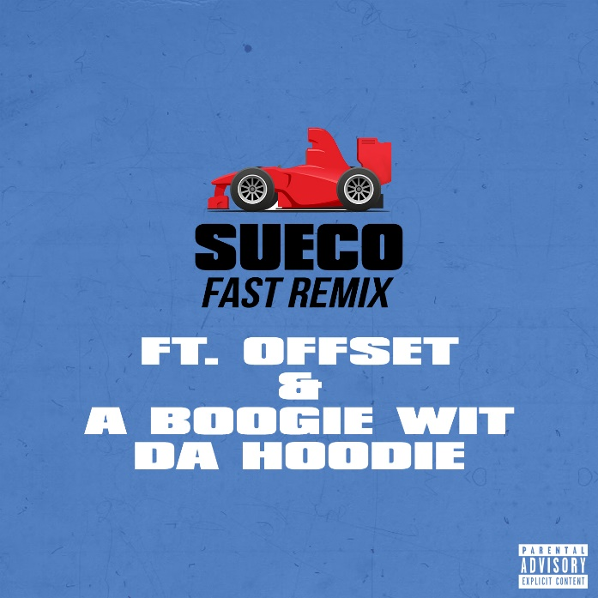
DOWNLOAD ARTWORK HERE

After racking up over 30 million global streams, Atlantic Records recording artist Sueco The Child has dropped a new remix of his viral hit single, “Fast.” Joined by hip-hop heavyweights Offset and A Boogie Wit Da Hoodie, the star-powered remix premiered today as Zane Lowe’s World First on Beats 1. “Fast (Remix)” feat. Offset & A Boogie Wit Da Hoodie is available at all DSPs and streaming services HERE.

Last week, Sueco The Child unveiled the official video for “Fast” which has garnered over 600K views in just a few days. Directed by RJ Sanchez (Migos, Travis Scott, Young Thug), the hilarious clip premiered via COMPLEX with the outlet praising, “The visual highlight's the Los Angeles artist's sense of humor while also critiquing the concept of "clout." We see Sueco & Co. running amok in a department store, posing next to cars that aren't theirs, taking up horseback riding, and making beats on a woman's buttocks.” “Fast” is now streaming at Sueco The Child’s official YouTube channel HERE.

From making beats on girls’ asses to going viral on TikTok, Sueco The Child has had an exciting year with the meteoric rise of his debut single. “Fast” initially gained momentum on TikTok just months after Sueco uploaded it to his Soundcloud, where it has since gone on to top the Spotify Global and US Viral Charts while simultaneously garnering over 30 million streams worldwide. Recently, the 22 year-old rapper dropped a follow-up track called “Fish Scale” – available at all DSPs and streaming services HERE.

The 22 year- old L.A.-based rapper recently announced his signing to Atlantic Records via Billboard where he mentioned that he was excited about the signing because he can “move out the back room of my dad’s house, I can sell my old Mini Coop[er], and I can get every single color Acne beanie."

WATCH OFFICIAL “FAST” VIDEO HERE | DOWNLOAD/STREAM “FAST” HERE
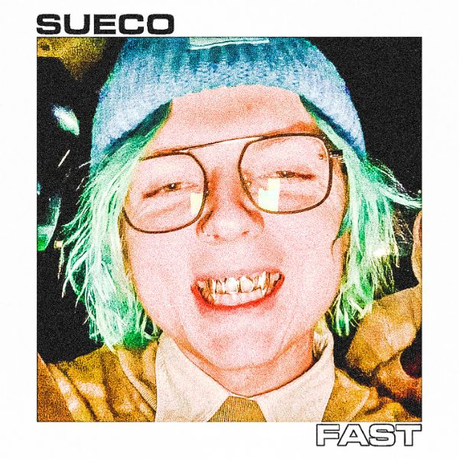

ABOUT SUECO THE CHILD
Long blue hair headbanging, grill blinging, beats buzzing, guitar humming, and eyes glazing behind thick glasses, Sueco The Child presides over a crazed carnival soundtracked by off-kilter hip-hop, punked-out presence, and pop disruption. If The Weeknd reimagined American Idiot (with a little Jack Kerouac nihilism and Taoist philosophy), it might conjure a similar sensation. Under a neon glow of genre-less ecstasy affirmed by 30 million streams and tastemaker acclaim, we find the Los Angeles singer, rapper, producer, and multi-instrumentalist as the ringmaster of a world unto himself on his 2019 Atlantic Records debut. Featured on Rolling Stone, Billboard, Genius, and more, his breakout single “Fast” rapidly doubled and tripled its streams on Spotify. Buoyed by airy production, cyber siren wails, and a driving beat from the artist himself, the track hinges on one meme-able boast after another as he claims, “Bitch I make beats and bad decisions.”

FOLLOW SUECO THE CHILD
Instagram | Twitter | Soundcloud | YouTube

