FOR IMMEDIATE RELEASE

AUGUST 15, 2016

“SUICIDE SQUAD: THE ALBUM” MAKES EXPLOSIVE DEBUT
AT NO. 1 ON BILLBOARD 200

MARKS HIGHEST-SELLING SOUNDTRACK DEBUT THIS YEAR &
LARGEST STREAMING WEEK OF ALL TIME FOR A SOUNDTRACK

COMPANION TO WARNER BROS. PICTURES’ BLOCKBUSTER
SCORES FIRST-WEEK SALES AND STREAMS IN EXCESS OF 180,000

FIRST SOUNDTRACK FROM A WARNER BROS. FILM TO EVER DEBUT AT NO. 1

GLOBAL PHENOMENON TOPS iTUNES ALBUM CHARTS IN 66 COUNTRIES

TWENTY ONE PILOTS’ “HEATHENS” CLAIMS NO. 1 SPOT ON iTUNES SINGLES CHART;
THREE TRACKS LAND IN TOP TEN

GROUNDBREAKING MUSIC VIDEOS RACK UP OVER 180 MILLION VIEWS

“SUICIDE SQUAD: THE ALBUM” AVAILABLE EVERYWHERE

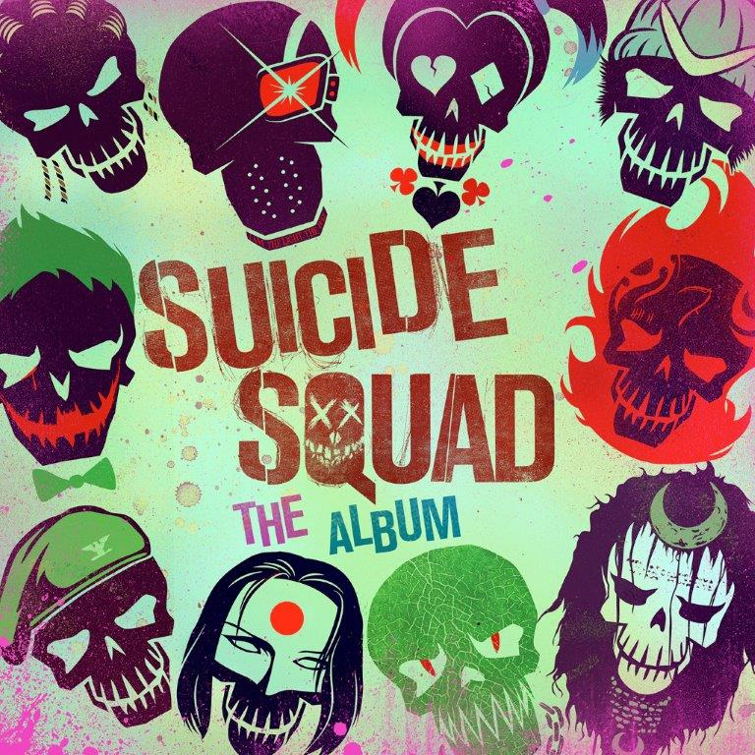

“SUICIDE SQUAD: THE ALBUM,” Atlantic Records’ massive musical companion to the Warner Bros. Pictures blockbuster, which has dominated the box office in its first two weekends of release, has made an explosive No. 1 debut atop the SoundScan/Billboard 200. The album racked up sales and streams in excess of 182,000 album equivalents, marking the highest debut for a soundtrack this year, and the largest streaming week for a soundtrack in history with over 32 million streams. “SUICIDE SQUAD: THE ALBUM” is also the first soundtrack from a Warner Bros.-distributed film to ever debut at No. 1 on the Billboard 200.

“This is an incredibly special moment for me, Atlantic Records, our partners at Warner Bros. Pictures, and the filmmakers, to see an album we all worked so tirelessly on achieve such a huge first week number,” said President of Film/TV at Atlantic Records, Kevin Weaver – the Grammy Award-winning soundtrack producer and A&R executive responsible for “SUICIDE SQUAD: THE ALBUM.” “We had a creative vision early on and remained vigilant to seeing that through to the very end. This is a true testament that great songs with a unique tone, created with the intent to become an artistic body of work – and connected to a film as massively and culturally relevant as SUICIDE SQUAD – can achieve momentous commercial success.”

“SUICIDE SQUAD: THE ALBUM” has proven itself a true global phenomenon, hitting No. 1 on the iTunes Top Overall Albums chart in 66 countries around the world, including the United States. The album boasts 14 tracks, 10 of which are brand new and exclusive to the soundtrack. All 10 new songs simultaneously landed on the iTunes Overall Singles Chart, led by the No. 1 smash, “Heathens,” from multi-platinum recording duo Twenty One Pilots; “Sucker For Pain” by Lil Wayne, Wiz Khalifa & Imagine Dragons with Logic and Ty Dolla $ign (Feat. X Ambassadors); and “Purple Lamborghini” by Skrillex & Rick Ross. “Heathens” and “Sucker For Pain,” along with Panic! At The Disco’s “Bohemian Rhapsody,” all sat within the Top 10 on the iTunes chart during the first weekend of the album’s release.

Having hit No. 1 on the iTunes chart, Twenty One Pilots’ “Heathens” is currently approaching the Top 10 on Billboard’s Hot 100. The single is also dominating the rock charts, ranking No. 1 on both Billboard’s “Rock Digital Songs” and “Rock Streaming Songs” charts. Additionally, “Heathens” is currently one of the most streamed tracks on Spotify, sitting at No. 4 on the U.S. Top 50 and at No. 5 on the Global Top 50. In addition, the track’s incredible companion video has now earned more than 103 million individual views via YouTube alone.

Meanwhile, “Sucker For Pain” by Lil Wayne, Wiz Khalifa & Imagine Dragons with Logic and Ty Dolla $ign (Feat. X Ambassadors), is proving a crossover blockbuster, debuting at No. 1 on Billboard’s “Rock Digital Songs” and “Rap Digital Songs” charts with over 67,000 downloads in its first week of release. “Sucker For Pain” is also seeing massive streaming success, currently sitting at No. 10 Spotify’s Global Top 50 chart and No. 13 on U.S. Top 50. The “Sucker For Pain” companion video is proving itself to be a massive blockbuster, boasting more than 47 million YouTube views and counting.

“Purple Lamborghini” by Skrillex & Rick Ross is currently blowing up the Internet with its masterpiece companion video, highlighted by a special appearance from SUICIDE SQUAD star Jared Leto as The Joker. The clip – directed by MTV Video Music Award-winner Colin Tilley (Kendrick Lamar, Chance the Rapper) – has over 31 million individual views at Skrillex’s official YouTube site alone. The smash single earned immediate acclaim from a wide range of media outlets upon its Zane Lowe premiere. “As dope as you could imagine,” exclaimed Billboard. “This track is a monster,” raved Stereogum.

The newest single from “SUICIDE SQUAD: THE ALBUM” is the Harley Quinn theme song “Gangsta,” performed by powerhouse R&B songstress Kehlani. Both the “Gangsta” track and video – which stars Kehlani decked out in full Harley Quinn regalia – arrived to massive critical acclaim upon their release. VIBE claims “the hard-hitting, yet sensual and emotional song finds Kehlani singing about needing some bad boys in her life,” while Paper Magazine applauds the “sultry, neon backlit video for her gorgeous Suicide Squad track.” The video has already drawn more than seven million views via YouTube in just one week.

“SUICIDE SQUAD: THE ALBUM” was produced by Atlantic Records President of Film & TV and GRAMMY® Award-winning soundtrack producer Kevin Weaver (FURIOUS 7, Boardwalk Empire, THE FAULT IN OUR STARS, Girls Volumes 1 & 2, True Blood Volumes 1 & 2); Warner Bros. Pictures Executive Vice President of Music Darren Higman (HAPPY FEET, THE GREAT GATSBY, MAD MAX: FURY ROAD); and Creative Officer of Warner Music Group and CEO of both Artist Publishing and Partner Groups, Mike Caren, who co-A&Red, with Weaver, the massively successful “FURIOUS 7: ORIGINAL MOTION PICTURE SOUNDTRACK” and has been responsible for signing more than twenty 20 gold and platinum-selling artists, including Trey Songz, T.I., Flo Rida, and Wiz Khalifa. SUICIDE SQUAD producers Charles Roven and Richard Suckle of Atlas Entertainment executive produced the album, and Season Kent (FAULT IN OUR STARS, MAGIC MIKE XXL, END OF WATCH and THE FIGHTER) and Gabe Hilfer (CREED, CENTRAL INTELLIGENCE, Blackish) served as music supervisors.

SUICIDE SQUAD is one of the year’s biggest cinematic successes, scoring the biggest August domestic debut weekend ever with grosses of $135 million. Overseas, SUICIDE SQUAD reaped $133.3 million in its debut in 57 international markets, marking the biggest August launch of any film in history. Continuing to command the box office, SUICIDE SQUAD is in theaters worldwide in both 3D and 2D, and in select IMAX 3D theaters.

For updates, please visit www.suicidesquad.com, www.facebook.com/SuicideSquad, twitter.com/suicidesquadwb (@suicidesquadwb), instagram.com/suicidesquadmovie, and atlanticrecords.com.

* * * * *

ABOUT SUICIDE SQUAD
From director David Ayer (Fury, End of Watch) comes SUICIDE SQUAD, starring Oscar-nominee Will Smith (Ali, The Pursuit of Happyness), Oscar-winner Jared Leto (Dallas Buyers Club), Margot Robbie (The Wolf of Wall Street, Focus), Joel Kinnaman (Netflix’s House of Cards) and Oscar nominee Viola Davis (The Help, Doubt).

It feels good to be bad… Assemble a team of the world’s most dangerous, incarcerated Super Villains, provide them with the most powerful arsenal at the government’s disposal, and send them off on a mission to defeat an enigmatic, insuperable entity. U.S. intelligence officer Amanda Waller has determined only a secretly convened group of disparate, despicable individuals with next to nothing to lose will do. However, once they realize they weren’t picked to succeed but chosen for their patent culpability when they inevitably fail, will the Suicide Squad resolve to die trying, or decide it’s every man for himself?

Written and directed by Ayer based on the characters from DC Comics, SUICIDE SQUAD also stars Jai Courtney (Insurgent), Jay Hernandez (Takers), Adewale Akinnuoye-Agbaje (Thor: The Dark World), Ike Barinholtz (Neighbors), Scott Eastwood (Fury), Cara Delevingne (Paper Towns), Adam Beach (Cowboys & Aliens), and Karen Fukuhara in her feature film debut. SUICIDE SQUAD is produced by Charles Roven and Richard Suckle, with Zack Snyder, Deborah Snyder, Colin Wilson and Geoff Johns serving as executive producers.

Ayer’s behind-the-scenes creative team includes director of photography Roman Vasyanov (Fury, End of Watch), production designer Oliver Scholl (Edge of Tomorrow), editor John Gilroy (Pacific Rim), costume designer Kate Hawley (The Hobbit Trilogy) and Oscar-nominated visual effects supervisor Jerome Chen (Stuart Little, Fury, The Amazing Spider-Man films). The music is by Oscar-winning composer Steven Price (Gravity).

Warner Bros. Pictures presents, an Atlas Entertainment production, a film by David Ayer, SUICIDE SQUAD. The film is distributed worldwide by Warner Bros. Pictures, a Warner Bros. Entertainment Company.

# # #

“SUICIDE SQUAD: THE ALBUM”
(Atlantic Records)

AVAILABLE EVERYWHERE NOW

TRACKLISTING

1) Skrillex & Rick Ross – “Purple Lamborghini”
2) Lil Wayne, Wiz Khalifa & Imagine Dragons with Logic and Ty Dolla $ign (Feat. X Ambassadors) - “Sucker For Pain”
3) Twenty One Pilots – “Heathens”
4) Action Bronson, Mark Ronson and Dan Auerbach (of The Black Keys) – “Standing In The Rain”
5) Kehlani – “Gangsta”
6) Kevin Gates – “Know Better”
7) Grace – “You Don't Own Me (Feat. G-Eazy)”
8) Eminem – “Without Me”
9) Skylar Grey – “Wreak Havoc”
10) Grimes – “Medieval Warfare”
11) Panic! At The Disco – “Bohemian Rhapsody”
12) War – “Slippin' Into Darkness”
13) Creedence Clearwater Revival – “Fortunate Son”
14) ConfidentialMX – “I Started A Joke (Feat. Becky Hanson)”

# # #

Sydney Margetson
212.707.2262
Sydney.Margetson@atlanticrecords.com

Chelsey Northern
818.238.6832
Chelsey.Northern@atlanticrecords.com

