**SABRINA CLAUDIO & KHALID JOIN FORCES ON**

**THE HYPNOTIC NEW SONG**

**“DON’T LET ME DOWN”**

**AVAILABLE NOW**

“Cause love is a waste of time if you and I don't do this right”

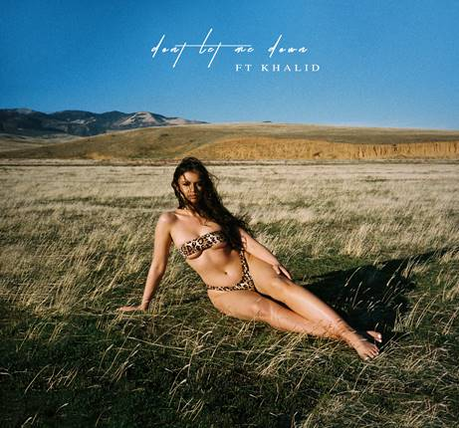

Photographer credit:  Fouad

When two of the most critically acclaimed and buzz worthy young artists come together it’s bound to create some major noise.  **Sabrina Claudio** and **Khalid** surprised fans today with the release of their sultry new song **“Don’t Let Me Down”** on SC Entertainment/Atlantic Records.The track written by Claudio and produced by Sad Money (Mikhail Beltran) is available at all digital providers and streaming providers [HERE](https://protect-us.mimecast.com/s/UAqYClYM7zcLGZRPfJMLOM).  Additionally, a YouTube audio only video is available [HERE.](https://protect-us.mimecast.com/s/qb3VCmZMyAsvXnyPfkEpGv)

“**Don’t Let Me Down”** marks the first collaboration between the two rising powerhouse talents who continue to garner praise from critics and fans alike.  Claudio says of the inspiration for the seductive song **“It’s about showing someone the vulnerable side of you and asking them, no matter what you do, just don’t prove me right – don’t give me a reason to be guarded again.”**

**“Don’t Let Me Down”** will be included as a bundle with Claudio’s highly anticipated, titillating new song **“All To You.”** The song released earlier this week is available at digital providers and streaming providers [HERE](https://protect-us.mimecast.com/s/efgPCn5NOBtnwo93tXgOOM).  MTV said the song is “so good that you might want to cancel your plans and go straight home, because it will leave you all hot and bothered.”

**About Sabrina Claudio**

**Sabrina Claudio** has been garnering much attention from fans and critics alike since she independently unveiled her debut EP ***Confidently Lost*** in 2016 on Soundcloud.  In under six months, she quietly amassed over 3 million cumulative plays.  The EP was eventually released commercially and shot to No. 3 on the iTunes R&B chart sitting only behind Khalid and The Weeknd. This was only the beginning for the Miami born and LA raised singer/songwriter whose breathy vocals immediately hypnotize and captivate.  Sabrina would follow with a 12-song collection ***About Time*** which shot to the top of R & B charts and continued to cement Claudio as one to watch.   On the heels of the new music, Sabrina was announced as **Apple’s “Up Next” Artist** and made her national TV debut with an alluring performance on ***The Late Late Show with James Corden***.   Audiences were treated to seeing Claudio’s sultry, beautiful live performances on her first ever national tour as main support for 6LACK.  Sabrina was recently featured on the ***Fifty Shades Freed Original Motion Picture Soundtrack***, with an original song called **“Cross Your Mind.”**

****

**MORE ON SABRINA CLAUDIO:**

[youtube.com/user/sabrinaclaudiomusic](https://protect-us.mimecast.com/s/wfYdCo26yDck9z2PS9zb7i)

[soundcloud.com/sabrina-claudio](https://protect-us.mimecast.com/s/_bfUCpYX2Ec5k84OUWuC_k)

[facebook.com/SabrinaClaudioMusic](https://protect-us.mimecast.com/s/OE5wCqxMZGc9B5Yki37v1R)

[twitter.com/sabrinaclaudio](https://twitter.com/sabrinaclaudio)

[instagram.com/sabrinaclaudio](https://www.instagram.com/sabrinaclaudio)