SABRINA CLAUDIO RELEASES
EMOTIONAL NEW SONG
“MESSAGES FROM HER”
AVAILABLE NOW

NEW PROJECT “NO RAIN, NO FLOWERS’ TO BE RELEASED AUGUST 15TH

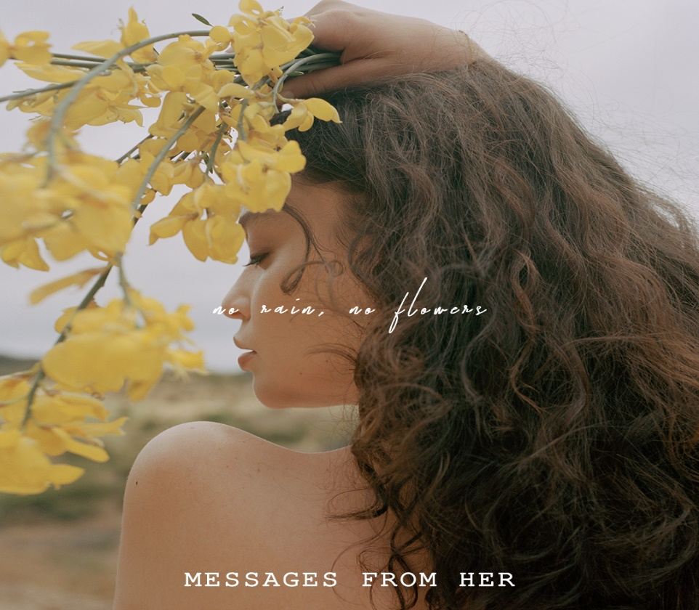
Single cover art approved for media use

Critically acclaimed singer/songwriter Sabrina Claudio returns with a highly anticipated new song Messages From Her. The very personal new song written by Claudio and produced by Sad Money (Mikhail Beltran) and Kaveh Rastegar is now available at all digital providers and streaming providers HERE and YouTube Audio Link HERE.

Claudio’s new music project No Rain, No Flowers will be released on August 15th via
SC Entertainment/Atlantic Records. On what to expect from the new project Claudio explains, “No Rain, No Flowers is an inside look into my journey of healing and growth. Rain symbolizes darkness but also represents an essential part of rebirth. If there is no rain, there are no flowers.”

Claudio says she wrote Messages From Her “during a moment of self –reflection to a happier time in my childhood where adulthood and every responsibility that is attached to it was nonexistent. Finding myself wishing I could speak to that little girl so she could give her perspective on what life and happiness are really about.” In the powerful chorus, Claudio sings, “To life when I was young; That girl inside me stays, If I am not here for me, she will be there.”

She can next be seen performing live this weekend at Lollapalooza followed by Outside Lands in San Francisco on August 11th.

About Sabrina Claudio
Sabrina Claudio has been garnering much attention from fans and critics alike since she independently unveiled her debut EP Confidently Lost in 2016 on Soundcloud. In under six months, she quietly amassed over 3 million cumulative plays. The EP was eventually released commercially and shot to No. 3 on the iTunes R&B chart sitting only behind Khalid and The Weeknd, This was only the beginning for the Miami born and LA raised singer/songwriter whose breathy vocals immediately hypnotize and captivate. Sabrina would follow with a 12 song collection About Time which shot to the top of R & B charts and continued to cement Claudio as one to watch. On the heels of the new music, Sabrina was announced as Apple’s “Up Next” Artist and made her national TV debut with an alluring performance on The Late Late Show with James Corden. Audiences were treated to seeing Claudio’s sultry, beautiful live performances on her first ever national tour as main support for 6LACK. Sabrina was featured on the Fifty Shades Freed Original Motion Picture Soundtrack, with an original song called “Cross Your Mind.” Most recently, Claudio released the titillating new song “All To You.” MTV said the song is “so good that you might want to cancel your plans and go straight home, because it will leave you all hot and bothered.”

****

MORE ON SABRINA CLAUDIO:
youtube.com/user/sabrinaclaudiomusic
instagram.com/sabrina_claudio
soundcloud.com/sabrina-claudio
twitter.com/sabrina_claudio
facebook.com/SabrinaClaudioMusic

