**SABRINA CLAUDIO SHARES FUTURISTIC VIDEO FOR “RUMORS”**

**LATEST SINGLE OFF CRITICALLY-ACCLAIMED ALBUM** [***TRUTH IS***](https://nam04.safelinks.protection.outlook.com/?url=https%3A%2F%2Flnk.to%2FTruthIsAlbumPR&data=02%7C01%7CMegan.Rasmussen%40atlanticrecords.com%7Cdd2b0bd569634f39257b08d751055ce0%7C8367939002ec4ba1ad3d69da3fdd637e%7C0%7C0%7C637066955777461696&sdata=ZZKe0KWBMgpfvlb44slNLn2jzmshQ%2BD%2F0Ohj739feKc%3D&reserved=0) **GETS AN AVANTGARDE COMPANION VISUAL**

**WATCH THE VIDEO FOR “RUMORS”** [**HERE**](https://lnk.to/Watch_Rumors)

**LARGEST NORTH AMERICAN HEADLINE “TRUTH IS TOUR” CURRENTLY UNDERWAY**

**WITH A SOLD-OUT SHOW AT HAMMERSTEIN BALLROOM IN NYC THIS FRIDAY, OCT. 18TH**

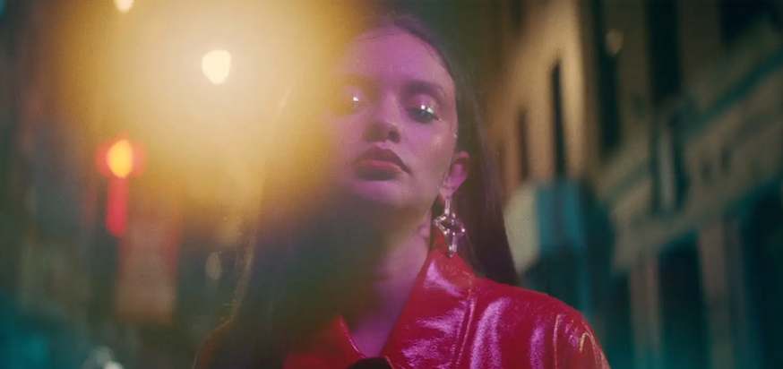

*“[Truth Is] showcases Claudio’s introspective lyrics and breathy, seductive croon”* ***–*** [**BILLBOARD**](https://nam04.safelinks.protection.outlook.com/?url=https%3A%2F%2Fwww.billboard.com%2Farticles%2Fcolumns%2Fpop%2F8532190%2Fsabrina-claudio-truth-is-album-stream-zayn&data=02%7C01%7CMegan.Rasmussen%40atlanticrecords.com%7Cdd2b0bd569634f39257b08d751055ce0%7C8367939002ec4ba1ad3d69da3fdd637e%7C0%7C0%7C637066955777461696&sdata=WCqrBOT9q0DsaboycC1mCjtIlIw5bvk%2BhkOFFUzJWW8%3D&reserved=0)

*“The truth is ‘Truth Is’ is incredible from start to finish, so do your homework and listen to everything.”* **–** [**E! ONLINE**](https://nam04.safelinks.protection.outlook.com/?url=https%3A%2F%2Fwww.eonline.com%2Fnews%2F1080029%2Fthe-mixtape-presents-justin-bieber-camila-cabello-and-more-new-music-musts&data=02%7C01%7CMegan.Rasmussen%40atlanticrecords.com%7Cdd2b0bd569634f39257b08d751055ce0%7C8367939002ec4ba1ad3d69da3fdd637e%7C0%7C0%7C637066955777471686&sdata=LO%2F1sIVVkt2H92DCgdTUQW4U0HeEhnBKhTv7SdaX4ts%3D&reserved=0)

*“Bless your ears with the songbird’s breathy, seductive vocals and vulnerable lyricism.”* **--** [**HYPEBAE**](https://nam04.safelinks.protection.outlook.com/?url=https%3A%2F%2Fhypebae.com%2F2019%2F10%2Fbest-new-music-october-summer-walker-over-it-travis-scott-highest-in-the-room&data=02%7C01%7CMegan.Rasmussen%40atlanticrecords.com%7Cdd2b0bd569634f39257b08d751055ce0%7C8367939002ec4ba1ad3d69da3fdd637e%7C0%7C0%7C637066955777471686&sdata=hbnNm%2BaI6U4vwrjWhDmdrMh%2F5O98066eRoTChd8tYSs%3D&reserved=0)

Critically-acclaimed Puerto Rican/Cuban songstress **Sabrina Claudio** recently unveiled her collaborative and empowered new body of work, [***TRUTH IS***](https://nam04.safelinks.protection.outlook.com/?url=https%3A%2F%2Flnk.to%2FTruthIsAlbumPR&data=02%7C01%7CMegan.Rasmussen%40atlanticrecords.com%7Cdd2b0bd569634f39257b08d751055ce0%7C8367939002ec4ba1ad3d69da3fdd637e%7C0%7C0%7C637066955777481685&sdata=QFjNvUlwjzQoPM%2FKCswah%2B5ubdm5YqCi1K6VtSxzCjo%3D&reserved=0)*.* Instantly, her sultry and hypnotic duet “**Rumors**” featuring **ZAYN** became a standout track. Initially accompanied by a transfixing [lyric video](https://nam04.safelinks.protection.outlook.com/?url=https%3A%2F%2Flnk.to%2FWatchRumorsPR&data=02%7C01%7CMegan.Rasmussen%40atlanticrecords.com%7Cdd2b0bd569634f39257b08d751055ce0%7C8367939002ec4ba1ad3d69da3fdd637e%7C0%7C0%7C637066955777481685&sdata=OCkj0EijE5tZ8Q%2FA%2FxmbnMzzChDwrlNk6%2BL1MZPK9cA%3D&reserved=0), the song now gains a stunningly futuristic video streaming now at Sabrina’s official YouTube channel [**HERE**](https://lnk.to/Watch_Rumors).

Sabrina’s newest album [***TRUTH IS***](https://nam04.safelinks.protection.outlook.com/?url=https%3A%2F%2Flnk.to%2FTruthIsAlbumPR&data=02%7C01%7CMegan.Rasmussen%40atlanticrecords.com%7Cdd2b0bd569634f39257b08d751055ce0%7C8367939002ec4ba1ad3d69da3fdd637e%7C0%7C0%7C637066955777491684&sdata=%2FvroYJojyTce9KW3%2FdacUqeMTHnLCfqn5zBF3p1i%2BqA%3D&reserved=0)marks the culmination of a three-year journey for Sabrina, from D.I.Y. bedroom singer and songwriter to prolific international headliner and, most importantly, a confident, conscious, and charismatic femme fatale. Having welcomed a myriad of co-writers and producers for the first time, the album sees Sabrina more vulnerable and collaborative than ever before. Notable collaborators range from esteemed songwriters **Julia Michaels** (**Justin Bieber**, **Selena Gomez**), **Simon Wilcox** (**Nick Jonas**, **Camila Cabello**), and **Stephan Moccio** to producers Stint (**Gallant, Demi Lovato**) and **Nolan Lombroza** (**Nick Jonas**, **DJ Khaled**, **Kehlani**). To honor and celebrate the incredible impact these collaborators had on both the album, and Sabrina’s personal growth, she included their portraits are prominently included on the official album artwork, the custom paintings were created by **Markedric**.

Claudio recently embarked on her biggest North American headline run to date. The “Truth Is” Tour – featuring backing from her live band and support from **Gallant** – travels the U.S. and Canada through early November. Following an incredible sold-out show at The Wiltern – with guests and friends in attendance including **Billie Eilish**, **Gallant**, **SiR** and more – Sabrina is set to play NYC’s Hammerstein Ballroom on October 18th and Sabrina’s upcoming show at London’s Brixton Electric, set for November 19th, both selling out in an instant!  For complete details and ticket information visit sabrinaclaudio.com/tour.

**LISTEN TO SABRINA’S NEW ALBUM** [***TRUTH IS***](https://nam04.safelinks.protection.outlook.com/?url=https%3A%2F%2Flnk.to%2FTruthIsAlbumPR&data=02%7C01%7CMegan.Rasmussen%40atlanticrecords.com%7Cdd2b0bd569634f39257b08d751055ce0%7C8367939002ec4ba1ad3d69da3fdd637e%7C0%7C0%7C637066955777491684&sdata=%2FvroYJojyTce9KW3%2FdacUqeMTHnLCfqn5zBF3p1i%2BqA%3D&reserved=0)

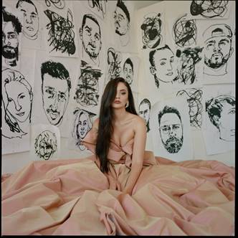

Download high res artwork [**HERE**](https://warnermusicgroup.app.box.com/s/ztrl3ls1bymamzn9q7082xtrkdiu9cab/file/518113031197)

Download additional press images [**HERE**](https://nam04.safelinks.protection.outlook.com/?url=http%3A%2F%2Fpress.atlanticrecords.com%2Fsabrina-claudio%2F&data=02%7C01%7CMegan.Rasmussen%40atlanticrecords.com%7Cdd2b0bd569634f39257b08d751055ce0%7C8367939002ec4ba1ad3d69da3fdd637e%7C0%7C0%7C637066955777501670&sdata=sa3RuJh7ZD6B3V5AG2khKi86IyzkTeCyvf%2FgsDwHgSI%3D&reserved=0)

**CONNECT:**

[youtube.com/user/sabrinaclaudiomusic](https://nam04.safelinks.protection.outlook.com/?url=https%3A%2F%2Fwww.youtube.com%2Fuser%2Fsabrinaclaudiomusic&data=02%7C01%7CMegan.Rasmussen%40atlanticrecords.com%7Cdd2b0bd569634f39257b08d751055ce0%7C8367939002ec4ba1ad3d69da3fdd637e%7C0%7C0%7C637066955777501670&sdata=4Yay8dpeCBNJPyCsd4lz26zsTELxz2bvybw%2BtvUa93k%3D&reserved=0)

[instagram.com/sabrina_claudio](https://nam04.safelinks.protection.outlook.com/?url=https%3A%2F%2Fwww.instagram.com%2Fsabrina_claudio&data=02%7C01%7CMegan.Rasmussen%40atlanticrecords.com%7Cdd2b0bd569634f39257b08d751055ce0%7C8367939002ec4ba1ad3d69da3fdd637e%7C0%7C0%7C637066955777511666&sdata=FBAWmL3RTS0hNUaAi5VIpbXkUmvq0g2XrxXYINNJpBU%3D&reserved=0)

[soundcloud.com/sabrina-claudio](https://nam04.safelinks.protection.outlook.com/?url=https%3A%2F%2Fsoundcloud.com%2Fsabrina-claudio&data=02%7C01%7CMegan.Rasmussen%40atlanticrecords.com%7Cdd2b0bd569634f39257b08d751055ce0%7C8367939002ec4ba1ad3d69da3fdd637e%7C0%7C0%7C637066955777511666&sdata=p%2F3g2dGriO%2F8S2R8azO6NUeFORV42%2FYH6Lw0xHeeVfE%3D&reserved=0)

[twitter.com/sabrina_claudio](https://nam04.safelinks.protection.outlook.com/?url=https%3A%2F%2Ftwitter.com%2Fsabrina_claudio&data=02%7C01%7CMegan.Rasmussen%40atlanticrecords.com%7Cdd2b0bd569634f39257b08d751055ce0%7C8367939002ec4ba1ad3d69da3fdd637e%7C0%7C0%7C637066955777521663&sdata=EOyhBH4Yr4C7h1J8UxBv624umnvYx03sHUU%2FrkLUwHw%3D&reserved=0)

[facebook.com/SabrinaClaudioMusic](https://nam04.safelinks.protection.outlook.com/?url=https%3A%2F%2Fwww.facebook.com%2FSabrinaClaudioMusic&data=02%7C01%7CMegan.Rasmussen%40atlanticrecords.com%7Cdd2b0bd569634f39257b08d751055ce0%7C8367939002ec4ba1ad3d69da3fdd637e%7C0%7C0%7C637066955777521663&sdata=BKblGzBGLyALly3rn089DpnVCLBc3TsmQW0ZFMTPVzE%3D&reserved=0)

**CONTACT:**

Chelsey Northern // [chelsey.northern@atlanticrecords.com](mailto:chelsey.northern@atlanticrecords.com)

Andrew George // [andrew.george@atlanticrecords.com](mailto:andrew.george@atlanticrecords.com)

**SABRINA CLAUDIO**

**ON TOUR FALL 2019**

**OCTOBER**

16 - Toronto, ON - Rebel Complex

17 - Montreal, QC - Corona Theatre

18 - New York, NY - Hammerstein Ballroom

19 - Philadelphia, PA - The Fillmore

21 - Silver Spring, MD - The Fillmore

22 - Charlotte, NC - The Fillmore

23 - Atlanta, GA - The Buckhead Theatre

25 - Fort Lauderdale, FL - Revolution

26 - Orlando, FL - The Becham Theatre

27 - Tampa, FL - The Ritz Theatre

29 - New Orleans, LA - House of Blues

30 - Austin, TX - Emo’s

31 - Dallas, TX - House of Blues

**NOVEMBER**

1 - Houston, TX - House of Blues

2 - San Antonio, TX - House of Blues

5 - Tucson, AZ - Rialto Theatre

6 - Phoenix, AZ - The Van Buren

7 - Las Vegas, NV - House of Blues

8 - San Diego, CA - Soma

17 - Manchester, UK - Academy 2

18 – London, UK – Electric Brixton

19 - London, UK – Electric Brixton

22 - Berlin, DE - Kesselhaus

24 - Paris, FR - Alhambra

25 - Amsterdam, ML - Melkweg (The Max)

26 - Antwerp, BE - Trix