**SAGE THE GEMINI ENLISTS CHRIS BROWN FOR “BUSS IT”**

**TRACK + VISUALIZER OUT NOW**

**WATCH/SHARE:** <https://youtu.be/wzFLEmPXnzI>

**BUY/STREAM:** <https://SageTheGemini.lnk.to/BussItPR>

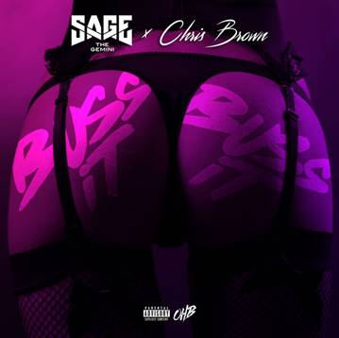

Multi-platinum rapper **Sage The Gemini** has been steadily making his return with recent releases like the energetic and charismatic video[**“4G,”**](https://www.youtube.com/watch?v=gttAvMXAkiA) and [**“Hoops Dreams”**](https://www.youtube.com/watch?v=JI5nEfvYVm0) featuring fellow Bay Area emcee Yhung T.O. With momentum behind him and with his loyal fanbase hinting at the collaboration for several weeks, Sage has officially released **“Buss It”** featuring **Chris Brown**. The explicit track mixes Sage’s evolved flow with Chris Brown’s silky smooth vocals, which includes a sample of Usher’s 1997 breakout hit “You Make Me Wanna…,” and a beat that will be stuck in your head all day. **Listen** [**here!**](https://youtu.be/wzFLEmPXnzI)

Sage’s signature touch has yielded an impressive string of smashes since he first emerged in 2013. Sage’s self-produced breakout single **“Gas Pedal” [feat. Iamsu]** went double-platinum and became his first Top 40 entry; receiving the remix treatment from none other than **Justin Bieber.** He followed up with **“Red Nose,”** also self-produced, which went platinum. His debut album, ***Remember Me***, earned critical acclaim and bowed in the **Top 50** of **Billboard’s Top 200**. He has since joined forces with **Nick Jonas** and **Flo Rida** and has toured with the likes of **Wiz Khalifa, Jeezy, Rich Homie Quan,** and **Ty Dolla $ign.**

Initiating a partnership with **Atlantic Records** in fall 2016, Sage released the single [“Now & Later”](https://youtu.be/ACPd7HSZkc0) which has racked up over **265 million** streams and **44 million** views of the official music video and counting. In July 2017, Sage went on to release his mixtape ***Morse Code*,** which features **Kap G, Show Banga, Kent Jones,** and **Lil Yase** and fan favorite tracks “Now and Later”, “Reverse”, and “Watchachacha”. In July, Sage released [“4G”](https://youtu.be/gttAvMXAkiA) with an official music video, and “[Hoop Dreams](https://www.youtube.com/watch?v=JI5nEfvYVm0)” ft. Yhung T.O was released early August.

FOR MORE ON SAGE THE GEMINI, PLEASE VISIT:

[WEBSITE](https://www.sagethegeminiofficial.com/) I [FACEBOOK](https://protect-us.mimecast.com/s/CZ-hCBBR6xTER4DNF6CG_l) I [TWITTER](https://protect-us.mimecast.com/s/ipigCDkJ8zcgJVoZuApJZp) I [YOUTUBE](https://protect-us.mimecast.com/s/PJkMCER6xAFR0DljIPiB93) I [ATLANTICRECORDS.COM](https://protect-us.mimecast.com/s/mwPcCG6Q8DhjOMB9ukMDqM)

# # #

Press inquiries: Corey Brewer – [Corey.Brewer@atlanticrecords.com](mailto:Corey.Brewer@atlanticrecords.com)