**SAGE THE GEMINI DROPS NEW TRACK “HOOP DREAMS” FEATURING YHUNG T.O.**

**WATCH/SHARE:** <https://youtu.be/JI5nEfvYVm0>

**BUY/STREAM:** <https://SageTheGemini.lnk.to/HoopDreams>

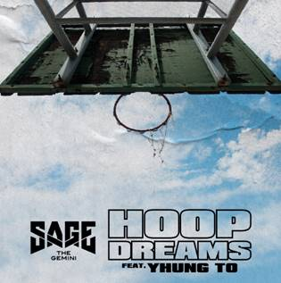

Multi-platinum rapper **Sage The Gemini** has collaborated with buzz-worthy **Yhung T.O.** for his newest track out today, **“Hoop Dreams”.** Listen [here!](https://youtu.be/JI5nEfvYVm0) The single features a tinging back beat, rolling lyrics, and Yhung T.O. adding his flair to the track. Sage raps, “My mama wanted me to be a baller but I ball a different way.”

***Pitchfork*** recently said of Yhung T.O., “… it’s the melancholy in Yhung T.O.’s melodies that make him special.” Yhung T.O. is a part of the California rap group **SOB x RBE** (DaBoii, Yhung T.O., Slimmy B, and Lul G). They formed in 2016 and are already well on their way, opening for **Post Malone** and **21 Savage** on their 2018 tour and releasing a mixtape and album. Yhung T.O. also signed with **Interscope** as a solo artist and his album titled ***Misunderstood***is on the way.

Sage’s signature touch has yielded an impressive string of smashes since he first emerged in 2013. Sage’s self-produced breakout single **“Gas Pedal” [feat. Iamsu]** went double-platinum and became his first Top 40 entry; receiving the remix treatment from none other than **Justin Bieber.** He followed up with **“Red Nose,”** also self-produced, which went platinum. His debut album, ***Remember Me***, earned critical acclaim and bowed in the **Top 50** of **Billboard’s Top 200**. He has since joined forces with **Nick Jonas** and **Flo Rida** and has toured with the likes of **Wiz Khalifa, Jeezy, Rich Homie Quan,** and **Ty Dolla $ign.**

Initiating a partnership with **Atlantic Records** in fall 2016, Sage released the single [“Now & Later”](https://youtu.be/ACPd7HSZkc0) which has racked up over **265 million** streams and **44 million** views of the official music video and counting. In July 2017, Sage went on to release his mixtape ***Morse Code*,** which features **Kap G, Show Banga, Kent Jones,** and **Lil Yase** and fan favorite tracks “Now and Later”, “Reverse”, and “Watchachacha”. His most recent release, [“4G”](https://youtu.be/gttAvMXAkiA) received an official music video last month.

FOR MORE ON SAGE THE GEMINI, PLEASE VISIT:

[WEBSITE](https://www.sagethegeminiofficial.com/) I [FACEBOOK](https://protect-us.mimecast.com/s/CZ-hCBBR6xTER4DNF6CG_l) I [TWITTER](https://protect-us.mimecast.com/s/ipigCDkJ8zcgJVoZuApJZp) I [YOUTUBE](https://protect-us.mimecast.com/s/PJkMCER6xAFR0DljIPiB93) I [ATLANTICRECORDS.COM](https://protect-us.mimecast.com/s/mwPcCG6Q8DhjOMB9ukMDqM)

# # #

Press inquiries: Corey Brewer – [Corey.Brewer@atlanticrecords.com](mailto:Corey.Brewer@atlanticrecords.com)