FOR IMMEDIATE RELEASE
JUNE 19, 2017

SAGE THE GEMINI ANNOUNCES “MORSE CODE”

ACCLAIMED BAY AREA RAPPER ANNOUNCES EAGERLY AWAITED MIXTAPE

NEW TRACK, “REVERSE,” PREMIERED VIA THE FADER

EUROPEAN HEADLINE TOUR SET FOR SEPTEMBER

“MORSE CODE” ARRIVES FRIDAY, JULY 14TH AT ALL DSPS AND STREAMING SERVICES

Global Gemini/HBK Gang/Atlantic recording artist Sage The Gemini has announced the release of his eagerly awaited new mixtape. “MORSE CODE” will arrive at all digital music retailers and streaming services on Friday, July 14th.

The Bay Area-based rapper is celebrating “MORSE CODE” with the release of the electrifying new single. “Reverse” premiered exclusively via The FADER and is available at all DSPs and streaming services.

“MORSE CODE” was previously heralded by the recently released track, “Pilot,” on sale now at all digital music retailers and streaming services. The track – produced by HBK Gang founding member P-Lo – is streaming now at Sage The Gemini’s official YouTube.

“MORSE CODE” follows Sage The Gemini’s 2016 worldwide smash hit, “Now and Later,” currently certified platinum in Australia and Canada, gold in Denmark, Germany, Italy, and New Zealand, and silver in the United Kingdom. The single – which was featured in a hugely popular Snapchat lens, at its peak the #2 most used lens with over 4 billion total plays and 10 million daily plays – is accompanied by a blockbuster companion visual, now with over 33 million individual views at Sage The Gemini’s official YouTube alone.

Sage The Gemini has unveiled plans for a major European tour, including stops in Germany, the United Kingdom, France, Belgium, Sweden, Norway, Denmark, the Netherlands, Austria, and Finland. Additional live dates will be announced soon – please visit www.sagethegeminiofficial.com/tour for updates.

Sage The Gemini debuted in 2008 with the viral smash hit, “You Should Know,” earning more than 3 million worldwide spins. 2013 saw the Fairfield, CA native unite with the Bay Area’s influential HBK Gang collective for the 2x RIAA platinum certified hit single, “Gas Pedal (Feat. IAMSU!).” The track proved a crossover sensation, reaching the top 5 on Billboard’s “Hot Rap Songs,” the top 10 on “Hot R&B/Hip-Hop Songs,” and #29 on the overall “Hot 100” – Sage’s first-ever top 40 success. Furthermore, the “Gas Pedal” companion video was an online blockbuster, now with over 98 million individual YouTube views alone.

“Red Nose” followed, earning RIAA platinum, “Hot 100” chart placement, and nearly 100 million individual YouTube views. Both “Red Nose” and Gas Pedal” were then included on the “GAS PEDAL” EP, a top 30 chart success upon its 2013 release. “REMEMBER ME,” Sage’s acclaimed debut album, dropped the next year and immediately entered the SoundScan/Billboard 200 at #47 amidst ecstatic press coverage and critical attention.

2015 saw the arrival of “Good Thing (Feat. Nick Jonas),” once again rocking Billboard’s “Hot 100” and drawing close to 21 million YouTube views. As if that weren’t enough, Sage The Gemini has proven an increasingly in-demand featured artist, with appearances including Flo Rida’s 3x RIAA certified platinum single, “G.D.F.R. (Feat. Sage the Gemini & Lookas).” A #1 smash on the iTunes Store’s “Top Hip-Hop/Rap Songs” chart, the track – which is also included on Atlantic’s worldwide #1 “FURIOUS 7 – ORIGINAL MOTION PICTURE SOUNDTRACK” – proved another huge hit for Flo Rida, reaching the top 3 on Billboard’s “Hot R&B/Hip-Hop Songs” while also ranking among the top 10 in multiple countries around the world. What’s more, the “G.D.F.R. (Feat. Sage the Gemini & Lookas)” companion video – directed by Malcolm Jones (R. Kelly, Chris Brown) – has logged more than 278 million individual YouTube views this far.

Sage The Gemini recently joined forces with two fellow superstars for Jeremih, Ty Dolla $ign, & Sage The Gemini’s “Don't Get Much Better,” featured on Artist Partner Group, Atlantic Records and Universal Pictures’ chart-topping “THE FATE OF THE FURIOUS: THE ALBUM.” The official musical companion to THE FATE OF THE FURIOUS is available now at all retailers and streaming outlets.
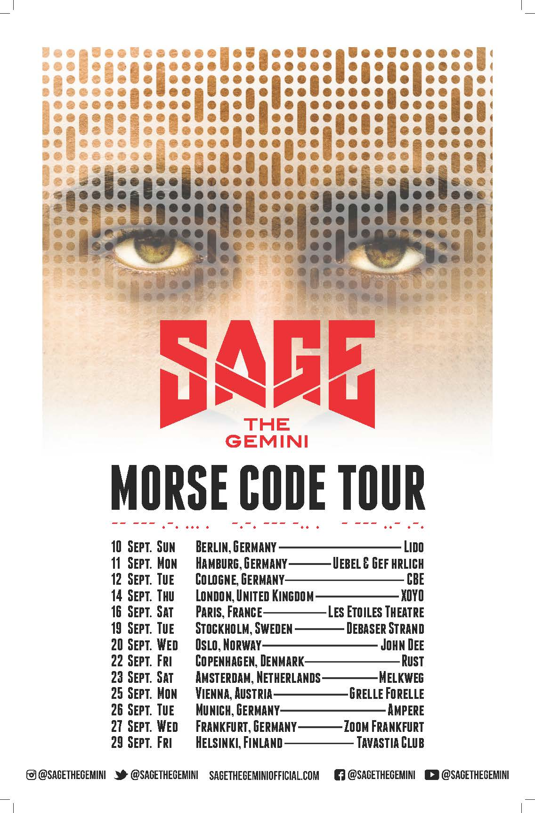

For additional news and information, please see sagethegeminiofficial.com, twitter.com/SageTheGemini (@SageTheGemini), facebook.com/SageTheGemini, instagram.com/sagethegemini, youtube.com/user/sagethegemini, and www.atlanticrecords.com.

Contact
Ashley Kalmanowitz
212-707-2051
Ashley.Kalmanowitz@atlanticrecords.com

