Shelley FKA DRAM RELEASES VISUAL FOR “ALL PRIDE ASIDE”
FROM LONG-AWAITED NEW ALBUM ‘Shelley FKA DRAM’ OUT TODAY

WATCH HERE

MULTIPLE GRAMMY-NOMINATED SINGER/SONGWRITER BRINGS BACK SOULFUL R&B WITH STUNNING NEW ALBUM
BOASTING COLLABORATIONS WITH SUMMER WALKER, H.E.R., ERYKAH BADU & WATT

Download/Stream “Shelley FKA DRAM” Here

“If D.R.A.M. was the ploy to break into the music industry, then Shelley is the longevity play.” - NPR

“…the star is exactly where he wants to be.” - BILLBOARD

“…he’s still got that same soulful, smooth voice…” - VULTURE

“…feels as textured as crushed velvet…” - NOISEY

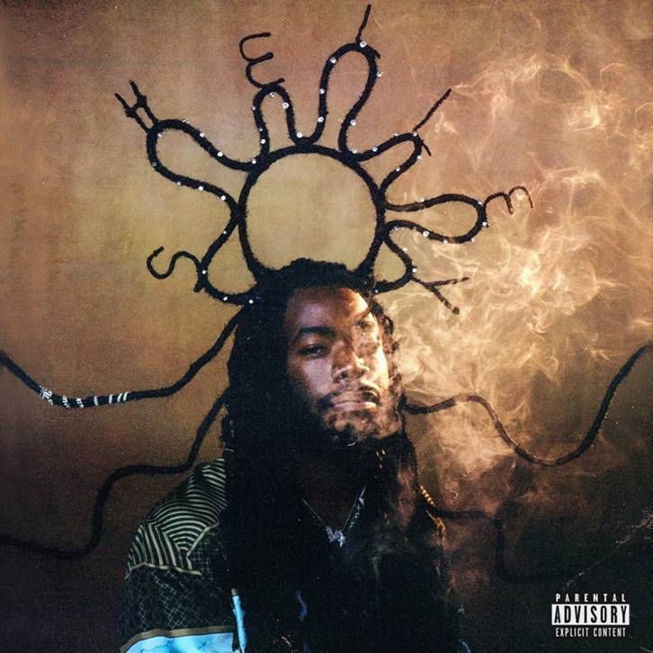

Shelley FKA DRAM Tracklist:
1. All Pride Aside with Summer Walker
2. Exposure
3. Something About Us
4. Beautiful
5. The Lay Down with H.E.R. & Watt
6. 93’ Acura Vigor with Erykah Badu
7. Married Woman
8. Cooking With Grease
9. Remedies
10. Rich & Famous

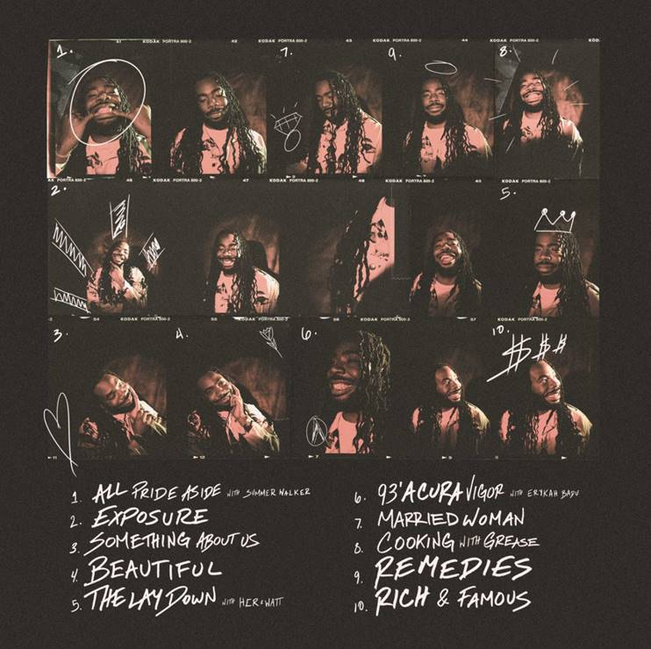

Watch Shelley’s Captivating NPR Tiny Desk Concert

Additional Must-See Performances/Videos:
Performance of “Exposure” on The Late Show with Stephen Colbert
“Cooking With Grease” music video
“Exposure” music video
“The Lay Down” music video

More from Shelley FKA DRAM:
“The Shelley Show At Night”: Episode 1 | Episode 2
“Cooking With Grease” Cooking Show: Episode 1 | Episode 2

About Shelley FKA DRAM
After the release of his critically-acclaimed debut album, Big Baby D.R.A.M., multiple GRAMMY nominee Shelley FKA DRAM has spent the past few years not only working on new music, but most importantly working on himself. Ever since he was introduced to the world with his songs, “Cha Cha,” and “Broccoli,” the multi-platinum singer’s career has taken him on a journey enabling him to meet people like Rick Rubin, Snoop Dogg, Beyoncé and Erykah Badu. He’s traveled the globe, toured with Kendrick Lamar and performed at Coachella. After getting wrapped up in the fast life with no breaks, he took some time to focus on improving his health, voice and personal growth. Now it’s time for everyone to meet him: Shelley.

For all press inquiries, please contact: Jason Davis – Jason.Davis@atlanticrecords.com

* * *

