**SHELLEY FKA DRAM PERFORMS “EXPOSURE” ON**

**THE LATE SHOW WITH STEPHEN COLBERT**

**Multi-platinum, multiple GRAMMY nominated singer brings soulful new single to late night TV,**

**from the set of *The Shelley Show At Night***

**Self-titled album, ‘*Shelley FKA DRAM’*, due out April 30**

[**WATCH HERE**](https://nam04.safelinks.protection.outlook.com/?url=https%3A%2F%2Fwww.youtube.com%2Fwatch%3Fv%3DlyPhShlEgSg&data=04%7C01%7CBrian.Sommer%40atlanticrecords.com%7C89251f79124949a9df1808d8fe8cc394%7C8367939002ec4ba1ad3d69da3fdd637e%7C0%7C0%7C637539227818461515%7CUnknown%7CTWFpbGZsb3d8eyJWIjoiMC4wLjAwMDAiLCJQIjoiV2luMzIiLCJBTiI6Ik1haWwiLCJXVCI6Mn0%3D%7C1000&sdata=6AFf5P222yTsZeBMp0HgwiPaoRJOas2oeQOf8oJ2vEI%3D&reserved=0)



[**PRE-ORDER *Shelley FKA DRAM***](https://nam04.safelinks.protection.outlook.com/?url=https%3A%2F%2Fshelley.lnk.to%2FShelleyFKADRAM&data=04%7C01%7CBrian.Sommer%40atlanticrecords.com%7C89251f79124949a9df1808d8fe8cc394%7C8367939002ec4ba1ad3d69da3fdd637e%7C0%7C0%7C637539227818471510%7CUnknown%7CTWFpbGZsb3d8eyJWIjoiMC4wLjAwMDAiLCJQIjoiV2luMzIiLCJBTiI6Ik1haWwiLCJXVCI6Mn0%3D%7C1000&sdata=lcWXxeQXAGaJkTxqYgmvY1iX70LRNh6ROVICD8gYfbw%3D&reserved=0)

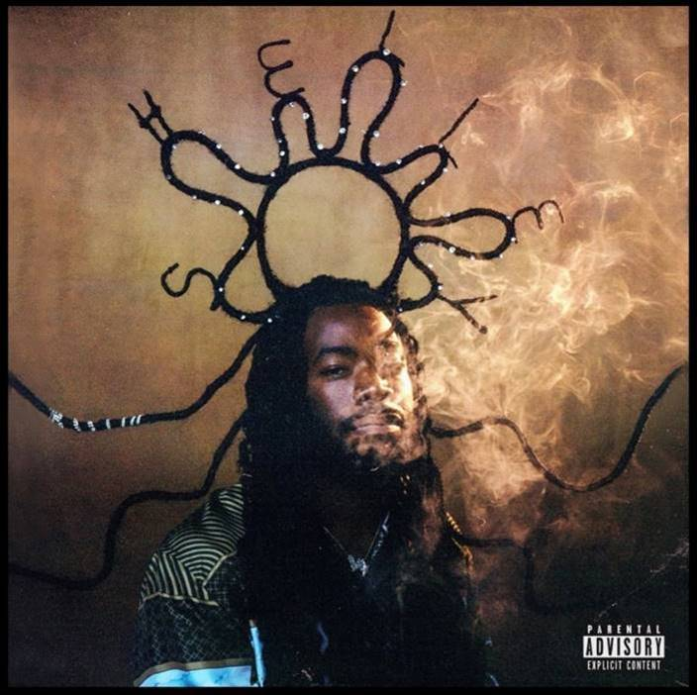

**WATCH:**

[“THE SHELLEY SHOW” TRAILER](https://nam04.safelinks.protection.outlook.com/?url=https%3A%2F%2Fwww.youtube.com%2Fwatch%3Fapp%3Ddesktop%26v%3DMfnmlbgQFmk%26feature%3Dyoutu.be&data=04%7C01%7CBrian.Sommer%40atlanticrecords.com%7C89251f79124949a9df1808d8fe8cc394%7C8367939002ec4ba1ad3d69da3fdd637e%7C0%7C0%7C637539227818471510%7CUnknown%7CTWFpbGZsb3d8eyJWIjoiMC4wLjAwMDAiLCJQIjoiV2luMzIiLCJBTiI6Ik1haWwiLCJXVCI6Mn0%3D%7C1000&sdata=%2BrFv4pqqLcoxLoUfgbxLZBfNJX0Z0apECRfo%2B06HiZU%3D&reserved=0)

[“EXPOSURE” MUSIC VIDEO](https://nam04.safelinks.protection.outlook.com/?url=https%3A%2F%2Fwww.youtube.com%2Fwatch%3Fv%3D6KptcBY7HKw&data=04%7C01%7CBrian.Sommer%40atlanticrecords.com%7C89251f79124949a9df1808d8fe8cc394%7C8367939002ec4ba1ad3d69da3fdd637e%7C0%7C0%7C637539227818481500%7CUnknown%7CTWFpbGZsb3d8eyJWIjoiMC4wLjAwMDAiLCJQIjoiV2luMzIiLCJBTiI6Ik1haWwiLCJXVCI6Mn0%3D%7C1000&sdata=4dxlDEurcl8al4ryzGUMtl7KS4ho9dRTj3pW%2BbDlybg%3D&reserved=0)

“[COOKING WITH GREASE” MUSIC VIDEO](https://nam04.safelinks.protection.outlook.com/?url=https%3A%2F%2Fwww.youtube.com%2Fwatch%3Fv%3Dnv6kvAXHFnA&data=04%7C01%7CBrian.Sommer%40atlanticrecords.com%7C89251f79124949a9df1808d8fe8cc394%7C8367939002ec4ba1ad3d69da3fdd637e%7C0%7C0%7C637539227818491499%7CUnknown%7CTWFpbGZsb3d8eyJWIjoiMC4wLjAwMDAiLCJQIjoiV2luMzIiLCJBTiI6Ik1haWwiLCJXVCI6Mn0%3D%7C1000&sdata=lyGaUX2hmP5Q8vXUNOfkkDxOlIHdYkVMZJKPcCqpwGs%3D&reserved=0)

“[COOKING WITH GREASE” WEB SERIES](https://nam04.safelinks.protection.outlook.com/?url=https%3A%2F%2Fwww.youtube.com%2Fwatch%3Fv%3DbN1y9ypUPas&data=04%7C01%7CBrian.Sommer%40atlanticrecords.com%7C89251f79124949a9df1808d8fe8cc394%7C8367939002ec4ba1ad3d69da3fdd637e%7C0%7C0%7C637539227818491499%7CUnknown%7CTWFpbGZsb3d8eyJWIjoiMC4wLjAwMDAiLCJQIjoiV2luMzIiLCJBTiI6Ik1haWwiLCJXVCI6Mn0%3D%7C1000&sdata=cxwmUYOLrgGI4t9kk5G2WoIhwggy0nmFihnV7XdnhV0%3D&reserved=0)

* * *

Photo Credit: Alex Harper

**About Shelley FKA DRAM**

After the release of his critically-acclaimed debut album, *Big Baby D.R.A.M.*, multiple GRAMMY nominee Shelley FKA DRAM has spent the past few years not only working on new music, but most importantly working on himself. Ever since he was introduced to the world with his songs, “Cha Cha,” and “Broccoli,” the multi-platinum singer’s career has taken him on a journey enabling him to meet people like Rick Rubin, Snoop Dogg, Beyoncé and Erykah Badu. He’s traveled the globe, toured with Kendrick Lamar and performed at Coachella. After getting wrapped up in the fast life with no breaks, he took some time to focus on improving his health, voice and personal growth. Now it’s time for everyone to meet him: Shelley.

* * *

For all press inquiries, please contact: Jason Davis – [Jason.Davis@atlanticrecords.com](mailto:Jason.Davis@atlanticrecords.com)