**Shelley FKA DRAM SERVES UP NEW SONG**

**“COOKING WITH GREASE”**

**ARRIVES TODAY ALONGSIDE CHRISTIAN SUTTON-DIRECTED COMPANION VISUAL**

**Multiplatinum, GRAMMY-nominated artist’s new song arrives accompanied by new cooking series of the same title**

**Shelley’s new self-titled album**

***‘Shelley FKA DRAM’***

**OUT APRIL 16TH**

[**WATCH “COOKING WITH GREASE” MUSIC VIDEO**](https://www.youtube.com/watch?v=nv6kvAXHFnA)

[**DOWNLOAD/STREAM “COOKING WITH GREASE”**](https://shelley.lnk.to/CookingWithGrease)

[PRE-ORDER ‘Shelley FKA DRAM’](https://shelley.lnk.to/ShelleyFKADRAM)



*“When it comes to grease, I’ll be cooking with it. So, whenever you’re ready to be entertained and learn a little bit of game or how to cook just the same, stick with me: Chef Shelley!”*



Directed by: Christian Sutton

Creative Direction by: Steven Othello

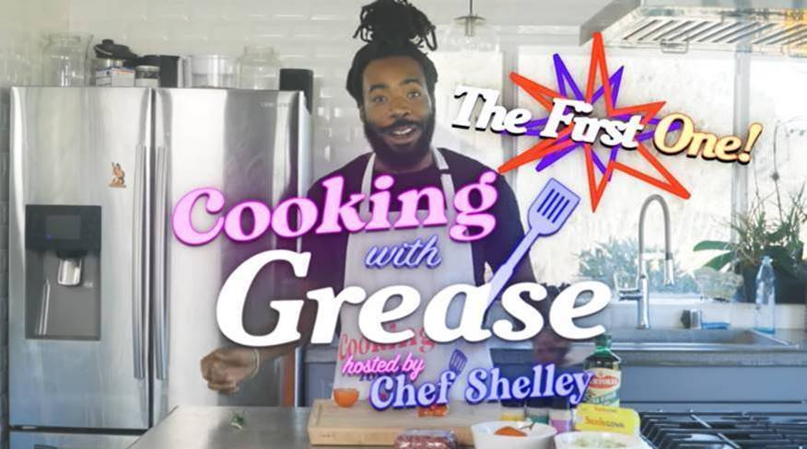



“Cooking With Grease” written by: Shelley FKA DRAM, Jack Rochon & Aaron Paris

Produced by: Jack Rochon

Additional Production by: Aaron Paris

***

[**DOWNLOAD/STREAM “EXPOSURE”**](https://nam04.safelinks.protection.outlook.com/?url=https%3A%2F%2Fshelley.lnk.to%2FExposure&data=04%7C01%7CBrian.Sommer%40atlanticrecords.com%7Caaf5d578b52245ba62c108d8f0734885%7C8367939002ec4ba1ad3d69da3fdd637e%7C0%7C0%7C637523725239526671%7CUnknown%7CTWFpbGZsb3d8eyJWIjoiMC4wLjAwMDAiLCJQIjoiV2luMzIiLCJBTiI6Ik1haWwiLCJXVCI6Mn0%3D%7C1000&sdata=avT0N%2F5b7uy2miDbWf9xeRMSlh7Fcc%2Bf9Uj8nV7GCLM%3D&reserved=0)

Directed by: Christian Sutton

Creative Direction by: Steven Othello

**+** [**WATCH THE TRAILER FOR “THE SHELLEY SHOW”**](https://nam04.safelinks.protection.outlook.com/?url=https%3A%2F%2Fwww.youtube.com%2Fwatch%3Fapp%3Ddesktop%26v%3DMfnmlbgQFmk%26feature%3Dyoutu.be&data=04%7C01%7CBrian.Sommer%40atlanticrecords.com%7Caaf5d578b52245ba62c108d8f0734885%7C8367939002ec4ba1ad3d69da3fdd637e%7C0%7C0%7C637523725239546657%7CUnknown%7CTWFpbGZsb3d8eyJWIjoiMC4wLjAwMDAiLCJQIjoiV2luMzIiLCJBTiI6Ik1haWwiLCJXVCI6Mn0%3D%7C1000&sdata=dtKIn6BxuyZka3MdFAcArvnp8bsEtQPRrhOzY1E0R8E%3D&reserved=0)

Photo Credit: Alex Harper

For all press inquiries, please contact: Jason Davis – [Jason.Davis@atlanticrecords.com](mailto:Jason.Davis@atlanticrecords.com)