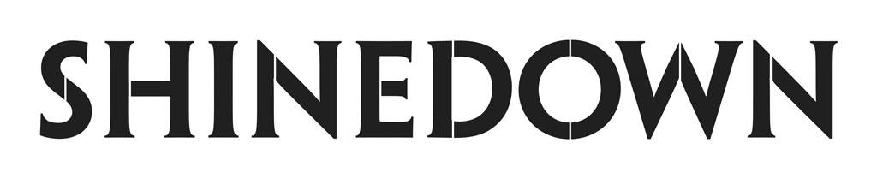

**Scores 16th #1 at Rock Radio with** [**"ATTENTION ATTENTION"**](https://shinedown.lnk.to/watchATTENTIONATTENTION)

**and**

**Fourth Consecutive #1 from Latest Studio Album**

***ATTENTION ATTENTION* Out Now Via Atlantic Records**

[**"DEVIL"**](https://www.youtube.com/watch?v=_AsPY1bQx70&feature=youtu.be) **Is Certified RIAA Gold**

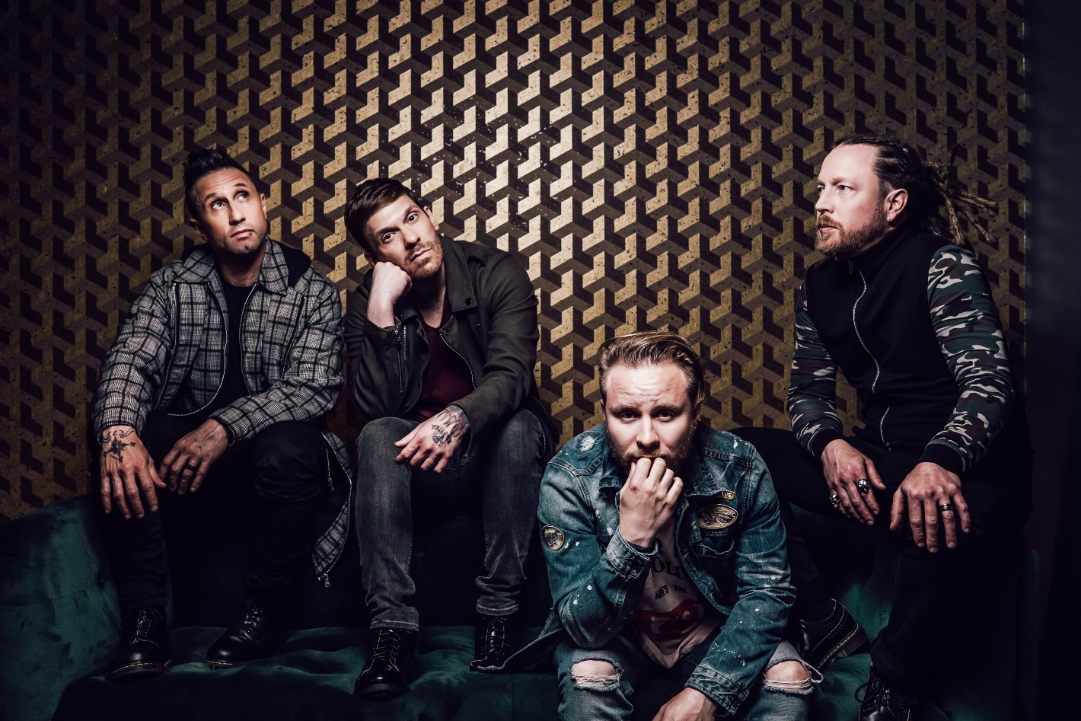   
(Photo Credit: Sanjay Parikh)

*New York, NY – [January 28, 2020] –* Multi-platinum band **Shinedown** has notched their **16th #1 single** on the **Mediabase Active Rock Chart** and their **15th #1 single on the Billboard Mainstream Rock Songs Chart** with their hit song **“ATTENTION ATTENTION.”** The band has now tied the **record for the most #1s ever on both of these charts.** [**PRESS HERE**](https://shinedown.lnk.to/watchATTENTIONATTENTION) **to watch the “ATTENTION ATTENTION” video**, directed by **Bill Yukich** (Beyoncé, Marilyn Manson, Wiz Khalifa).

**“ATTENTION ATTENTION”** is **Shinedown**’s **fifth consecutive #1** following [**"How Did You Love"**](https://www.youtube.com/watch?v=GA1Sm3tvS0c)from their album ***Threat To Survival***, and **“**[**DEVIL**](https://www.youtube.com/watch?v=_AsPY1bQx70&feature=youtu.be)**,” “**[**GET UP**](https://www.youtube.com/watch?v=RcohgARJTWQ&feature=youtu.be)**,”** **and “**[**MONSTERS**](https://www.youtube.com/watch?v=J6sIK2KnhH8&feature=youtu.be)**”** all from their latest critically acclaimed studio album [***ATTENTION ATTENTION***](https://lnk.to/AttentionAttention)**(Atlantic Records),** which **simultaneously hit #1 on Billboard’s Alternative, Top Rock, and Hard Rock Albums Charts,** and **debuted Top 5 on the Billboard 200**. Shinedown has amassed over **2.4 billion collective track streams** and has racked up **324 million global streams** for ***ATTENTION ATTENTION***.

**Every one of Shinedown’s 26 consecutive singles has reached the Top 5 on the Billboard Mainstream Rock Songs airplay chart** - an unparalleled achievement – and they **continue to hold the record for the most Top 5s ever on this chart**. **“ATTENTION ATTENTION”** also **ties the band for the second most Top 10s ever on this chart.**

Additionally**, “DEVIL” was recently certified gold by the RIAA.**

**Shinedown** was also recently nominated for **two iHeart Radio Music Awards** including **Rock Song of the Year** for **#1 rock hit “MONSTERS”** and **Rock Artist of the Year.** The iHeart Radio Music Awards which will air on **FOX** live from **The Shrine** in **Los Angeles** on **March 29th** at **8/7c.**

The band will kick off their **Shinedown: Deep Dive** Tour, an intimate run of Spring 2020 dates that will see the band diving into their extensive catalog to perform an array of deep cuts and B-sides along with their biggest hits. The tour will include stops in **Memphis, Houston, Austin, back-to-back nights at the House of Blues in Dallas, San Francisco, Los Angeles** at the legendary venue **The Wiltern,** and more. Shinedown will also make headlining festival appearances at **98 Rockfest** in **Tampa**, **Earthday Birthday** in **Orlando**, and **Musikfest** in **Bethlehem, PA.** Full routing below. For more details, please visit [**www.shinedown.com**](http://www.shinedown.com).

**MORE ON SHINEDOWN & *ATTENTION ATTENTION***  
Multi-platinum, record-breaking band **Shinedown - Brent Smith [vocals], Zach Myers [guitar], Eric Bass [bass, production] and Barry Kerch [drums]** - have sold **more than 10 million albums and 10 million singles** worldwide, earned **14 platinum and gold singles, five platinum and gold album, 16 #1 Active Rock hits**, and amassed **more than 2.4 billion total streams**. The story that unfolds on their latest album ***ATTENTION ATTENTION*****(Atlantic Records)** is an enduring statement about the resolve of the human spirit – touching on themes such as mental health, overcoming struggles and not being afraid to fail and the importance of our human connection with one another. Speaking to the human spirit in a time of need, **“GET UP”** quickly became a crossover hit and a beacon of light for listeners around the globe with its urgent and universal message of hope, empathy and encouragement. The album has received major media acclaim from the likes of ***Live with Kelly & Ryan, Huffington Post, Forbes, Salon, Billboard, Consequence of Sound, Buzzfeed, Grammy.com, Parade, Popdust***and more, and landed the band a slot in **92Y’s prestigious talk series, 92Y Talks**. **Shinedown**’s distinct mix of explosive rock ‘n’ roll spirit, thought-provoking lyrics, melodic sensibility and cinematic flourishes colors ***ATTENTION ATTENTION***. Hailed for their high-octane live shows, **Shinedown** continues to engender diehard love from millions of global fans and has racked up countless sold-out tours and festival headlining sets, propelled by their world-class showmanship and the undeniable power of front man **Brent Smith**’s voice.

**PRAISE FOR SHINEDOWN & *ATTENTION ATTENTION***

“Smith’s lyrics reflect a shared experience…pain can be a universal human experience and that sense of unconditional support and solidarity is the driving factor behind the song…” - ***Salon***

“Emotional and personal…cinematic and nuanced…” -***HuffPost***

“...[ATTENTION ATTENTION is] a deeply confessional brilliant piece of work...most rock bands don’t possess what Shinedown does — unfathomable talent, an unwavering fan base and unbridled tenacity.” - ***Buzzfeed***

“Shinedown is on the cusp of adding to its legend…” – ***Billboard***

“…conviction, authenticity, and real life intensity. Brent Smith and Shinedown are familiar purveyors of all those artistic qualities.” - ***No Depression***

“Shinedown have a knack for crafting rock anthems…” - ***Consequence of Sound***

**SHINEDOWN TOUR DATES**

April 15 Chattanooga, TN @ Tivoli Theatre

April 17 Tampa, FL @ WXTB 98 Rockfest at Amalie Arena

April 18 Orlando, FL @ WJRR Earthday Birthday at Central Florida Fairground

April 19 Columbia, SC @ Township Auditorium

April 21 Greensboro, NC @ Piedmont Hall

April 22 Savannah, GA @ Johnny Mercer Theater

April 25 Memphis, TN @ Orpheum Theatre

April 26 Little Rock, AR @ Robinson Center

April 28 Louisville, KY @ Louisville Palace

May 1 Lake Charles, LA @ Golden Nugget Casino

May 2 Houston, TX @ Revention Music Center

May 3 Austin, TX @ ACL Live at The Moody Theater

May 5 Dallas, TX @ House of Blues

May 6 Dallas, TX @ House of Blues

May 8 Tulsa, OK @ The Joint at Hard Rock Hotel & Casino  
May 9 Maryland Heights, MO @ Pointfest

May 11 Midland, TX @ Wagner Noel Performing Arts Center

May 12 El Paso, TX @ Plaza Theater

May 14 Los Angeles, CA @ The Wiltern

May 15 Indio, CA @ Fantasy Springs Resort Casino – Special Event Center

May 16 Valley Center, CA @ Harrah’s Resort Southern California – The Events Center

May 18 San Francisco, CA @ The Warfield

May 19 Las Vegas, NV @ The Pearl

August 4 Bethlehem, PA @ Musikfest

August 6 Davenport, IA @ Mississippi Valley Fair

August 8 Sturgis, SD @ Buffalo Chip Campground

**FOLLOW SHINEDOWN**

[Facebook](http://www.facebook.com/Shinedown) | [Instagram](https://www.instagram.com/shinedown/?hl=en)| [Twitter](https://twitter.com/Shinedown?ref_src=twsrc%5Egoogle%7Ctwcamp%5Eserp%7Ctwgr%5Eauthor) | [Website](http://www.shinedown.com) | [Atlantic Records](http://press.atlanticrecords.com/shinedown/)

**For more information on Shinedown, please contact:**

**Press Here**

Carla Senft / [carla@pressherepublicity.com](mailto:carla@pressherepublicity.com)

Lucy Binetti / [lbinetti@pressherepublicity.com](mailto:lbinetti@pressherepublicity.com)

**Atlantic Records**

Glenn Fukushima / [glenn.fukushima@atlanticrecords.com](mailto:glenn.fukushima@atlanticrecords.com)