FOR IMMEDIATE RELEASE

SEPTEMBER 7, 2018

**SHORELINE MAFIA KICK OFF BIGGEST HEADLINE TOUR THIS FAR**

**“ONLY THE XCLUSIVES” BEGINS TONIGHT IN SANTA CRUZ, CA WITH TWO BACK-TO-BACK SOLD OUT SHOWS**

**LOS ANGELES-BASED RAP FAMILY TO OPEN SURPRISE POP-UP SHOPS**

**FEATURING EXCLUSIVE TOUR MERCH AND FIRST CHANCE AT**

**ZUMIEZ’ NEW SHORELINE PROJECT CAPSULES**

***PARTY PACK* EP AVAILABLE NOW AT ALL DSPS AND STREAMING SERVICES**

**FULL LENGTH ATLANTIC RECORDS DEBUT COMING SOON**

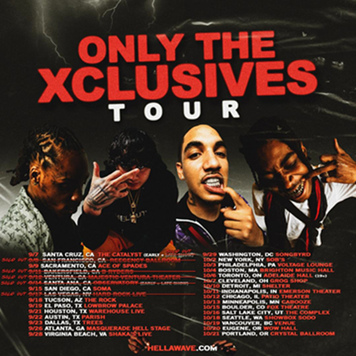

Atlantic recording group Shoreline Mafia is set to embark on their biggest North American headline tour to date. “Only The Xclusives” begins tonight at with two back to back SOLD OUT shows at The Catalyst in Santa Cruz, CA and then continues into late October (see attached itinerary).  As with the Los Angeles-based rap family’s two previous headline tours, most dates are now completely sold out. For updates and ticket availability, please see [hellawave.com/tour](https://hellawave.com/tour).

Shoreline Mafia– a.k.a. OhGeesy  (real name: Alejandro Coranza), Rob Vicious (Robert Magee), Fenix (Fenix Rypinski), and Master Kato (Malik Carson) – will celebrate “Only The Xclusives” by opening a series of pop-up shops along the way, featuring an array of exclusive items including a first chance for fans to purchase Zumiez’ new Shoreline Project capsules, set to hit [Zumiez](https://www.zumiez.com/) shops later this month. Additional pop-ups in select markets will feature further Shoreline Mafia tour merch. For full details and pop-up shop announcements, please visit the official Shoreline Mafia YouTube channel [HERE](https://www.youtube.com/shorelinemafia).

Shoreline Mafia has made its bones as an electrifying live act, including two sold out 2018 tours: “Off The Xtras” and “Still OTX Tour.” In addition, Shoreline Mafia has unleashed show-stopping performances at festivals like Rolling Loud, Made In America, and the Billboard Hot 100 Music Festival.

Currently hard at work wrapping up their full length Atlantic Records debut, Shoreline Mafia marked Labor Day weekend by releasing the four track *Party Pack* EP, available now at all DSPs and streaming services [HERE](https://shoreline.lnk.to/PartyPack). The EP – which includes the previously released favorites, “Foreign” and “Boot It Up” – features collaborations with a number of production stars, among them Ace Santana, FactorBeats, thankyoutakeoff, and Jonny Cash.

In addition, Shoreline Mafia’s Rob Vicious recently unleashed his own major label debut mixtape. [*Traplantic*](https://shoreline.lnk.to/TraplanticID) is available now at all digital music retailers and streaming services [HERE](https://shoreline.lnk.to/TraplanticID). The project includes tracks including “[Traplantic](https://www.youtube.com/watch?v=dgnAbn2Voy8)

” and “[Bands (Feat. OhGeesy, Fenix Flexin & Master Kato)](https://www.youtube.com/watch?v=vNQVcB-X1p0),” both streaming now at the official Shoreline Mafia YouTube channel. The latter track will be joined soon by a new companion visual; a behind-the-scenes look at the production of “Bands” is streaming now [HERE](https://shoreline.lnk.to/BandsInStudio) exclusively via Dirty Glove Bastard.

Shoreline Mafia leapt to the forefront of new hip-hop last year with their first full-length mixtape, *ShorelineDoThatShit*, highlighted by such viral favorites as tracks like “Nun Major,” “Musty,” “Spaceship,” “Serve A Boat,” and “Whuss The Deal.” High profile media attention followed, including [Noisey Beats 1](https://noisey.vice.com/en_us/article/d3wpnm/noisey-beats-1-shoreline-mafia-and-ron-ron-the-producer), [XXL](http://www.xxlmag.com/news/2018/01/shoreline-mafia-interview-the-break/), and [The Fader,](https://www.thefader.com/2018/05/29/shoreline-mafia-musty-atlantic-records-interview) which noted “…Shoreline is positioned to break out as the banner act from L.A.’s new renaissance, a youth-led movement that aims to unite the city’s disparate component parts.” [LyricalLemonade](http://lyricallemonade.com/ll-presents-the-shoreline-mafia-qa/) says, “OhGeesy, Fenix, Rob Vicious, and Master Kato…naturally blend their different sounds together perfectly and are quickly proving to be a huge force in the next wave of rap music.” [PassionWeiss.com](https://www.passionweiss.com/2018/02/22/shoreline-mafia/) declared the quartet “Los Angeles’ fastest rising rap group” while praising *ShorelineDoThatShit* as “one of the strongest releases in recent memory, full of songs that are destined to remain in rotation for the foreseeable future.”

**CONNECT WITH SHORELINE MAFIA:**

[HELLAWAVE.COM](http://hellawave.com/)

[TWITTER](https://twitter.com/shorelinemafia)

[FACEBOOK](https://www.facebook.com/ShorelineMafia/)

[SOUNDCLOUD](https://soundcloud.com/shorelinemafia)

[YOUTUBE](https://www.youtube.com/shorelinemafia)

# # #