FOR IMMEDIATE RELEASE
FEBRUARY 24, 2022

QUANDO RONDO RELEASES “SIX-0 BUSINESS”

LISTEN TO “SIX-0 BUSINESS” HERE | WATCH THE OFFICIAL VIDEO HERE

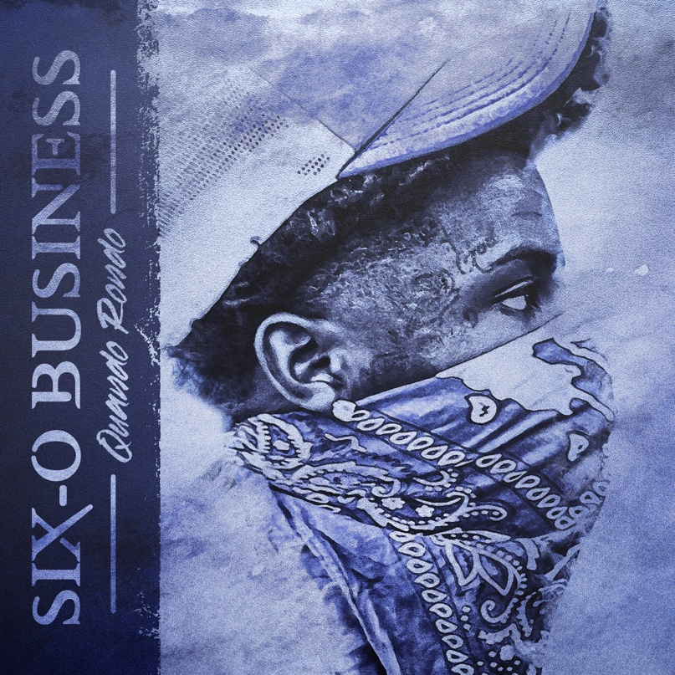

Multi-platinum rapper Quando Rondo has shared his newest single. “Six-0 Business” is available now at all DSPs and streaming services HERE; an official music video premieres today via YouTube HERE.

“Six-0 Business” continues what is fast shaping up as another landmark year for the Savannah, GA-based rapper, following the release of the track “Jakiyah” and his recent guest verse on YoungBoy Never Broke Again’s “Gangsta (Ft. Quando Rondo)” – the only feature on YoungBoy’s chart-topping new mixtape, COLORS. What’s more, YoungBoy shouts out Quando on two of the mixtape’s standout tracks, “Bring It On” and “No Switch.”

Quando officially kicked off his busy 2022 with the recently released single, “Dead Wrong,” available for streaming and download HERE; an official music video is streaming HERE. The wildly prolific streak commenced with last year’s release of the critically acclaimed album, Still Taking Risks, and was swiftly followed by guest verses on the explosive Never Broke Again: The Compilation Vol. 1. A stunning series of singles also dropped, including “Blueprint,” “The Realest,”“Time Spent,” “What I’m On (Ft. Jo Dirt),” and “Shine,” all available now with official music videos streaming via YouTube.

# # #

FOR MORE INFORMATION, PLEASE VISIT:
OFFICIAL
INSTAGRAM
TWITTER
FACEBOOK
YOUTUBE

FOR ALL PRESS INQUIRIES, PLEASE CONTACT:
ARIANA.WHITE@ATLANTICRECORDS.COM

