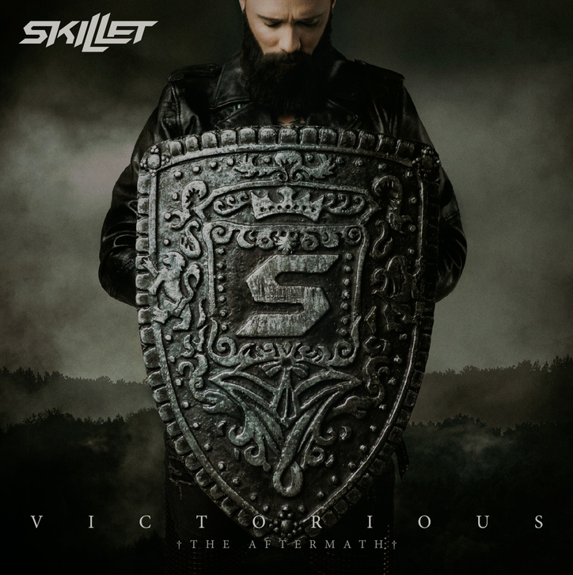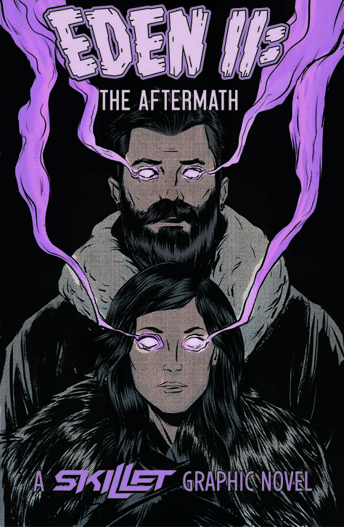

MULTI-PLATINUM ROCKERS SKILLET ANNOUNCE SEPT 11 RELEASE OF DELUXE EDITION PROJECT,
VICTORIOUS: THE AFTERMATH;

SIMULTANEOUSLY UNVEIL COMBO PRE-SALE PACKAGE:
VICTORIOUS: THE AFTERMATH and Graphic Novel, EDEN II: THE AFTERMATH Available For Pre-Sale Today with Instant Grat Track, "Terrify the Dark Reimagined"

July 24, 2020 - Today, multi-platinum and GRAMMY-nominated rock band Skillet announced the upcoming, September 11 release of their Deluxe Edition project, Victorious: The Aftermath, simultaneously unveiling a pre-sale package that includes the album and their second graphic novel, EDEN II: The Aftermath (9/11/20). Also available today is the instant grat track for “Terrify the Dark (Reimagined)” as well as its corresponding lyric video.
Victorious: The Aftermath will feature all twelve original tracks from Victorious, plus eight additional tracks, including 2 brand new unreleased songs, and 5 reimagined songs. Full track listing will be unveiled at later date.
Eden II: The Aftermath once again pairs Random Shock Studios with Skillet frontman John Cooper and his Eden artist Chris Hunt. Two editions will again be available; both the standard and a limited deluxe edition. Skillet's return to the post-apocalyptic world of Eden, as established in their 2019 graphic novel debut of the same name, is an exciting one for the band as well as their publisher, Z2 Comics, as the original book became their best-selling graphic novel of all time. According to Cooper, Aftermath promises "more action, more surprises, more suspense."
ABOUT SKILLET:
On Victorious, one of the best-selling rock bands of the 21st century, two-time GRAMMY® Award-nominated, Pandora Billionaires Club recipients, multiplatinum Wisconsin quartet SKILLET—John Cooper [lead vocals/bass], Korey Cooper [guitar/keys], Jen Ledger [drums/vocals], and Seth Morrison [lead guitar]—write the soundtrack to triumph. An undying spirit humbly asserted and affirmed the band as one of this generation’s most successful rock acts. However, as all classic underdog stories do, it happened quietly under the radar. By 2019, they not only garnered a pair of GRAMMY® Award nods and sold over 12 million albums worldwide, but they also took home a Billboard Music Award for the double-platinum Awake. Its breakout single “Monster” remains “one of the most-streamed rock songs of all-time” with over 3 Billion global audio streams. 2016’s Unleashed bowed at #3 on the Billboard Top 200. Going #1 on Rock Radio, the lead single “Feel Invincible” cracked 150 million global audio streams and went platinum. Meanwhile, the gold-certified Unleashed became their fourth consecutive album to receive either a gold, platinum, or double-platinum status. To date, nine original tunes earned RIAA recognition in tandem with high-profile syncs by everyone from WWE and Marvel to ESPN and NFL. Between selling out arenas on four continents, the group performed on CONAN and graced the pages of USA Today and New York Times, to name a few. In 2018 alone, the band clocked 1 billion streams. This momentum continues on their 2019 tenth full-length, Victorious. With the bulk produced by Korey and John, it lives up to its name for Skillet as their most triumphant body of work yet. On top ofVictorious, Skillet debuted their first graphic novel, EDEN: A Skillet Graphic Novel with Z2 Comics, which has become the publisher’s best-selling book of all time.
###
Get Connected With Skillet:
Website: www.skillet.com
Facebook: @Skillet
Twitter & Instagram: @skilletmusic

