SKIZZY MARS UNVEILS NEW ALBUM “FREE SKIZZY MARS”

RAPPER ANNOUCES FALL HEADLINE “THE FREE SKIZZY MARS TOUR”
DATES BEGIN OCTOBER 12th AT NEW YORK’S WEBSTER HALL

TICKETS FOR “THE FREE SKIZZY MARS TOUR” ON SALE NOW

“FREE SKIZZY MARS” AVAILABLE NOW

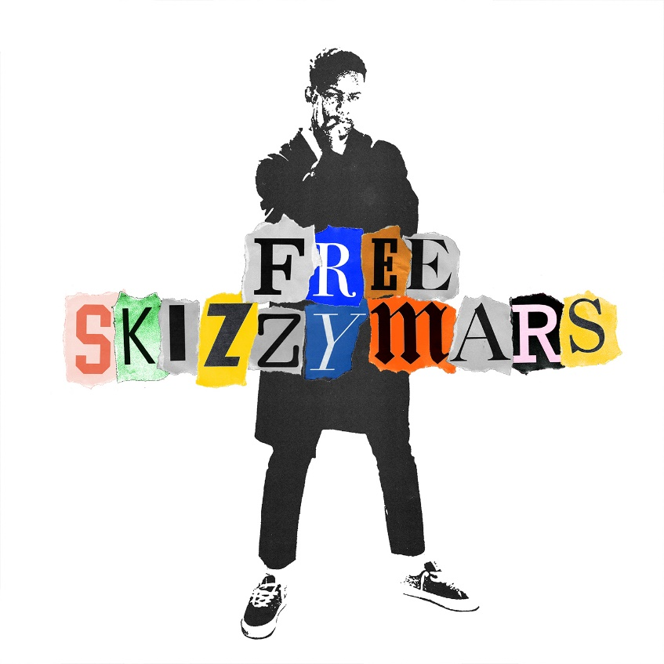

Skizzy Mars has released his latest album, Free Skizzy Mars. Heralded by singles “No Advice” and “Calabasas,” Free Skizzy Mars is available now at all DSPs and streaming services. Skizzy recently sat down with Travis Mills in a Beats1 interview to discuss the album. Also released today is the companion video for “Calabasas.”

In addition to today’s album release, Skizzy Mars has also announced plans for a Fall tour titled “The Free Skizzy Mars Tour,” which kicks off October 12th at New York’s Webster Hall and continues through November, wrapping in New Orleans’ The Parish Room on November 21st. Tickets for “The Free Skizzy Mars Tour” are available now. Full tour routing below. For more information visit http://skizzymars.com/tour.

Free Skizzy Mars includes some notable features by 24kGoldn on “Bayside,” Yoshi Flower on “All The Time” and Trevor Daniel on the album closer “Afraid.” Released earlier this year, “No Advice,” the first single off Free Skizzy Mars, marked Skizzy’s first solo material since his joint project with labelmate Prelow, I Can’t Take Me Anywhere; the 9-track collaborative project was released in November of 2018. I Can’t Take Me Anywhere follows Skizzy Mars’ last EP, “are you OK?” which includes hit singles, “2006” and “American Dream,” the latter of which was joined by a companion video that premiered on HypeBeast. “American Dream” was also featured on the soundtrack for Madden NFL 19.

NYC native, Skizzy Mars earned instant buzz with his first single, 2011’s “Douchebag,” and has since made his bones as one of contemporary rap’s most eclectic new stars. The Harlem-based MC – known to his family as Myles Mills – followed “Douchebag” with the powerful “Profound“ as well as a pair of much-talked-about mixtapes and increasingly popular live appearances as both headliner and support to such stars as G-Eazy, Logic, and Ty Dolla $ign.

Highlighted by chart-topping tracks like “Time (Ft. G-Eazy & Olivver the Kid),” “The Red Balloon Project” EP dropped in February 2015 and proved a straight-up sensation, debuting at #4 on Billboard’s “Top Rap Albums” chart before peaking at #35 on the overall SoundScan/Billboard 200. A 33-city headline tour followed, highlighted by sold out shows in Los Angeles, Dallas, and Skizzy’s own NYC.

Skizzy has also received a remarkable range of press coverage, with features in such outlets as The Fader, NYLON, Complex, i-D, Pigeons & Planes, and HypeBeast, as well as an appearance on the premiere installment of XXL’s “Ante Up” podcast.

For more news and information:
SITE
TWITTER
FACEBOOK
INSTAGRAM
YOUTUBE

“THE FREE SKIZZY MARS TOUR”
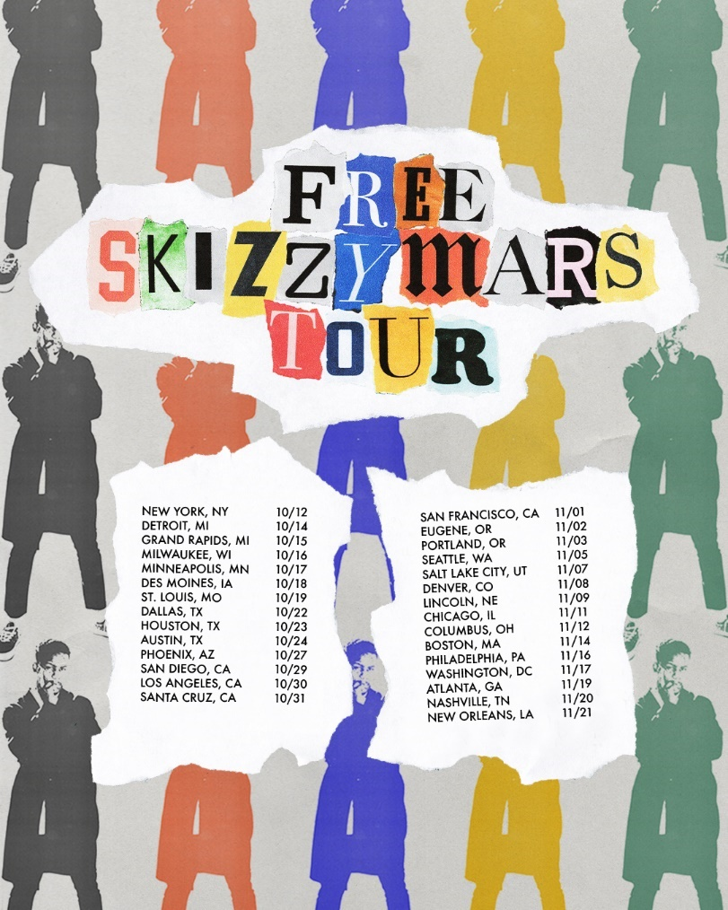

OCTOBER
10/12 – New York, NY – Webster Hall
10/14 – Detroit, MI – El Club
10/15 – Grand Rapids, MI – Stache at Intersection
10/16 – Milwaukee, WI – Turner Hall
10/17 – Minneapolis, MN – Varsity Theater
10/18 – Des Moines, IA – Wooly's
10/19 – St. Louis, MO – Delmar Hall
10/22 – Dallas, TX – Canton Hall
10/23 – Houston, TX – Bronze Peacock at House of Blues
10/24 – Austin, TX – Empire Control Room
10/27 – Phoenix, AZ – Valley Bar
10/29 – San Diego, CA – Music Box
10/30 – Los Angeles, CA – The Roxy
10/31 – Santa Cruz, CA – The Catalyst

NOVEMBER
11/1 – San Francisco, CA – Slim's
11/2 – Eugene, OR – WOW Hall
11/3 – Portland, OR – Hawthorne Theatre
11/5 – Seattle, WA – Neumos
11/7 – Salt Lake City, UT – The Grand @ The Complex
11/8 – Denver, CO – Cervantes’ Masterpiece Ballroom
11/9 – Lincoln, NE – Bourbon Theatre
11/11 – Chicago, IL – Metro
11/12 – Columbus, OH – Skully's
11/14 – Boston, MA – Royale
11/16 – Philadelphia, PA – TLA
11/17 – Washington, DC – U Street Music Hall
11/19 – Atlanta, GA – Terminal West
11/20 – Nashville, TN – Exit/In
11/21 – New Orleans, LA – The Parish Room at House of Blues

FREE SKIZZY MARS
TRACKLISTING

1. Skiz Again
2. Take It Back
3. No Advice
4. Calabasas
5. Sideways
6. Trippy
7. Bayside (feat. 24kGoldn)
8. Demons
9. All The Time (feat. Yoshi Flower)
10. Waist Deep
11. ...
12. Run It Up
13. Afraid (feat. Trevor Daniel)

Contact Information:
Ashley Kalmanowitz
212.707.2051
Ashley.Kalmanowitz@atlanticrecords.com

