SKRILLEX SHARES SURPRISE 'SHOW TRACKS' EP

BUY/STREAM: https://Skrillex.lnk.to/showtracksPR

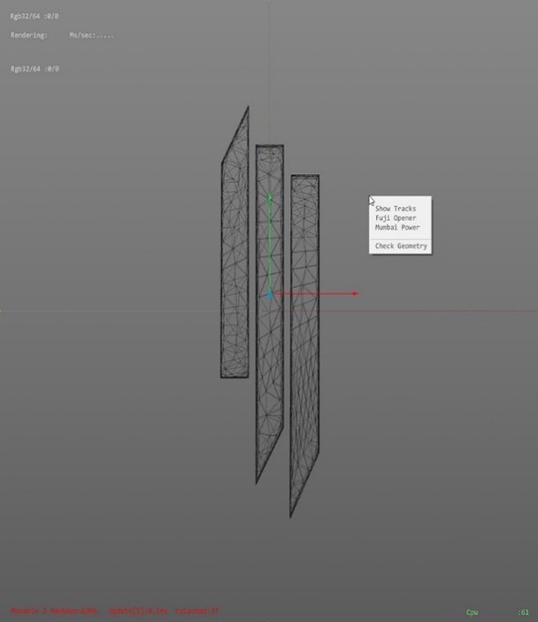

Skrillex has shared two new songs, "Fuji Opener (feat. Alvin Risk)" and "Mumbai Power (feat. Beam)" as a surprise EP titled Show Tracks. Both tracks have appeared in his recent live sets and are a special gift for fans. Listen HERE!

This year Skrillex reunited with Boys Noize as their supergroup Dog Blood, worked on Ed Sheeran's No.6 Collaborations Project and Kelsey Lu's album Blood, produced Lykke Li's "Two Nights" Pt. 2 with Ty Dolla Sign, collaborated with TroyBoi for "WARLORDZ," plus made the theme song for the highly-anticipated video game Kingdom Hearts III with Japanese superstar Hikaru Utada.

Listen to Show Tracks below and watch for more from Skrillex coming soon.
Listen to Show Tracks EP: https://Skrillex.lnk.to/showtracksPR

(Download hi-res, credit Marilyn Hue)

Press site: https://press.wearebigbeat.com/artists/skrillex/

CONNECT WITH SKRILLEX
TWITTER | INSTAGRAM | FACEBOOK | SITE

FOR MORE INFORMATION:
Paige Rosoff – Big Beat Records
Paige.Rosoff@atlanticrecords.com

Brett Burin- Biz3
brett@biz3.net

