SKRILLEX, NOISIA, JOSH PAN & DYLAN BRADY RELEASE NEW TRACK “SUPERSONIC (MY EXISTENCE)”

STREAM HERE

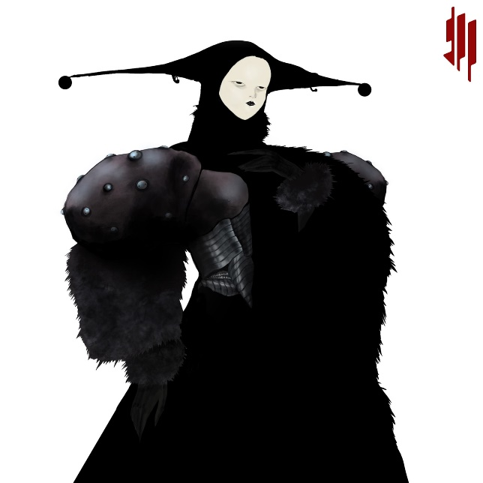
Download “Supersonic (My Existence)” Artwork HERE
Artwork by Alfie Pietroni @alfredpietroni

Skrillex has shared the new track “Supersonic (My Existence)” with Noisia, josh pan and Dylan Brady. On the new release, josh pan offers a haunting, spectral vocal performance that weaves between the searing production work of Skrillex and collaborators Dutch producer-trio Noisia along with an original contribution by 100 gecs’ Dylan Brady. This marks Skrillex’ third new release of 2021, following the nuanced house collab “Butterflies” with Four Tet and Starrah and the propulsive pop punk track “Too Bizarre” with Swae Lee and Siiickbrain.

Photo Credit: Marilyn Hue

CONNECT WITH SKRILLEX:
Facebook | Instagram | Twitter | YouTube | Spotify
SKRILLEX PRESS ASSETS: https://press.atlanticrecords.com/skrillex/

FOR MORE INFORMATION:
Paige Rosoff | Atlantic Records
Paige.Rosoff@atlanticrecords.com

