SKRILLEX RELEASES ARTFUL NEW VIDEO FOR “BUTTERFLIES”

WATCH THE VIDEO HERE

STREAM “BUTTERFLIES” HERE

Skrillex has shared a new video for his recent release “Butterflies” with Four Tet and Starrah. Watch HERE! The house inspired track provides a dynamic backdrop for the cinematic video that follows a group of friends as they dance and weave through dimly lit city streets. Shadowed by haunting and amorphously beautiful ghostlike figures, the crew and their spectral counterparts become intertwined with elegant choreography and seamless CGI. This marks Skrillex’ second new video of 2021, following the underground punk show visual for “Too Bizarre” with Swae Lee and Siiickbrain.

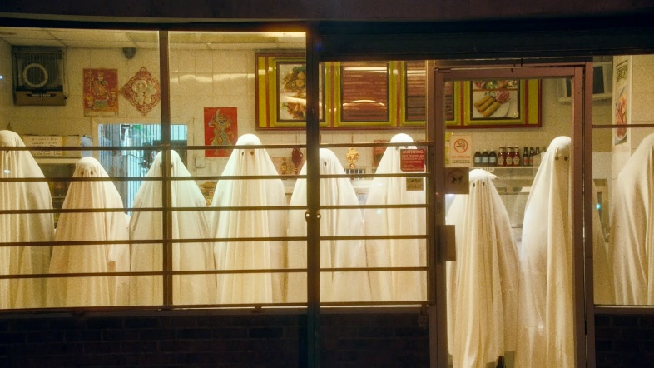
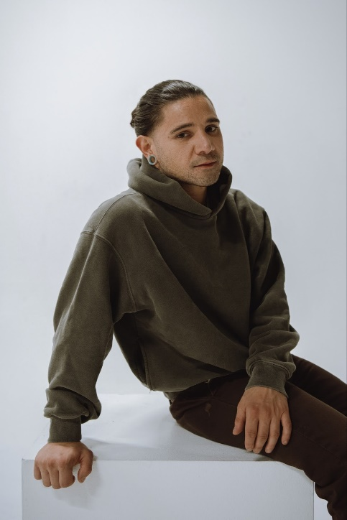
Photo Credit: Marilyn Hue

SKRILLEX PRESS ASSETS: https://press.atlanticrecords.com/skrillex/

CONNECT WITH SKRILLEX:
Facebook | Instagram | Twitter | YouTube | Spotify

FOR MORE INFORMATION:
Paige Rosoff | Atlantic Records
Paige.Rosoff@atlanticrecords.com

