FOR IMMEDIATE RELEASE
DECEMBER 4, 2020

SUECO RETURNS WITH “PRIMADONA”

RIAA GOLD-CERTIFIED ARTIST RETURNS WITH ELECTRIFYING NEW SINGLE

LISTEN TO “PRIMADONA” HERE
WATCH THE VIDEO HERE
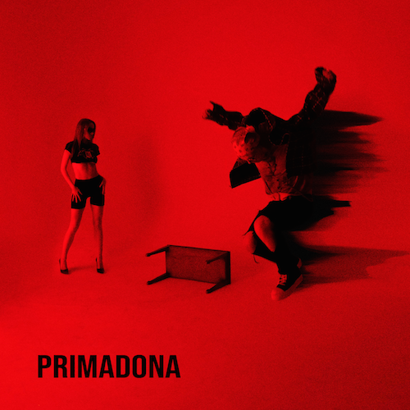
DOWNLOAD ARTWORK HERE

RIAA gold certified singer/producer Sueco has released his striking new single “PRIMADONA” available now HERE. “PRIMADONA” arrives today with an official companion video streaming now HERE.

“PRIMADONA” showcases an electrifying new sound for the blue-haired artist formerly known as Sueco the Child, fusing alternative pop energy to his already wildly inventive sonic approach. The track marks the latest in a series of acclaimed releases, including the hypnotic “Smackdown (Feat. TOKYO’S REVENGE),” “Juice,” and last year’s full-length debut project, MISCREANT, the latter highlighted by the worldwide streaming smashes, “fast” and “dork.”

What’s more, Sueco joined forces with global superstars Ty Dolla $ign, Wiz Khalifa, and Lil Yachty for “Speed Me Up,” produced by Take A Daytrip (Lil Nas X, Big Sean, YBN Cordae) and featured in Paramount Pictures’ blockbuster action-adventure, Sonic The Hedgehog. The track now boasts over 20 million worldwide streams, propelled by a hugely successful TikTok Challenge that drew more than 1.8 billion views. “Speed Me Up” was accompanied by a star-studded official video streaming now via which premiered during MTV’s GRAMMY® Awards special. In addition, Sueco made his high profile network television debut with a spectacular group performance of the track on ABC’s Jimmy Kimmel Live! – watch the performance HERE.

Instantly recognizable for his long blue hair, gleaming grill, and headbanging beats, Sueco proved an online sensation with last year’s RIAA gold certified breakthrough hit single, “fast.” Hailed by Rolling Stone as “a low-slung, battering ram of a record made up of little more than ‘a clap, a hi-hat and an 808,’” the track lit up TikTok with over 2.5 million videos en route to more than 200 million worldwide streams, catapulting it to the top spot at TikTok and #1 on Spotify’s “Viral 50 - Global” and “Viral 50 – US” charts. Furthermore, “fast” was followed by an official remix featuring Offset and A Boogie Wit Da Hoodie, which premiered on Apple Music’s Beats 1 as Zane Lowe’s #WorldFirst.

A wide range of international media attention followed “fast,” as did another viral smash in “dork,” now boasting over 25 million streams around the world. The track was joined by both a colorful companion video as well as an official remix featuring trap superstar Rich The Kid.

CONNECT WITH SUECO
INSTAGRAM l TWITTER l SOUNDCLOUD l YOUTUBE

For press inquiries, please contact:
Jessica Nall // Jessica.Nall@atlanticrecords.com

