FOR IMMEDIATE RELEASE
AUGUST 13, 2021

SUECO DROPS VIRAL TRACK “PARALYZED”

RIAA GOLD-CERTIFIED SINGER/PRODUCER MAKES EPIC RETURN WITH
JOHN FELDMANN (MACHINE GUN KELLY, BLINK-182, AVRIL LAVIGNE)-PRODUCED TRACK

TEASER OF POP-PUNK ANTHEM EXPLODED ON TIKTOK
BOASTING OVER 47 MILLION VIEWS + 9 MILLION LIKES

RECENT COLLABORTATIONS “SWERVE” WITH PAPA ROACH AND JASON AALON OF FEVER 333
AND “SOS” WITH TRAVIS BARKER OUT NOW

LISTEN TO “PARALYZED” HERE
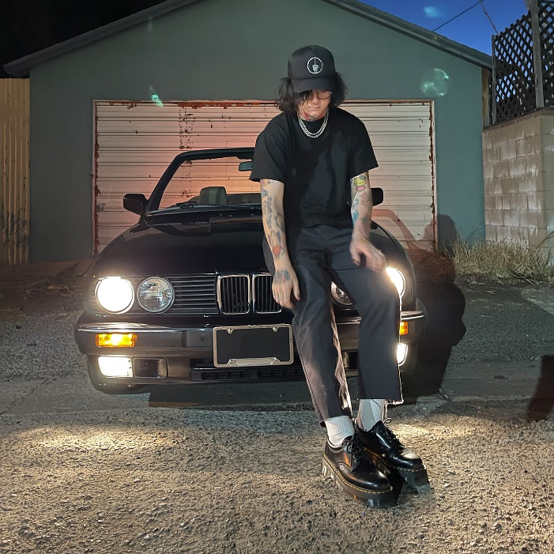
DOWNLOAD ARTWORK HERE

“Sueco is as on brand as ever…”
-BILLBOARD

“Sueco’s discography hasn’t failed to thrill or delight…”
-MTV

“Sueco is undoubtedly a product of a new generation, one whose humor and meteoric success is unexpected, unpredictable, and nothing short of enthralling.”
– ONES TO WATCH

Due to overwhelming demand, RIAA gold-certified singer/producer Sueco has released his latest track “Paralyzed” – streaming now HERE. The viral artist posted a teaser of the John Feldmann (Machine Gun Kelly, blink-182, JXDN, 5SOS, Avril Lavigne, MOD SUN)-produced track on his TikTok last week and in just week racked up 47M views and 9M likes.

Sueco – f.k.a. Sueco the Child – continues to fuse electric, alt-pop energy to his already wildly inventive sonic approach. Since his 2019 debut project MISCREANT, highlighted by RIAA Certified Gold track “fast” and hit single “dork,” Sueco has released an impressive string of singles including “PRIMADONA,” “Smackdown (Feat. TOKYO’S REVENGE),” “Juice,” and the impressive collaboration with global superstars Ty Dolla $ign, Wiz Khalifa, and Lil Yachty “Speed Me Up.”

Most recently, Sueco teamed up with Papa Roach and Jason Aalon of Fever 333 for their track “Swerve” and legendary drummer Travis Barker for their rising single “SOS,” which currently boasts over 12M streams. The rising artist also starred in Prom in Hell podcast alongside JXDN, Nessa Barrett and more. Sueco has received widespread critical acclaim from EUPHORIA, Nylon, Alternative Press, Hollywire, and more. Stay tuned for more from this rising star!

CONNECT WITH SUECO
INSTAGRAM l TIKTOK | TWITTER l SOUNDCLOUD l YOUTUBE

For press inquiries, please contact:
Jessica Nall // Jessica.Nall@atlanticrecords.com

