FOR IMMEDIATE RELEASE
SEPTEMBER 10, 2021

SUECO DROPS OFFICIAL “PARALYZED” VIDEO

RIAA GOLD-CERTIFIED ARTIST CELEBRATES DEBUT ON BILLBOARD + ROLLING STONE CHARTS
WITH OFFICIAL VIDEO FOR VIRAL TRACK “PARALYZED”

CURRENTLY #1 ON SPOTIFY US VIRAL 50 CHART +
TOP 5 ALTERNATIVE SINGLE ON APPLE MUSIC & iTUNES

WATCH OFFICIAL VIDEO
Directed By: Alex Bittan (Harry Styles, Ty Dolla $ign, BRELAND, Amy Allen)

DOWNLOAD/STREAM

RIAA gold-certified singer/producer Sueco is celebrating the success of his latest viral single, “Paralyzed,” with today’s arrival of the official video. Directed by Alex Bittan (Harry Styles, Ty Dolla $ign, BRELAND, Amy Allen), the gritty, high-energy companion visual is now streaming at Sueco’s YouTube channel HERE.

After amassing millions of views and likes on a TikTok teasing “Paralyzed,” Sueco dropped the single which exploded out of the gate. The pop-punk anthem produced by John Feldmann (Machine Gun Kelly, blink-182, jxdn) and Colin 'DOC' Brittain (5 Seconds of Summer, All Time Low, Papa Roach) with additional production from dwilly (Royal & The Serpent, Trevor Daniel, bbno$), has garnered over 30 million worldwide streams, hit #1 on the Spotify US 50 Viral chart, and marked Sueco’s debut on the Billboard Hot 100 and Rolling Stone 100 charts.

A true viral sensation, Sueco currently boasts over 5.6 million TikTok followers and nearly 500 million global streams. In addition to the impressive debut on the Billboard Hot 100 chart, the track landed at #1 on the Rock Digital Song Sales chart, #2 on Alternative Digital Song Sales chart, #2 on Rolling Stone’s Top 25 Breakthrough chart, and earned Sueco a spot on the Rolling Stone Artists 500 for the first time. The track debuted at #3 on Spotify US Song Debuts and is currently charting in the top 100 on Spotify’s US 200 Chart. “Paralyzed,” is currently a Top 10 Track on TikTok nationwide and featured on Spotify’s biggest Rock playlist Rock This (5.6M) and the coveted playlist Pop Rising (2.3M) as well as Apple Music’s ALT CTRL, The New Rock and more. The viral single continues to chart in the Top 5 of Apple Music and iTunes Alternative Charts a month after release.

Sueco is hard at work on his next project as he continues to fuse electric, alt-pop energy to his already wildly inventive sonic approach. Stay tuned for more from this rising star…

WHAT PEOPLE ARE SAYING ABOUT SUECO:

“Sueco is as on brand as ever…”
-BILLBOARD

“Sueco’s discography hasn’t failed to thrill or delight…”
-MTV

“Sueco is known for mixing pop, pop punk and rap with inventive beats to create something entirely unrestrained by genre.”
-ALT PRESS

“Sueco is undoubtedly a product of a new generation, one whose humor and meteoric success is unexpected, unpredictable, and nothing short of enthralling.”
– ONES TO WATCH

“’Paralyzed’ is a natural evolution for Sueco. Beginning with a hip-hop cadence, the song kicks into high gear with a scream-fueled chorus that blends the best of early 2000s hardcore/screamo with the modern-day punk sound.”
-HOLLYWOOD LIFE

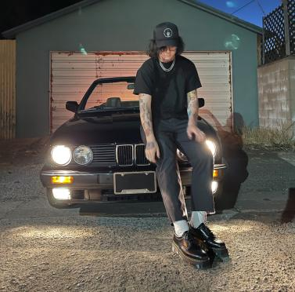
DOWNLOAD PRESS PHOTOS

CONNECT WITH SUECO
INSTAGRAM l TIKTOK | TWITTER l SOUNDCLOUD l YOUTUBE

For press inquiries, please contact:
Jessica Nall // Jessica.Nall@atlanticrecords.com

