FOR IMMEDIATE RELEASE
APRIL 16, 2021

SUECO AND TRAVIS BARKER TEAM UP FOR “SOS”

RIAA GOLD-CERTIFIED ARTIST JOINS FORCES WITH LEGENDARY DRUMMER
FOR EXPLOSIVE NEW SINGLE

LISTEN TO “SOS (FEAT. TRAVIS BARKER)” HERE
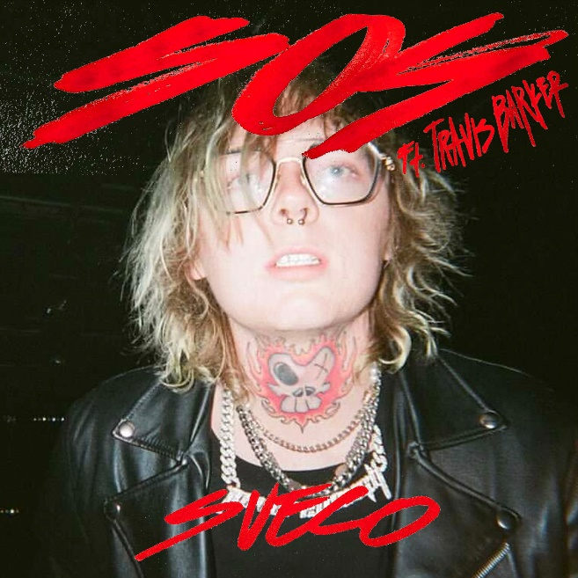
DOWNLOAD ARTWORK HERE |DOWNLOAD SOCIAL CLIPS

“Sueco is as on brand as ever…”
-BILLBOARD

“Sueco’s discography hasn’t failed to thrill or delight…”
-MTV

“Sueco is undoubtedly a product of a new generation, one whose humor and meteoric success is unexpected, unpredictable, and nothing short of enthralling.”
– ONES TO WATCH

RIAA gold-certified singer/producer Sueco has teamed up with the legendary Travis Barker for their new high-energy, pop-punk anthem “SOS”- available everywhere now HERE via Atlantic Records.

Produced by Barker and dwilly (Mike Posner, Ty Dolla $ign, Trevor Daniel), with additional production by Colin “DOC” Brittain (5 Seconds of Summer, All Time Low, Papa Roach), “SOS (Feat. Travis Barker)” sees Sueco – f.k.a. Sueco the Child – further continue to fuse electric, alt-pop energy to his already wildly inventive sonic approach.

Sueco first unveiled his electrifying new sound late last year with his single, “PRIMADONA.” The genre-bending single followed a series of acclaimed releases from Sueco, including the hypnotic “Smackdown (Feat. TOKYO’S REVENGE),” “Juice,” and 2019’s full-length debut project, MISCREANT, highlighted by the global streaming smash, “fast.”

Last year, Sueco joined forces with global superstars Ty Dolla $ign, Wiz Khalifa, and Lil Yachty for “Speed Me Up,” produced by Take A Daytrip (Lil Nas X, Big Sean, YBN Cordae) and featured in Paramount Pictures’ blockbuster action-adventure, Sonic The Hedgehog. “Speed Me Up” was accompanied by a star-studded official video which premiered during MTV’s GRAMMY® Awards special. In addition, Sueco made his high profile network television debut with a spectacular performance of the track on Jimmy Kimmel Live!

Immediately recognizable for his long blue hair, gleaming grill, and headbanging beats, Sueco proved an online sensation with 2019’s RIAA gold certified breakthrough hit single, “fast.” Hailed by Rolling Stone as “a low-slung, battering ram of a record made up of little more than ‘a clap, a hi-hat and an 808,’” the track lit up TikTok with over 2.5 million videos en route to more than 200 million worldwide streams, catapulting it to the top spot at TikTok and #1 on Spotify’s “Viral 50 - Global” and “Viral 50 – US” charts. Furthermore, “fast” was followed by an official remix featuring Offset and A Boogie Wit Da Hoodie, which premiered on Apple Music’s Beats 1 as Zane Lowe’s #WorldFirst.

CONNECT WITH SUECO
INSTAGRAM l TWITTER l SOUNDCLOUD l YOUTUBE

For press inquiries, please contact:
Jessica Nall // Jessica.Nall@atlanticrecords.com

