FOR IMMEDIATE RELEASE
MAY 21, 2021

SUECO AND TRAVIS BARKER RELEASE “SOS” VIDEO

POP-PUNK ANTHEM RECIEVES OFFICIAL VIDEO STARRING
RIAA GOLD-CERTIFIED ARTIST AND LEGENDARY DRUMMER

EXPLOSIVE VIDEO ARRIVES ALONGSIDE NEW ACOUSTIC VERSION OF THE HIT SINGLE

WATCH THE VIDEO HERE
LISTEN TO “SOS (ACOUSTIC)” HERE
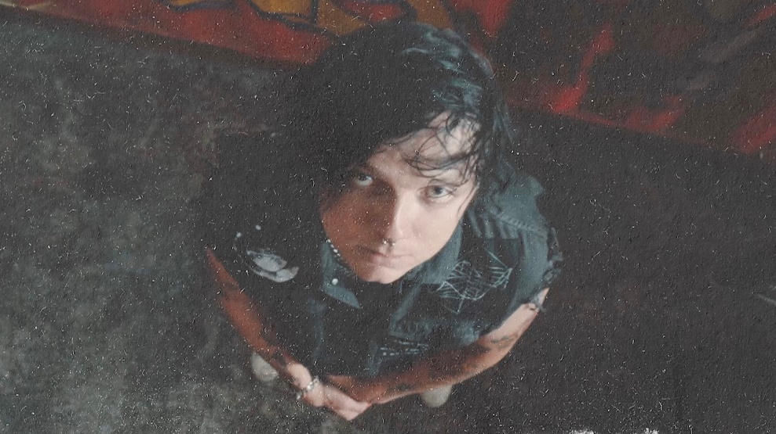
“Sueco is as on brand as ever…”
-BILLBOARD

“Sueco’s discography hasn’t failed to thrill or delight…”
-MTV

“Sueco is undoubtedly a product of a new generation, one whose humor and meteoric success is unexpected, unpredictable, and nothing short of enthralling.”
– ONES TO WATCH

RIAA gold-certified singer/producer Sueco and the legendary Travis Barker have released their new video for their explosive, pop-punk anthem “SOS,” streaming now HERE. Also arriving today, is a brand-new acoustic version of the track, highlighted by Sueco’s emotive vocals, listen to it now HERE.

“This is my favorite video I’ve ever made,” Sueco says. “Travis has been an inspiration of mine since I was a kid, so working with him was super dope and a dream come true”

Produced by Barker and dwilly (Mike Posner, Ty Dolla $ign, Trevor Daniel), with additional production by Colin “DOC” Brittain (5 Seconds of Summer, All Time Low, Papa Roach), “SOS (Feat. Travis Barker)” saw Sueco – f.k.a. Sueco the Child – continue to fuse electric, alt-pop energy to his already wildly inventive sonic approach. The high-energy track was released last month and met with widespread critical acclaim with EUPHORIA stating, “As an artist who has consistently been completely defying genres, Sueco continues to push the boundaries with this new one” and NYLON naming it “energetic” and one of the best releases of the week.

DOWNLOAD ARTWORK + PRESS PHOTOS HERE

CONNECT WITH SUECO
INSTAGRAM l TWITTER l SOUNDCLOUD l YOUTUBE

For press inquiries, please contact:
Jessica Nall // Jessica.Nall@atlanticrecords.com

