FOR IMMEDIATE RELEASE
NOVEMBER 15, 2021

SUECO AND ARIZONA ZERVAS SHARE EXPLOSIVE
“SOBER/HUNGOVER” VIDEO

RIAA CERTIFIED ARTIST AND CHART-TOPPING VIRAL RAPPER
RELEASE HIGH-ENERGY OFFICIAL VIDEO

SUECO TO TOUR WITH VIRAL PHENOMENON OLIVER TREE IN 2022
TICKETS ARE AVAILABLE HERE

WATCH “SOBER/HUNGOVER (FEAT. ARIZONA ZERVAS)” HERE
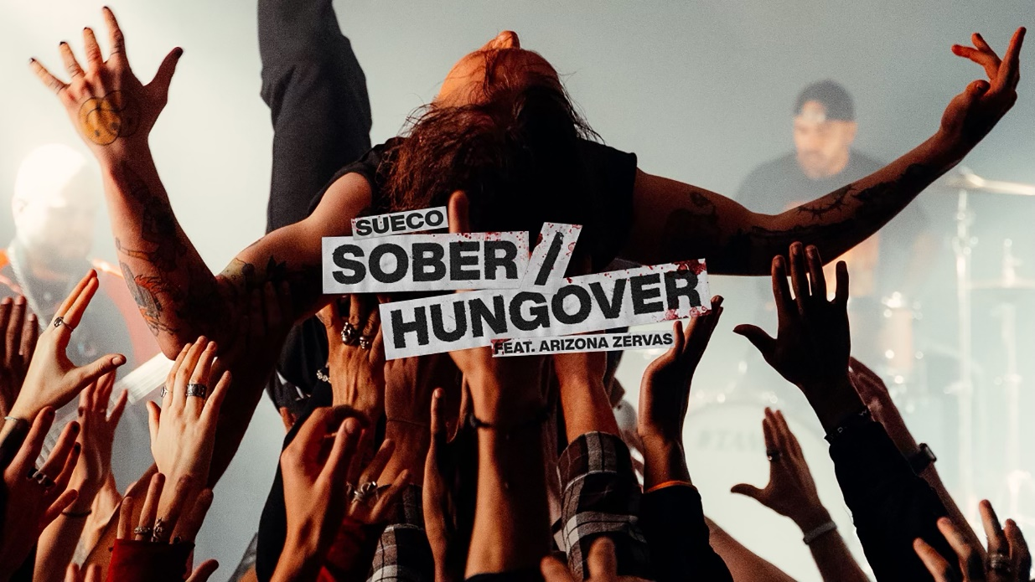
(DOWNLOAD PHOTOS HERE)

RIAA certified singer/producer Sueco and viral rapper Arizona Zervas have released the official video for their punk rock anthem, “Sober/Hungover.” Directed by JakeTheShooter, the visual is streaming now HERE.

Gracing the October issue of Alternative Press, Sueco’s momentum continues to build. “Sober/Hungover” arrived on the heels of the high energy hit, “Paralyzed,” joined by an official music video directed by Alex Bittan (Harry Styles, Ty Dolla $ign). In addition, Sueco released a stripped-down rendition of the viral track, “Paralyzed (Acoustic),” is available now HERE.

Produced by John Feldmann (Machine Gun Kelly, blink-182, jxdn), dwilly (Royal & The Serpent, Trevor Daniel, bbno$), Colin “DOC” Brittain (5 Seconds of Summer, All Time Low, Papa Roach), and Jae Green (Justin Bieber, Machine Gun Kelly, DaBaby, Arizona Zervas), and featuring chart-topping viral rapper Arizona Zervas (known for the 4x RIAA platinum, worldwide #1 smash, “ROXANNE”), “Sober/Hungover” marked the latest in a seemingly unstoppable series of anthemic new tracks from Sueco.

Breakthrough track, “Paralyzed,” continues to climb quickly approaching nearly 100 million streams since its September release. First heralded with a TikTok teaser that has now amassed more than 11.3M likes and 70M views, “Paralyzed” has quickly garnered more than 80M worldwide streams, reaching #1 on Spotify’s “Viral 50 - US” while proving Sueco’s first-ever Billboard “Hot 100” and Rolling Stone “Top 100” hit. The track is quickly shaping up as the wildly inventive artist’s biggest single to date, earning him a spot on the Rolling Stone “Top 500 Popular Artists” chart for the first time after landing at #1 on Billboard’s “Rock Digital Song Sales,” #2 on “Alternative Digital Song Sales,” and #2 on Rolling Stone’s “Top 25 Breakthrough Music Artists.”

Sueco will join chart-topping artist Oliver Tree on his North American Cowboy Tears tour next year. The highly anticipated tour kicks off February 19, 2022 at Los Angeles, CA’s legendary venue, The Shrine Expo Hall, and continues through late March. Tickets are on sale now, for details please visit: https://www.sueco.com/.

ABOUT SUECO:
Sueco has gleefully defied expectation right from the jump, fusing electric alt-pop energy with punk rock furor and off-kilter hip-hop to create something altogether without precedent and entirely his own. Now boasting over 550M worldwide streams, the Los Angeles-based singer/producer/multi-instrumentalist proved an online sensation with 2019’s RIAA gold certified breakthrough hit single, “fast.” Hailed by Rolling Stone as “a low-slung, battering ram of a record,” the track rocketed to the top spot at TikTok and #1 on Spotify’s “Viral 50 - Global” and “Viral 50 - US” charts. Sueco followed “fast” with his full-length debut project, MISCREANT, but then quickly shook up his electrifying sound with a string of increasingly pop-punk releases, including “PRIMADONA” and “SOS (Feat. Travis Barker).”

Sueco has also proven a diverse, in-demand collaborator, busting out remixes featuring such icons as Offset and A Boogie Wit Da Hoodie, joining forces with global superstars Ty Dolla $ign, Wiz Khalifa, and Lil Yachty for 2020’s “Speed Me Up,” and lighting up Papa Roach’s 2021 single, “Swerve (Feat. FEVER 333 & Sueco).” Having earned applause from Billboard, MTV, NYLON and Alternative Press, Sueco is currently hard at work on his eagerly awaited new project, now as always expanding the parameters of his forward-thinking musical approach with idiosyncratic invention, powerhouse passion, and unstoppable creativity.

ABOUT ARIZONA ZERVAS:
Arizona Zervas, who writes and engineers all his songs himself, has steadily been releasing music since 2016 and has played more than 50 shows across the U.S. The explosive “ROXANNE” took off meteorically in late 2019 and was topping Spotify’s U.S. Top 50 chart just a few weeks after release, before Zervas joined the Columbia Records family. “ROXANNE” is the first track by an unsigned, fully independent artist to top the chart since the beginning of 2017 – the earliest date on Spotify’s online archive.

WHAT PEOPLE ARE SAYING ABOUT SUECO:
“Sueco is as on brand as ever…” - BILLBOARD

“Sueco’s discography hasn’t failed to thrill or delight…” - MTV

“Sueco is known for mixing pop, pop punk and rap with inventive beats to create something entirely unrestrained by genre.” - ALT PRESS

“Sueco is undoubtedly a product of a new generation, one whose humor and meteoric success is unexpected, unpredictable, and nothing short of enthralling.” - ONES TO WATCH

“‘Paralyzed’ is a natural evolution for Sueco. Beginning with a hip-hop cadence, the song kicks into high gear with a scream-fueled chorus that blends the best of early 2000s hardcore/screamo with the modern-day punk sound.” - HOLLYWOOD LIFE

CONNECT WITH SUECO
INSTAGRAM l TIKTOK | TWITTER l SOUNDCLOUD l YOUTUBE

For press inquiries, please contact:
Jessica Nall // Jessica.Nall@atlanticrecords.com

