FOR IMMEDIATE RELEASE
APRIL 17, 2020

SUECO THE CHILD UNVEILS “JUICE”

INTERNET PHENOMENON IS BACK WITH HIS LATEST IRRESISTIBLY CATCHY SINGLE

GLOBAL SMASH “FAST” RIAA CERTIFIED GOLD WITH OVER 150 MILLION STREAMS

NEW TRACK FOLLOWS DEBUT PROJECT MISCREANT

LISTEN TO “JUICE” HERE
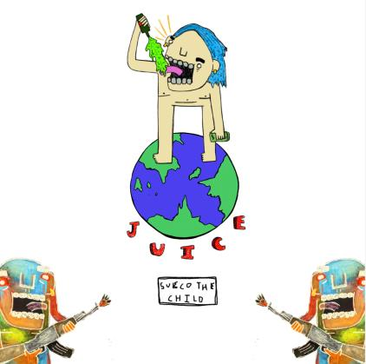
DOWNLOAD ARTWORK HERE

LA-based singer/producer Sueco The Child has returned with a new single “Juice” – listen HERE. Sueco co-produced the catchy song with David Morse (Lil Yachty, Lil Pump, Lil Skies) and N.I.K (Dae Dae, Strick). “Juice” follows the artist’s debut project MISCREANT which features global smash hits, “fast” and “dork.”

Most recently, Sueco joined global superstars Ty Dolla $ign, Wiz Khalifa and Lil Yachty on the Take A Daytrip (Lil Nas X, Big Sean, YBN Cordae) produced record “Speed Me Up” for the major motion picture Sonic The Hedgehog. The blockbuster song boasts over 30 million streams and was accompanied by a star-studded music video which premiered during the MTV GRAMMY special broadcast.

“fast,” the single that made Sueco an online sensation, is now RIAA Certified Gold and has racked up over 150 million streams. The viral song has been used in over 2.5 million TikTok videos, which earned it the #1 spot on the app as well as the top spot on the Spotify Global and US Viral Charts. Sueco recently teamed up with trap star Rich The Kid for a remix of the blue-haired rapper’s hit song “dork.” The original single has racked up over 25 million streams, more than 50,000 uploads on TikTok and is accompanied by an official video that has over 1.55 million views.

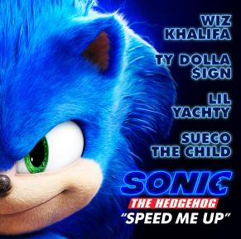

On MISCREANT, Sueco worked with a variety of close friends and collaborators to write, produce, and mix the project, including Ronny J. “Overall, the primary focus on this project was sonic excellence,” concludes Sueco, “I wanted it to feel like ear candy. Ultimately, I hope people come out of this project seeing it as the beginning of a grand movement. The beginning of something great.”

DOWNLOAD ARTWORK

ABOUT SUECO THE CHILD
Long blue hair headbanging, grill blinging, beats buzzing, and guitar humming, Sueco The Child creates off-kilter hip-hop with a punked-out presence and pop disruption. Under a neon glow of genre-less ecstasy affirmed by 150 million streams and tastemaker acclaim, we find the Los Angeles singer, rapper, producer, and multi-instrumentalist as the ringmaster of a world unto himself on his 2019 Atlantic Records debut. Featured in Rolling Stone, Billboard, Genius, and more, his massive breakout single “fast” has become a certified viral smash. Buoyed by airy production, cyber siren wails, and a driving beat from the artist himself, the track hinges on one meme-able boast after another as he claims, “Bitch I make beats and bad decisions.”

FOLLOW SUECO THE CHILD
Instagram | Twitter | Soundcloud | YouTube

