SUECO THE CHILD TEAMS UP WITH 1TAKEJAY AND AZCHIKE FOR “NO FUCKS”

LISTEN TO “NO FUCKS” HERE
WATCH “NO FUCKS” HERE

NEW FEATURE FOLLOWS SUECO THE CHILD’S DEBUT PROJECT MISCREANT
WHICH INCLUDES MASSIVE HIT “FAST” + HILARIOUS “DORK”

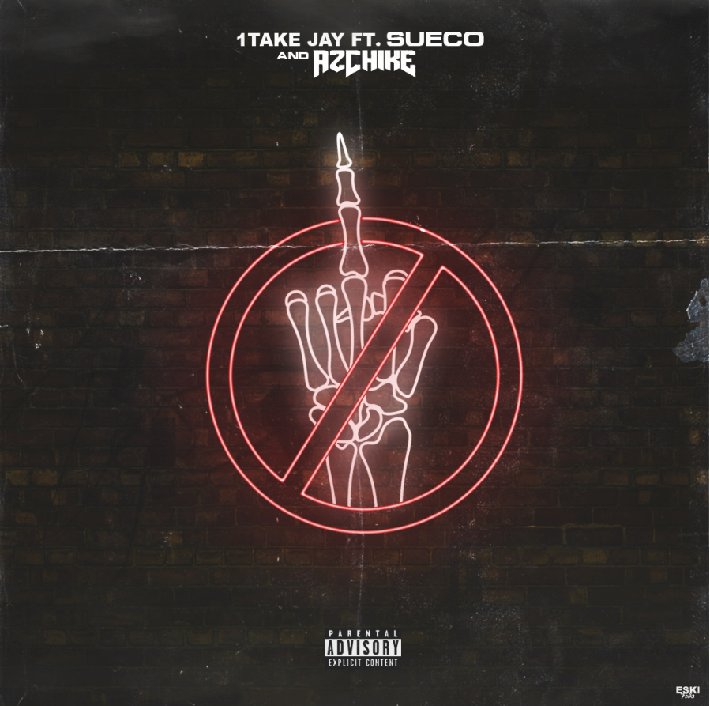

LA rappers 1TakeJay, and AzChike have teamed up with fellow Angeleno Sueco The Child for the new party track “No Fucks,” available on all DSPs and streaming services now. The collaborative new track is perfect for having a good time with your fellow miscreants. The trio of rappers invite you along to their party with the track’s companion video, streaming HERE. After racking up over 100 million global streams with his viral single “fast,” and his recently released debut project “MISCREANT,” Sueco The Child lends his talents to the catchy hook of this cool and carefree song.

ABOUT SUECO THE CHILD
Long blue hair headbanging, grill blinging, beats buzzing, and guitar humming, Sueco The Child creates off-kilter hip-hop with a punked-out presence and pop disruption. Under a neon glow of genre-less ecstasy affirmed by 100 million streams and tastemaker acclaim, we find the Los Angeles singer, rapper, producer, and multi-instrumentalist as the ringmaster of a world unto himself on his 2019 Atlantic Records debut. Featured in Rolling Stone, Billboard, Genius, and more, his massive breakout single “fast” has become a certified viral smash. Buoyed by airy production, cyber siren wails, and a driving beat from the artist himself, the track hinges on one meme-able boast after another as he claims, “Bitch I make beats and bad decisions.”

FOLLOW SUECO THE CHILD
Instagram | Twitter | Soundcloud | YouTube

