FOR IMMEDIATE RELEASE
JUNE 26, 2020

SUECO THE CHILD RELEASES “SMACKDOWN (FEAT. TOKYO’S REVENGE)”

INTERNET PHENOMENON TEAMS UP WITH VIRAL TIK TOK RAPPER FOR NEW COLLAB

GLOBAL SMASH BREAKOUT SINGLE “FAST” RIAA-CERTIFIED GOLD

LISTEN TO “SMACKDOWN (FEAT. TOKYO’S REVENGE)” HERE
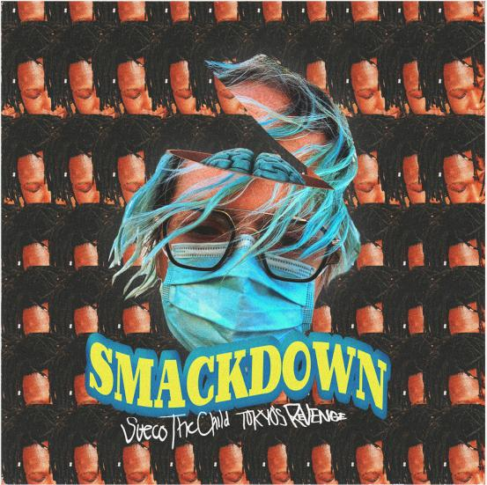
DOWNLOAD ARTWORK HERE

RIAA-certified Gold singer/rapper/producer Sueco The Child has tapped rising rapper TOKYO’S REVENGE for the new banger “Smackdown” – available today at all DSPs and streaming services HERE via Atlantic Records. “I made this song and it’s pretty good hope you like it,” Sueco shared. The hypnotic track follows Sueco’s recent single “Juice,” as well as the artist’s debut project MISCREANT which features global smash hits, “fast” and “dork.”

Earlier this year, Sueco joined global superstars Ty Dolla $ign, Wiz Khalifa and Lil Yachty on the Take A Daytrip (Lil Nas X, Big Sean, YBN Cordae) produced record “Speed Me Up” for the major motion picture Sonic The Hedgehog. The blockbuster song boasts over 30 million streams and was accompanied by a star-studded music video which premiered during the MTV GRAMMY special broadcast as well as Sueco’s debut television performance on Jimmy Kimmel Live!.

“fast,” the smash single that made Sueco an online sensation, is now RIAA-certified Gold and has racked up over 200 million streams. The viral song has been used in over 2.5 million TikTok videos, which earned it the #1 spot on the app as well as the top spot on the Spotify Global and US Viral Charts. Hip-Hop superstars Offset and A Boogie Wit da Hoodie hopped on the official remix of the hit track which premiered as Zane Lowe’s World First on Beat 1.

Last year, Sueco teamed up with trap star Rich The Kid for a remix of the blue-haired rapper’s hit song “dork.” The original single has racked up over 25 million streams, more than 50,000 uploads on TikTok and is accompanied by an official video that has over 1.8 million views.

DOWNLOAD PRESS PHOTO

ABOUT SUECO THE CHILD
Long blue hair headbanging, grill blinging, beats buzzing, and guitar humming, Sueco The Child creates off-kilter hip-hop with a punked-out presence and pop disruption. Under a neon glow of genre-less ecstasy affirmed by over 300 million streams and tastemaker acclaim, we find the Los Angeles singer, rapper, producer, and multi-instrumentalist as the ringmaster of a world unto himself on his 2019 Atlantic Records debut. Featured in Rolling Stone, Billboard, Genius, and more, his massive breakout single “fast” has become a certified viral smash. Buoyed by airy production, cyber siren wails, and a driving beat from the artist himself, the track hinges on one meme-able boast after another as he claims, “Bitch I make beats and bad decisions.”

FOLLOW SUECO THE CHILD
Instagram | Twitter | Soundcloud | YouTube

