April 28, 2017
For Immediate Release

THE WAR ON DRUGS RETURN WITH “THINKING OF A PLACE,”
NEW SONG OUT TODAY ON ATLANTIC RECORDS, AND ANNOUNCE FALL TOUR

ALBUM DETAILS COMING SOON!

(photo credit – Dustin Condren)

“[Granduciel’s] influence has become omnipresent in the indie world . . . each element here—the steady, percussive piano; the quivering harmonica—feels necessary and bold, making Granduciel sound more present than ever.” — Pitchfork [BEST NEW TRACK]

“an epic, mood-shifting guitar jam” – NPR Music’s “All Songs Considered”

“What makes the song is what surrounds the strum: a smooth yet constantly changing backdrop of instruments and voices, with a neo-psychedelic lead guitar or a folksy harmonica sometimes floating to the surface. Behind the seeming simplicity, everything is in flux.” — The New York Times’ The Playlist

The War On Drugs return with the new song “Thinking of a Place,” and the announcement of a fall North American, European and UK tour. Their first new, original material since 2014’s Lost In The Dream and their debut for Atlantic Records, “Thinking of a Place” was produced by The War On Drugs’ Adam Granduciel and recorded and mixed by Shawn Everett. It was released as a limited edition, vinyl-only Record Store Day exclusive, and is available as of today via all DSPs.

The War On Drugs – Granduciel joined by longtime core members – Dave Hartley, Robbie Bennett, Charlie Hall, Anthony LaMarca, and Jon Natchez – will hit the road for two-plus months beginning mid-September. Fans who join the band’s email list (www.thewarondrugs.net) will receive first access to pre-sale tickets. Pre-sale begins Monday, May 1 in North America and Tuesday, May 2 in the UK and Europe at 10am local time. General on-sale is Friday, May 5 at 10 am local. Tickets will be available for purchase at www.thewarondrugs.net.

News of The War On Drugs’ fourth full-length album will be coming soon.

Listen To The War On Drugs’ “Thinking of a Place” –
https://youtu.be/TeaDE1magRk

Stream or Purchase “Thinking of a Place” --
https://atlantic.lnk.to/ThinkingOfAPlace

The War On Drugs’ Tour Dates:
Thu. Sep. 21 – Philadelphia, PA @ Dell Music Center
Fri. Sep. 22 – New York, NY @ SummerStage in Central Park
Sat. Sep. 23 – Boston, MA @ Blue Hills Bank Pavilion
Mon. Sep. 25 – Charlotte, NC @ The Fillmore Charlotte
Tue. Sep. 26 – Atlanta, GA @ The Tabernacle
Thu. Sep. 28 – Dallas, TX @ The Bomb Factory
Fri. Sep. 29 – Houston, TX @ White Oak Music Hall [Outside Lawn]
Sat. Sep. 30 – Austin, TX @ Stubb’s Waller Creek Amphitheater
Thu. Oct. 5 – Los Angeles, CA @ Greek Theatre
Fri. Oct. 6 – Berkeley, CA @ Greek Theatre
Mon. Oct. 9 – Seattle, WA @ Moore Theatre
Wed. Oct. 11 – Portland, OR @ Arlene Schnitzer Concert Hall
Fri. Oct. 13 – Salt Lake City, UT @ The Complex
Sat. Oct. 14 – Denver, CO @ Ogden Theatre
Wed. Oct. 18 – St. Paul, MN @ Palace Theatre
Thu. Oct. 19 – Chicago, IL @ Riviera Theatre
Fri. Oct. 20 – Columbus, OH @ Express Live!
Sat. Oct. 21 – Toronto, ON @ Massey Hall
Thu. Nov. 2 – Amsterdam, NL @ AFAS Live
Fri. Nov. 3 – Cologne, DE @ E-Werk
Sat. Nov. 4 – Brussels, BE @ Forest National
Mon. Nov. 6 – Paris, FR @ Bataclan
Thu. Nov. 9 – Glasgow, UK @ Barrowlands
Fri. Nov. 10 – Glasgow, UK @ Barrowlands
Sun. Nov. 12 – Manchester, UK @ O2 Apollo Manchester
Tue. Nov. 14 – London, UK @ Alexandra Palace
Fri. Nov. 17 – Zurich, CH @ X-tra
Sat. Nov. 18 – Milan, IT @ Fabrique
Mon. Nov. 20 – München, DE @ Muffathalle
Tue. Nov. 21 – Hamburg, DE @ Große Freiheit 36
Wed. Nov. 22 – Berlin, DE @ Tempodrom
Fri. Nov. 24 – Oslo, NO @ Spektrum
Sat. Nov. 25 – Copenhagen, DK @ Tap 1
Mon. Nov. 27 – Stockholm, SE @ Annexet

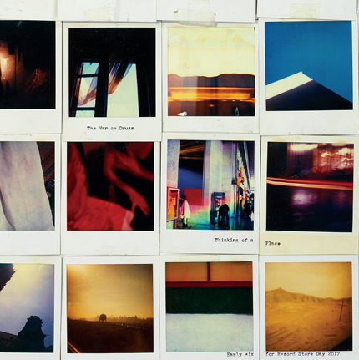
(“Thinking of a Place” cover artwork)

Download hi-res cover art and press images –
www.pitchperfectpr.com/the-war-on-drugs/

Official Website | Instagram | Twitter | Facebook

