FOR IMMEDIATE RELEASE
OCTOBER 30, 2018

“TINY CHANGES: A CELEBRATION OF THE SONGS OF SCOTT HUTCHISON”
TRIBUTE CONCERT SET TO TAKE PLACE
AT ROUGH TRADE NYC ON DECEMBER 5TH

FEATURED PERFORMERS INCLUDE JULIEN BAKER, THE NATIONAL’S AARON DESSNER, KEVIN DEVINE, THE HOLD STEADY’S CRAIG FINN,
AND DEATH CAB FOR CUTIE’S BEN GIBBARD

TICKETS ON SALE FRIDAY, NOVEMBER 2ND

ALL PROCEEDS TO BENEFIT THE SCOTT HUTCHISON FUND

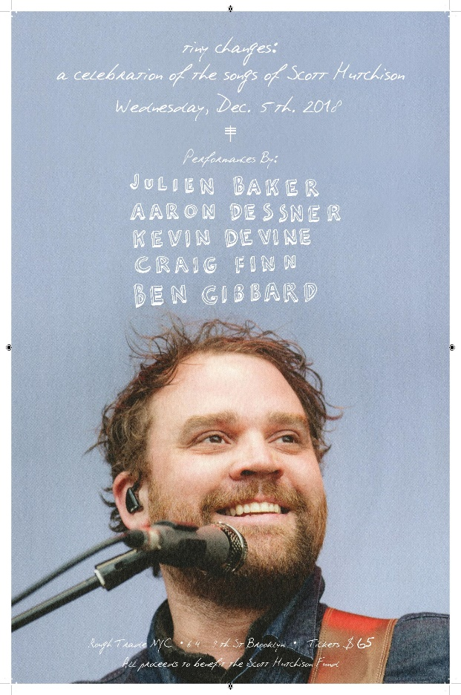

Canvasback Music/Atlantic and Bowery Presents have announced details for “Tiny Changes: A Celebration Of the Songs of Scott Hutchison,” a special tribute concert featuring performances by friends of Frightened Rabbit’s Scott Hutchison. The concert will take place at Rough Trade NYC on December 5th. Performers include Julien Baker, The National’s Aaron Dessner, Kevin Devine, The Hold Steady’s Craig Finn, and Death Cab For Cutie’s Ben Gibbard. Tickets go on sale this Friday, November 2nd at [12pm ET] at http://axs.com/events/364405/a-celebration-of-the-songs-of-scott-hutchison-tickets?skin=roughtrade.
All proceeds benefit the newly formed Scott Hutchison Fund, which Scott’s brother, Grant Hutchison, describes as follows: "The Scott Hutchison Fund has been set up in memory of our beloved Scott. It will form the basis for a Mental Health Charity to be set up fully in the coming months. We hope to be able to help others the way Scott did with kindness, empathy and hope."
PRESS CONTACTS:

Glenn Fukushima (National) Libby Kober (Online)
GlennFukushima@elektra.com Libby.Kober@atlanticrecords.com

